CE100 Lab Report 7

Freeze

Justin Fortner

Lab 1C

TU/TH 1:30-3:20

12/6/17

**Description:**

The goal of this lab was to create the game called freeze tag. This game began with a square blinking. After a few seconds it stops blinking and begins bouncing around the screen. Four buttons control the direction of the square. Once the start button is pressed 8 bars randomly drop from the top of the screen and the game timer begins to count down. If the square tags a bar the bar is frozen in its current location and begins blinking. The score counter increments by one each time a bar is tagged. If the timer runs out before all bars are tagged then you lose and the game restarts. If all bars are tagged before the timer runs out then you win. The border will flash to indicate this. If the game is won the start button will start a new game. The bar and timer length can be manipulated through the use of switches thus making the game easier or harder.

**Methods:**

**Top Level:**

The top level of Lab 7 ties together all other portions of this lab. As well as containing the logic to display the bar, square and borders for the game. The logic for the LEDs and 7 segment display are also housed within the top level module.

**LFSR:**

The LFSR gives random 8 bit numbers. These random numbers are achieved by linking together 8 synchronous D flip flops. The input to the first D flip flop is the XOR output of the output of four of the D flip flops. Any four are allowed. When one of these random numbers matches a desired random number a high signal is given. This high signal will later be used to notify when the bar is to begin falling.

**VGA Controller:**

The VGA Controller consists of two count10L modules. One of these counters keeps track of the rows. The other keeps track of the columns. The column counter will count first, thus we will go through a full row. Once we have gone through a full row we go down one spot on the column. A pixel address can be obtained by the counting output of these two 10 bit counters. The HSync and VSync are set to high anywhere outside of designated low regions. The active region is set high when it is within the boundaries of the screen and set to low otherwise. A frame is completed once all rows and columns have been completed within the active region.

**Time Counter:**

The time counter is an eight bit up counter. The frame complete signal is the clock for this module. Every increment in the count represents a complete frame. For this lab we needed a four second counter. A high output was given when the counter reached 11111110 to represent four seconds.

**Ball State Machine Left/Right:**

The ball left and right actions are handled differently than the up and down actions. Initially the ball is blinking and not moving. After a few seconds the ball moves out of this initial state and into the right moving state. If button R is hit while in this state then it will remain in this state. If the ball hits the rightmost border of the game then it will move to the move left state. Likewise if button L is hit then the ball will move to the move left state. If button L is hit while in the move left state then it will remain in this state. If the ball hits the leftmost border of the game then it will move to the move right state. Likewise if button R is hit then the ball will move to the move right state.

**Ball State Machine Up/Down:**

The ball up and down actions are handled differently than the up and down actions. Initially the ball is blinking and not moving. After a few seconds the ball moves out of this initial state and into the down moving state. If button R is hit while in this state then it will remain in this state. If the ball hits the bottom border of the game then it will move to the move up state. Likewise if button L is hit then the ball will move to the move up state. If button L is hit while in the move up state then it will remain in this state. If the ball hits the top border of the game then it will move to the move down state. Likewise if button R is hit then the ball will move to the move down state.

**12 Bit Up Down Counter:**

The 12 bit Up Down counter is made up of three 4 bit up down counter. Counters are only able to count if the one to the right of it is full and only able to count down if the one to the left of it is empty.

**Target Creator:**

The target creator hold everything that would be needed to create and move a bar. As well as handle the interaction between the square and the bar.

**Edge Detector:**

The edge detector consists of two flip flops. The input to the first flip flop is if in the flash state. The input to the second flip flop is the output of the first. If the output of both flip flops is 0 and then in the flash state then a high value is generated.

**Target State Machine:**

My target state machine consists of three states, waiting, showing and falling, and stopped and flashing. The bar begins in the waiting state. In this state the bar can not be seen. Once the random number signal goes high the correspond bar will move into the show and move state. The bar moves down the screen. If the bar reaches the end of the screen it resets to the waiting state. If the square tags the bar then it moves into the stopped and flashing state. In this state the bar stops moving and begins flashing. This will also make the score counter increment by one.

**14 Bit Up Down Counter:**

The 14 bit Up Down counter is made up of four 4 bit up down counter. Counters are only able to count if the one to the right of it is full and only able to count down if the one to the left of it is empty.

**Results:**

**Design:**

**Top Level:**

The top level connects each aspect of my lab as well as allowing inputs from the board and outputs to the board and VGA. This is done through various assign statements shown below.

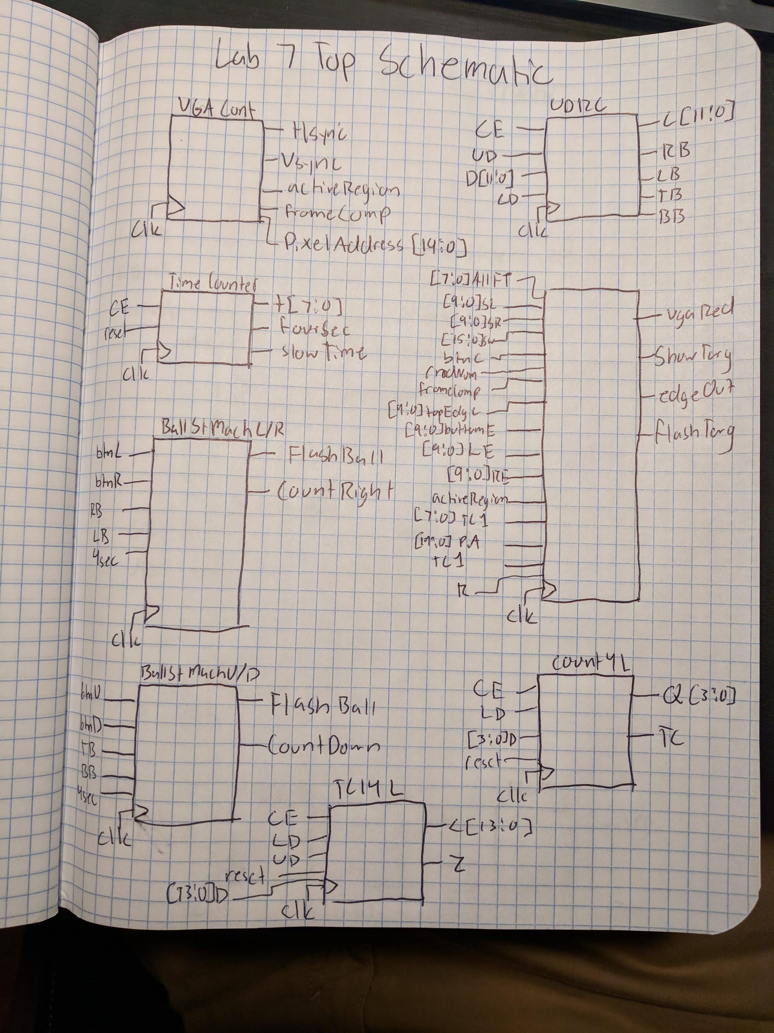

assign wVGAGreenExtend = ((wFlashBallUp & ~wFourSec & wTimeCounterOut0[4])|(wFourSec)) & wActiveRegion & (((wPixelAddress[9:0] >= wLeftEdge) & (wPixelAddress[9:0] <= wRightEdge)) & ((wPixelAddress[19:10] >= wTopEdge) & (wPixelAddress[19:10] <= wBottomEdge)));

assign vgaGreen = {wVGAGreenExtend, wVGAGreenExtend, wVGAGreenExtend, wVGAGreenExtend};

//Color Boarder

assign wVGABlueExtend = ((wFlashingCounterOut[3] & ~wTimeCounter14Z & wTimeCounterOut1[4] & ~wNewGame)|(~wFlashingCounterOut[3])) & wActiveRegion & (((wPixelAddress[9:0] <= 10'd7) & (wPixelAddress[9:0] >= 10'd0)) | ((wPixelAddress[9:0] >= 10'd632) & (wPixelAddress[9:0] <= 10'd639)) | ((wPixelAddress[19:10] <= 10'd7) & (wPixelAddress[19:10] >= 10'd0)) | ((wPixelAddress[19:10] <= 10'd479) & (wPixelAddress[19:10] >= 10'd472)));

assign vgaBlue = {wVGABlueExtend, wVGABlueExtend, wVGABlueExtend, wVGABlueExtend};

//Color Target

//assign wVGARedExtend = ((wFlashTarg & wTimeCounterOut1[4])|(~wFlashTarg)) & wShowTarg & wActiveRegion & (((wPixelAddress[9:0] >= wLeftEdgeTarg) & (wPixelAddress[9:0] <= wRightEdgeTarg)) & ((wPixelAddress[19:10] >= wTopEdgeTarg) & (wPixelAddress[19:10] <= wBottomEdgeTarg)));

assign vgaRed = {(wVGARedExtend0 | wVGARedExtend1 | wVGARedExtend2 | wVGARedExtend3 | wVGARedExtend4 | wVGARedExtend5 | wVGARedExtend6 | wVGARedExtend7), (wVGARedExtend0 | wVGARedExtend1 | wVGARedExtend2 | wVGARedExtend3 | wVGARedExtend4 | wVGARedExtend5 | wVGARedExtend6 | wVGARedExtend7), (wVGARedExtend0 | wVGARedExtend1 | wVGARedExtend2 | wVGARedExtend3 | wVGARedExtend4 | wVGARedExtend5 | wVGARedExtend6 | wVGARedExtend7), (wVGARedExtend0 | wVGARedExtend1 | wVGARedExtend2 | wVGARedExtend3 | wVGARedExtend4 | wVGARedExtend5 | wVGARedExtend6 | wVGARedExtend7)};

//Assign Hsync and Vsync

assign Hsync = wHsync;

assign Vsync = wVsync;

assign led = sw;

assign an [3] = ~wRingCounterOut[3];

assign an [1] = ~wRingCounterOut[1];

assign an [0] = ~wRingCounterOut[0];

assign wNewGame = (wFlashingCounterOut[3] & ~wTimeCounter14Z & wBtnC)|(wTimeCounter14Z & ~wFlashingCounterOut[3]);

**LFSR:**

The random number generator was implemented as follows. 8 Dflip flops were hooked together in series. The output of one going into the input of the next. Then four flip flop outputs were fed into an xor gate. The output of this gate is the input of the first D flip flop inn the series mentioned above. A random 8 bit number is output from the circuit described.

assign wXor = wRnd[0] ^ wRnd[2] ^ wRnd[6] ^ wRnd[7];

assign rNum[0] = ~wRnd[0] & ~wRnd[1] & wRnd[2] & wRnd[3] & ~wRnd[4] & ~wRnd[5] & wRnd[6] & ~wRnd[7];

assign rNum[1] = wRnd[0] & ~wRnd[1] & ~wRnd[2] & ~wRnd[3] & ~wRnd[4] & wRnd[5] & ~wRnd[6] & ~wRnd[7];

assign rNum[2] = wRnd[0] & ~wRnd[1] & wRnd[2] & wRnd[3] & wRnd[4] & ~wRnd[5] & wRnd[6] & ~wRnd[7];

assign rNum[3] = wRnd[0] & ~wRnd[1] & ~wRnd[2] & wRnd[3] & wRnd[4] & wRnd[5] & ~wRnd[6] & wRnd[7];

assign rNum[4] = ~wRnd[0] & ~wRnd[1] & ~wRnd[2] & wRnd[3] & ~wRnd[4] & wRnd[5] & wRnd[6] & wRnd[7];

assign rNum[5] = wRnd[0] & ~wRnd[1] & wRnd[2] & ~wRnd[3] & ~wRnd[4] & wRnd[5] & wRnd[6] & wRnd[7];

assign rNum[6] = ~wRnd[0] & ~wRnd[1] & wRnd[2] & wRnd[3] & ~wRnd[4] & wRnd[5] & wRnd[6] & wRnd[7];

assign rNum[7] = wRnd[0] & ~wRnd[1] & ~wRnd[2] & wRnd[3] & wRnd[4] & wRnd[5] & wRnd[6] & ~wRnd[7];

**VGA Controller:**

The VGA controller uses two 10 bit counters in order to keep track of the rows and columns of the display. The pixel address given from this module is essential in coloring the correct pixels in the display and keeping track of the collisions of the objects.

assign wColTC = pixelAddress[9:0] == 10'd799;

assign wRowTC = pixelAddress[19:10] == 10'd524;

assign Hsync = (10'd654 >= wQ[9:0]) | (wQ[9:0] >= 10'd751);

assign Vsync = (10'd489 > wQ[19:10]) | (wQ[19:10] > 10'd490);

assign activeRegion = (10'd479 >= wQ[19:10]) & (10'd639 >= wQ[9:0]);

assign frameComp = (10'd479 == wQ[19:10]) & (10'd639 == wQ[9:0]);

**Time Counter:**

Equations are obtained from the table below.

|  |  |  |  |  |  |  |  |  |  |  |  |  |
| --- | --- | --- | --- | --- | --- | --- | --- | --- | --- | --- | --- | --- |
| **CE** | **Q5** | **Q4** | **Q3** | **Q2** | **Q1** | **Q0** | **Q5+** | **Q4+** | **Q3** | **Q2+** | **Q1+** | **Q0+** |
| **1** | **0** | **0** | **0** | **0** | **0** | **0** | **0** | **0** | **0** | **0** | **0** | **1** |
| **1** | **0** | **0** | **0** | **0** | **0** | **1** | **0** | **0** | **0** | **0** | **1** | **0** |
| **1** | **0** | **0** | **0** | **0** | **1** | **0** | **0** | **0** | **0** | **0** | **1** | **1** |
| **1** | **0** | **0** | **0** | **0** | **1** | **1** | **0** | **0** | **0** | **1** | **0** | **0** |
| **1** | **0** | **0** | **0** | **1** | **0** | **0** | **0** | **0** | **0** | **1** | **0** | **1** |
| **1** | **0** | **0** | **0** | **1** | **0** | **1** | **0** | **0** | **0** | **1** | **1** | **0** |
| **1** | **0** | **0** | **0** | **1** | **1** | **0** | **0** | **0** | **0** | **1** | **1** | **1** |
| **1** | **0** | **0** | **0** | **1** | **1** | **1** | **0** | **0** | **1** | **0** | **0** | **0** |
| **1** | **0** | **0** | **1** | **0** | **0** | **0** | **0** | **0** | **1** | **0** | **0** | **1** |
| **1** | **0** | **0** | **1** | **0** | **0** | **1** | **0** | **0** | **1** | **0** | **1** | **0** |
| **1** | **0** | **0** | **1** | **0** | **1** | **0** | **0** | **0** | **1** | **0** | **1** | **1** |
| **1** | **0** | **0** | **1** | **0** | **1** | **1** | **0** | **0** | **1** | **1** | **0** | **0** |
| **1** | **0** | **0** | **1** | **1** | **0** | **0** | **0** | **0** | **1** | **1** | **0** | **1** |
| **1** | **0** | **0** | **1** | **1** | **0** | **1** | **0** | **0** | **1** | **1** | **1** | **0** |
| **1** | **0** | **0** | **1** | **1** | **1** | **0** | **0** | **0** | **1** | **1** | **1** | **1** |
| **1** | **0** | **0** | **1** | **1** | **1** | **1** | **0** | **1** | **0** | **0** | **0** | **0** |
| **1** | **0** | **1** | **0** | **0** | **0** | **0** | **0** | **1** | **0** | **0** | **0** | **1** |
| **1** | **0** | **1** | **0** | **0** | **0** | **1** | **0** | **1** | **0** | **0** | **1** | **0** |
| **1** | **0** | **1** | **0** | **0** | **1** | **0** | **0** | **1** | **0** | **0** | **1** | **1** |
| **1** | **0** | **1** | **0** | **0** | **1** | **1** | **0** | **1** | **0** | **1** | **0** | **0** |
| **1** | **0** | **1** | **0** | **1** | **0** | **0** | **0** | **1** | **0** | **1** | **0** | **1** |
| **1** | **0** | **1** | **0** | **1** | **0** | **1** | **0** | **1** | **0** | **1** | **1** | **0** |
| **1** | **0** | **1** | **0** | **1** | **1** | **0** | **0** | **1** | **0** | **1** | **1** | **1** |
| **1** | **0** | **1** | **0** | **1** | **1** | **1** | **0** | **1** | **1** | **0** | **0** | **0** |
| **1** | **0** | **1** | **1** | **0** | **0** | **0** | **0** | **1** | **1** | **0** | **0** | **1** |
| **1** | **0** | **1** | **1** | **0** | **0** | **1** | **0** | **1** | **1** | **0** | **1** | **0** |
| **1** | **0** | **1** | **1** | **0** | **1** | **0** | **0** | **1** | **1** | **0** | **1** | **1** |
| **1** | **0** | **1** | **1** | **0** | **1** | **1** | **0** | **1** | **1** | **1** | **0** | **0** |
| **1** | **0** | **1** | **1** | **1** | **0** | **0** | **0** | **1** | **1** | **1** | **0** | **1** |
| **1** | **0** | **1** | **1** | **1** | **0** | **1** | **0** | **1** | **1** | **1** | **1** | **0** |
| **1** | **0** | **1** | **1** | **1** | **1** | **0** | **0** | **1** | **1** | **1** | **1** | **1** |
| **1** | **0** | **1** | **1** | **1** | **1** | **1** | **1** | **0** | **0** | **0** | **0** | **0** |
| **1** | **1** | **0** | **0** | **0** | **0** | **0** | **0** | **0** | **0** | **0** | **0** | **0** |

assign wD[0] = (~CE&t[0])|(CE&~t[0]);

assign wD[1] = (~CE&t[1])|(t[1]&~t[0])|(CE&~t[1]&t[0]);

assign wD[2] = (~CE&t[2])|(t[2]&~t[1])|(t[2]&~t[0])|(CE&~t[2]&t[1]&t[0]);

assign wD[3] = (~CE&t[3])|(t[3]&~t[2])|(t[3]&~t[1])|(t[3]&~t[0])|(CE&~t[3]&t[2]&t[1]&t[0]);

assign wD[4] = (~CE&t[4])|(t[4]&~t[3])|(t[4]&~t[2])|(t[4]&~t[1])|(t[4]&~t[0])|(CE&~t[4]&t[3]&t[2]&t[1]&t[0]);

assign wD[5] = (~CE&t[5])|(t[5]&~t[4])|(t[5]&~t[3])|(t[5]&~t[2])|(t[5]&~t[1])|(t[5]&~t[0])|(CE&~t[5]&t[4]&t[3]&t[2]&t[1]&t[0]);

assign wD[6] = (~CE&t[6])|(t[6]&~t[5])|(t[6]&~t[4])|(t[6]&~t[3])|(t[6]&~t[2])|(t[6]&~t[1])|(t[6]&~t[0])|(CE&~t[6]&t[5]&t[4]&t[3]&t[2]&t[1]&t[0]);

assign wD[7] = (~CE&t[7])|(t[7]&~t[6])|(t[7]&~t[5])|(t[7]&~t[4])|(t[7]&~t[3])|(t[7]&~t[2])|(t[7]&~t[1])|(t[7]&~t[0])|(CE&~t[6]&t[5]&t[4]&t[3]&t[2]&t[1]&t[0]);

assign FourSec = t[7] & t[6] & t[5] & t[4] & t[3] & t[2]& t[1]& ~t[0];

**Ball State Machine Left/Right:**

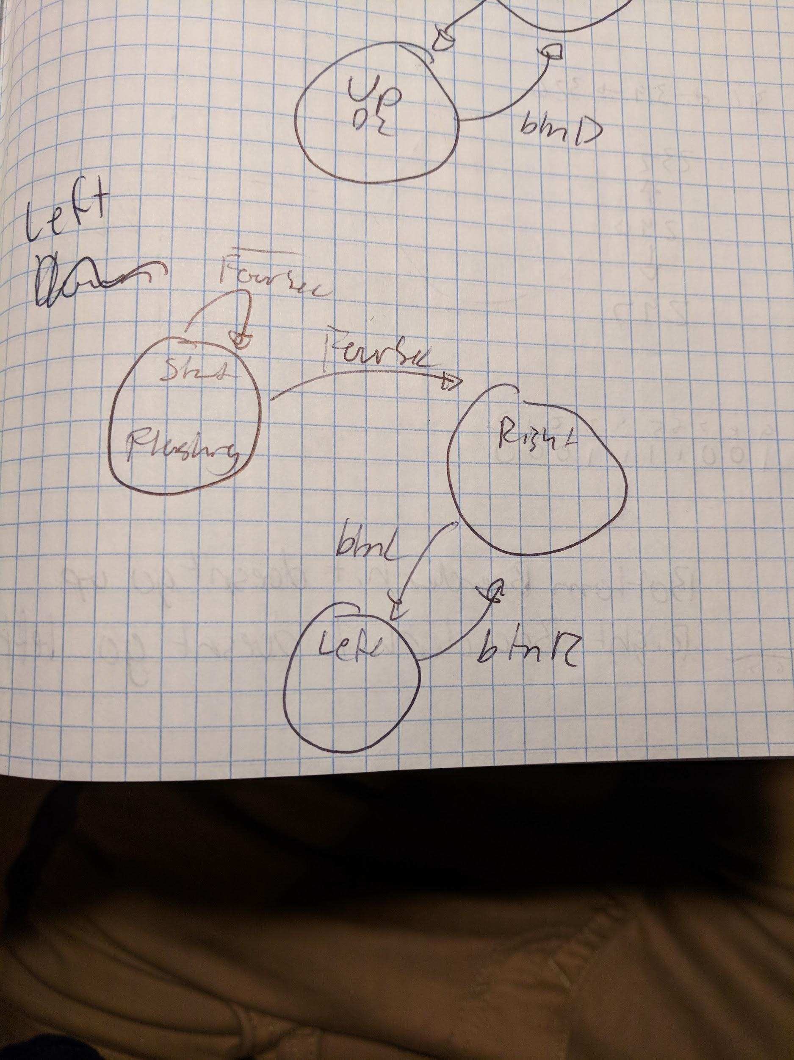

The left and right state machine handle the left and right motion of the square. This is accomplished through the states seen below. Their interaction is explained in the methods label above.

//Start

assign D[0] = (Q[0] & ~FourSec);

//Right

assign D[1] = (Q[1] & ~btnL & btnR) | (Q[0] & FourSec & ~btnL & ~btnR) | (Q[2] & ~btnL & btnR) | (Q[1] & ~btnL & ~btnR & ~RightBoarderHit) | (Q[1] & btnL & btnR) | (Q[2] & LeftBoarderHit & ~RightBoarderHit);

//Left

assign D[2] = (Q[1] & btnL & ~btnR) | (Q[2] & btnL & ~btnR) | (Q[2] & ~btnL & ~btnR) | (Q[2] & btnL & btnR) | (Q[1] & RightBoarderHit & ~LeftBoarderHit);

assign FlashBall = Q[0] & ~Q[1] & ~Q[2];

assign countRight = Q[1];

**Ball State Machine Up/Down:**

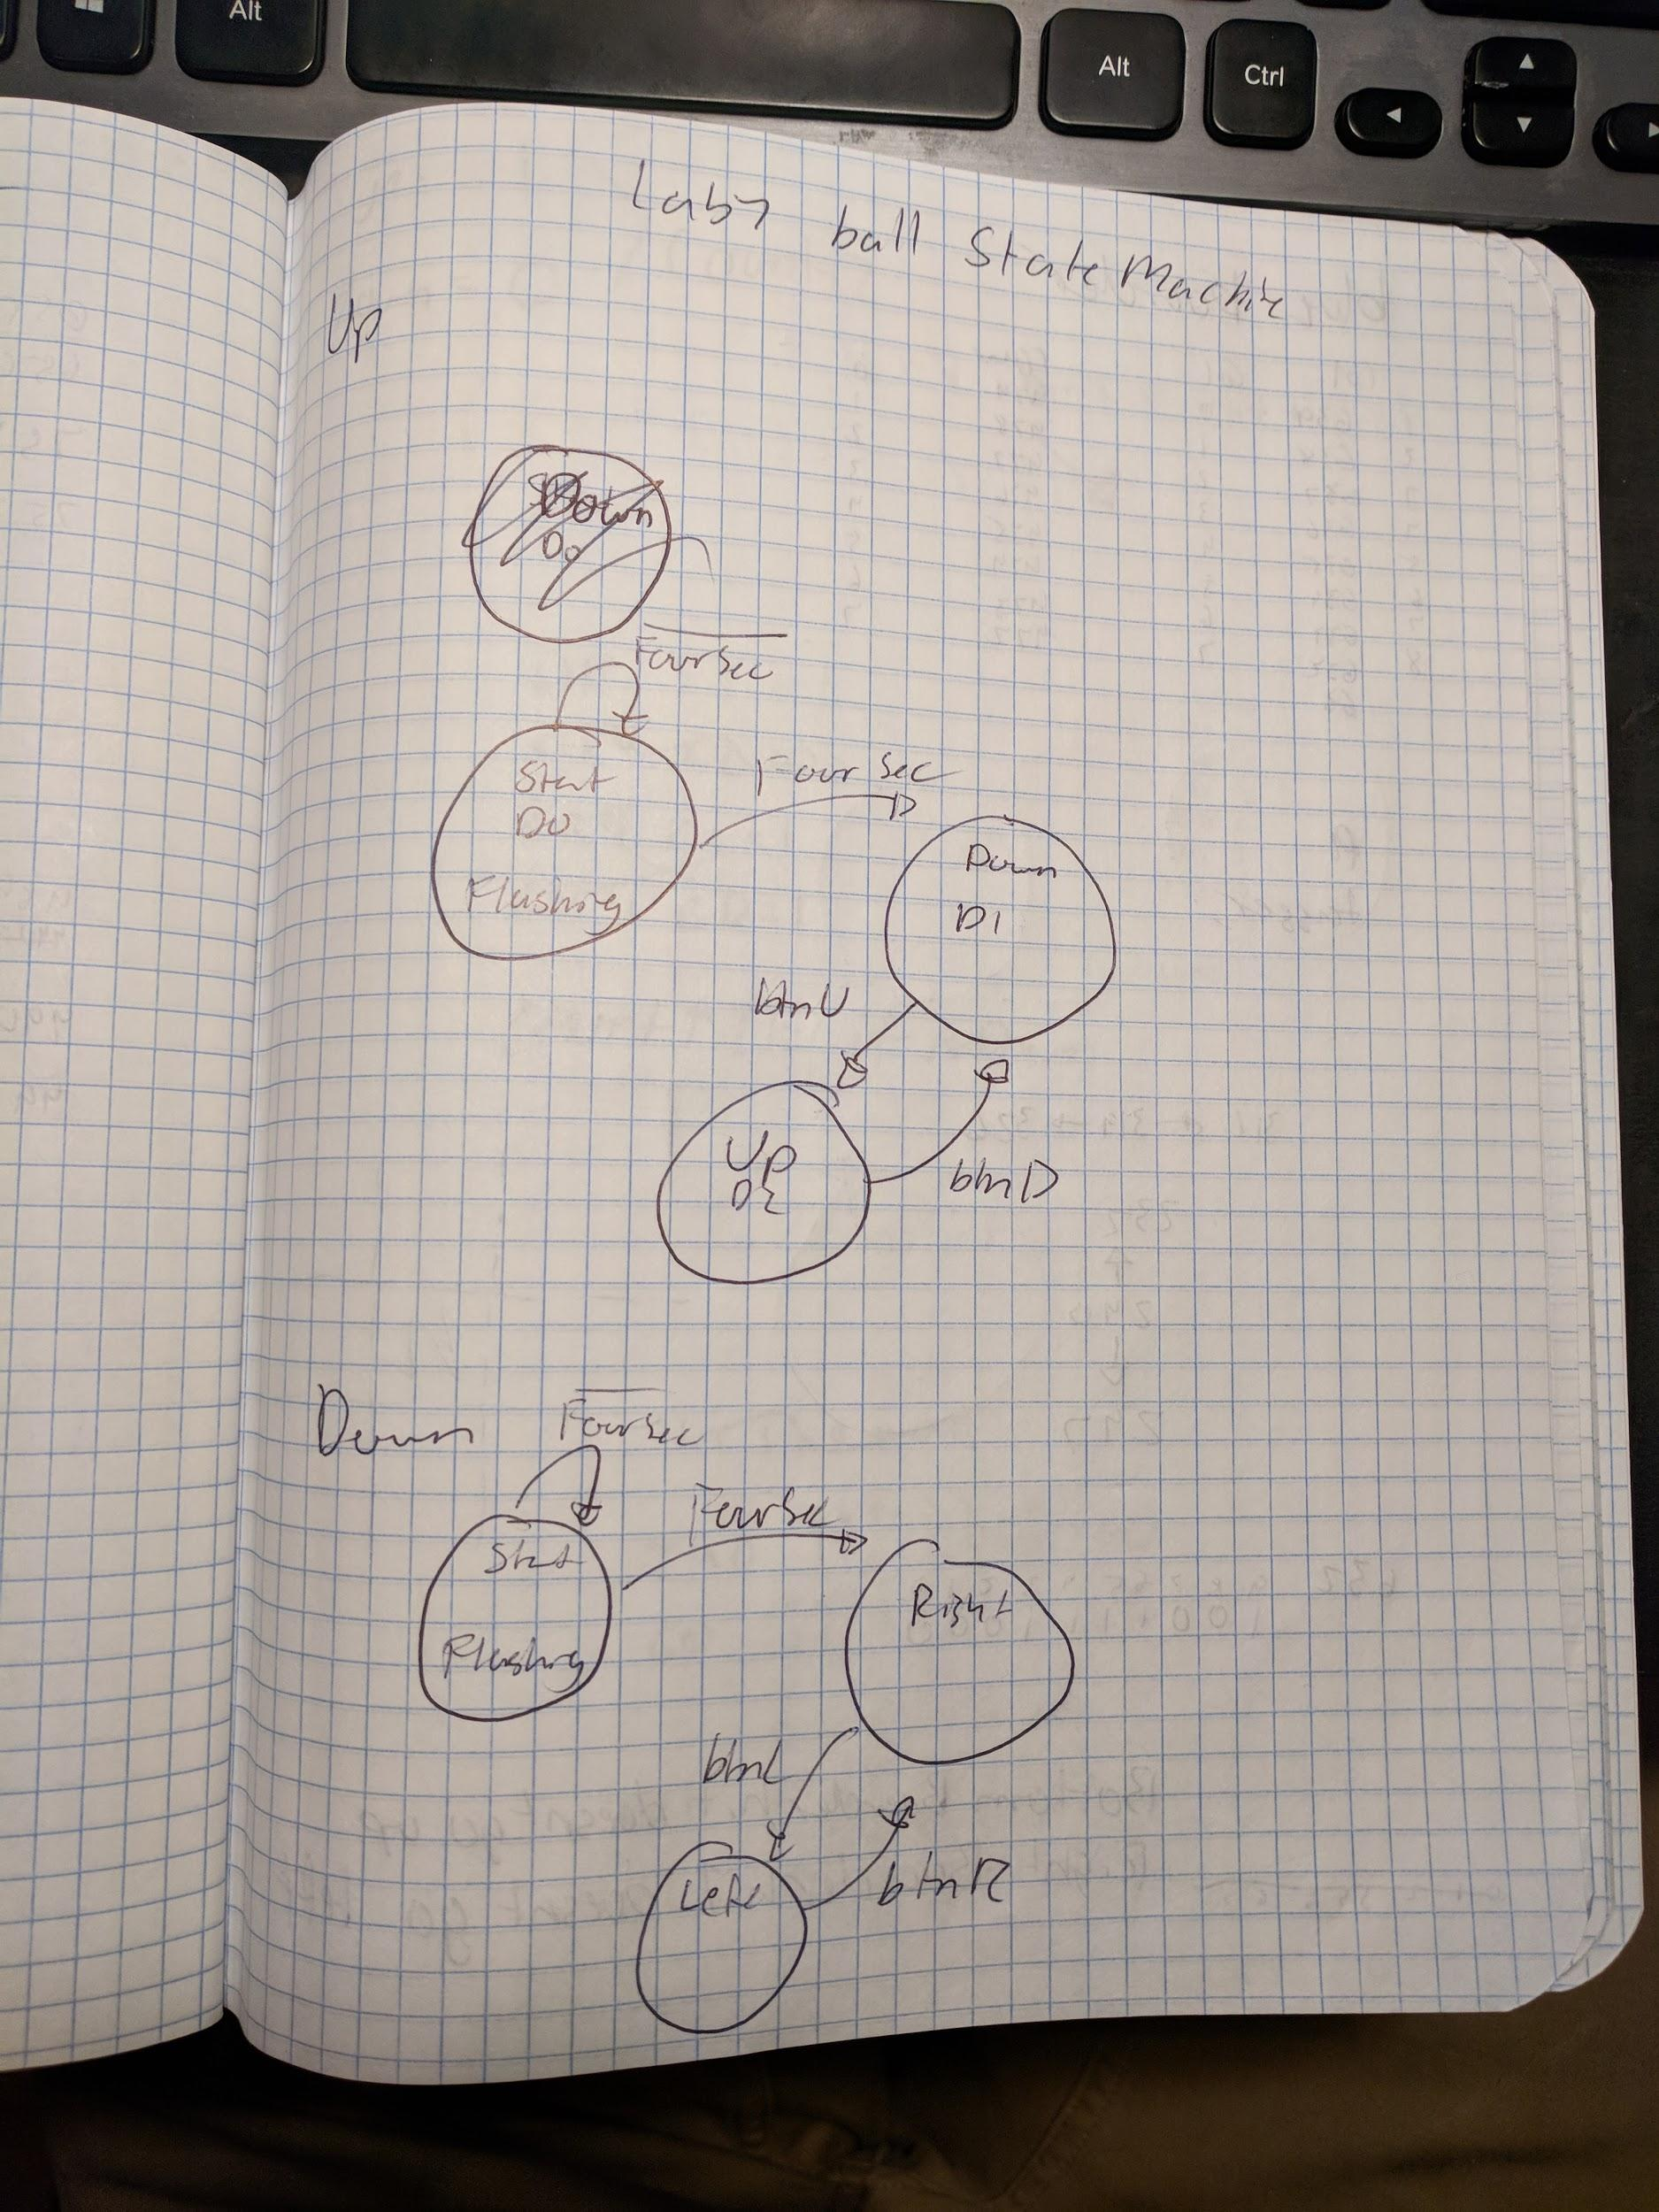

The up and down state machine handle the up and down motion of the square. This is accomplished through the states seen below. Their interaction is explained in the methods label above.

//Start

assign D[0] = (Q[0] & ~FourSec);

//Down

assign D[1] = (Q[1] & btnD & ~btnU) | (Q[0] & FourSec & ~btnU & ~btnD) | (Q[2] & btnD & ~btnU) | (Q[1] & ~btnD & ~btnU & ~BottomBoarderHit) | (Q[1] & btnD & btnU) | (Q[2] & TopBoarderHit);

//Up

assign D[2] = (Q[1] & ~btnD & btnU) | (Q[2] & ~btnD & btnU) | (Q[2] & ~btnD & ~btnU)|(Q[2] & btnD & btnU) | (Q[1] & BottomBoarderHit);

assign FlashBall = Q[0] & ~Q[1] & ~Q[2];

assign countUp = Q[1];

**12 Bit Up Down Counter:**

The 12 bit counter is used to draw the square. This is accomplished by using four of these to create the borders of the square. Then the middle of the square is filled in. Thus completing the square.

assign RightBoarderHit = UD & ~c[11] & ~c[10] & c[9] & ~c[8] & ~c[7] & c[6] & c[5] & c[4] & ~c[3] & c[2] & c[1] & c[0];

assign LeftBoarderHit = ~UD & ~c[11] & ~c[10] & ~c[9] & ~c[8] & ~c[7] & ~c[6] & ~c[5] & ~c[4] & c[3] & ~c[2] & ~c[1] & ~c[0];

assign TopBoarderHit = ~UD & ~c[11] & ~c[10] & ~c[9] & ~c[8] & ~c[7] & ~c[6] & ~c[5] & ~c[4] & c[3] & ~c[2] & ~c[1] & ~c[0];

assign BottomBoarderHit = UD & ~c[11] & ~c[10] & ~c[9] & c[8] & c[7] & c[6] & ~c[5] & c[4] & ~c[3] & c[2] & c[1] & c[0];

**Target Creator:**

The target creator handles all interactions of of all other modules to the targets. And then relays this outcome to the top level. This allowed for 8 calls of only this to create all of the targets.

**Edge Detector:**

The target creator hold everything that would be needed to create and move a bar. As well as handle the interaction between the square and the bar.

**Target State Machine:**

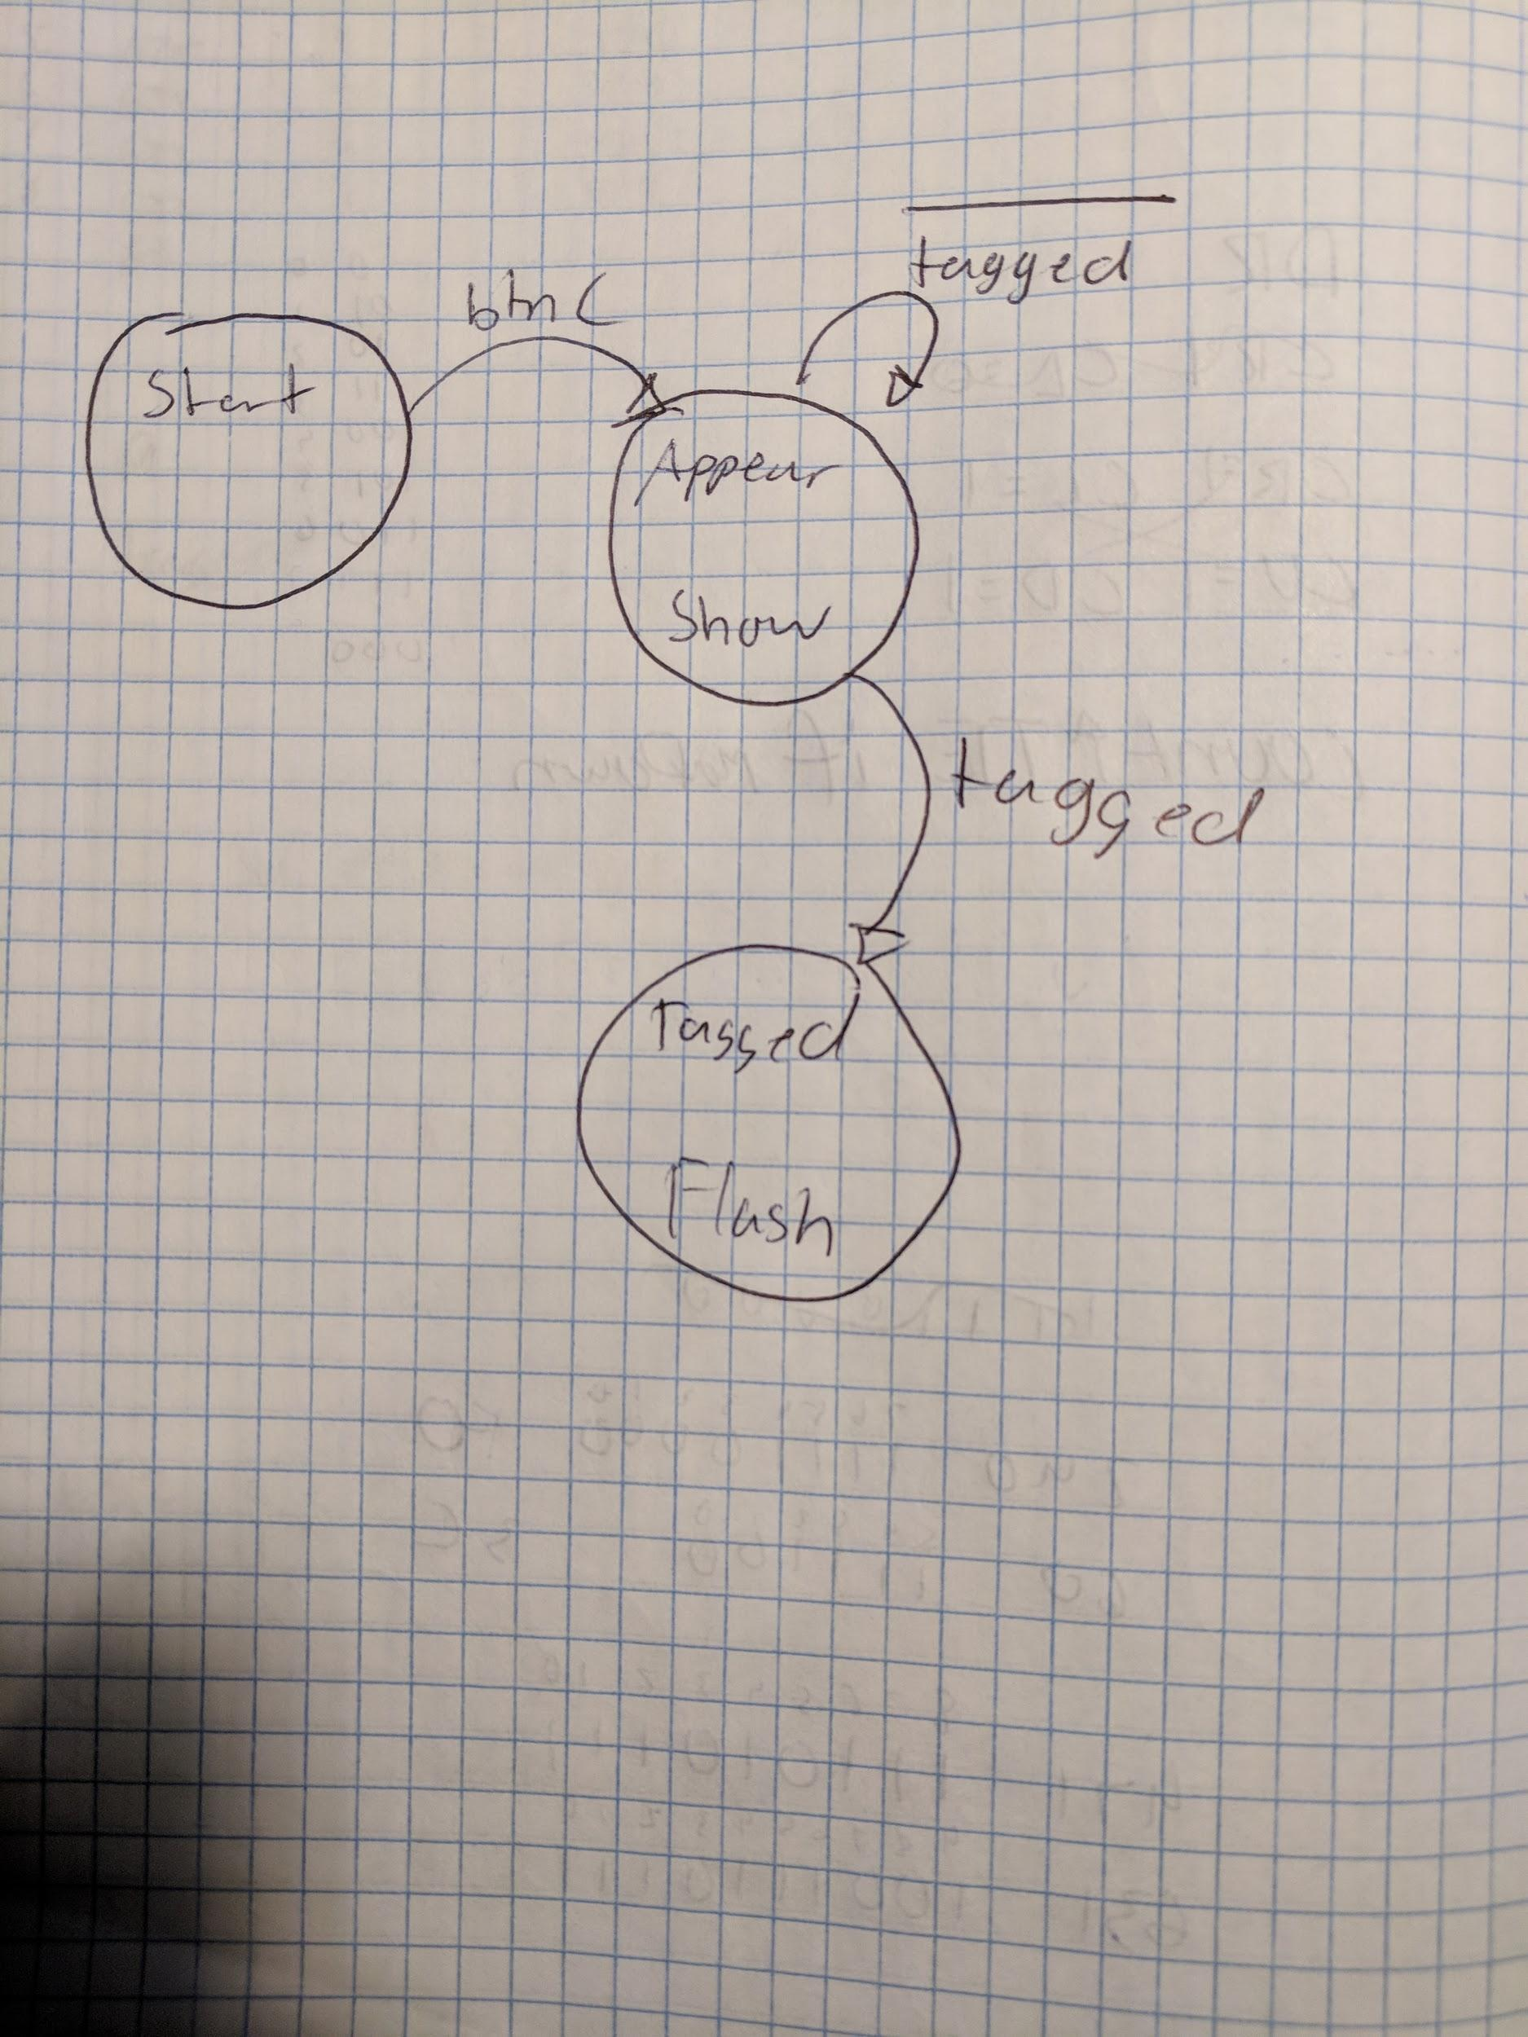

The target state machine handle the motion, appearance, and flashing of the targets. This is accomplished through the states seen below. Their interaction is explained in the methods label above.

assign wTagL = (wLeftEdge <= wRightEdgeTarg) & (wLeftEdge >= wLeftEdgeTarg);

assign wTagR = (wRightEdge <= wRightEdgeTarg) & (wRightEdge >= wLeftEdgeTarg);

assign wTagU = (wBottomEdge >= wTopEdgeTarg) & (wBottomEdge <= wBottomEdgeTarg);

assign wTagD = (wTopEdge >= wTopEdgeTarg) & (wTopEdge <= wBottomEdgeTarg);

assign wTagged = (wTagL | wTagR) & (wTagU | wTagD);

assign vgaRedExtend = ((wFlashTarg & wTimeCounterOut1[4])|(~wFlashTarg)) & wShowTarg & wActiveRegion & (((wPixelAddress[9:0] >= wLeftEdgeTarg) & (wPixelAddress[9:0] <= wRightEdgeTarg)) & ((wPixelAddress[19:10] >= wTopEdgeTarg) & (wPixelAddress[19:10] <= wBottomEdgeTarg)));

assign edgeOut = wEdgeOut;

assign flashTarg = wFlashTarg;

assign showTarg = wShowTarg;

**14 Bit Up Down Counter:**

This 14 bit up down counter counts down the time of the game. Starting when the game is begun and stopped when it reaches 0 or when all of the bars are tagged. This is implemented using the equations below and 4 smaller 4 bit up down counters.

assign c = {wC[13:12], wC[11:8], wC[7:4], wC[3:0]};

assign Z = wZ[0] & wZ[1] & wZ[2] & wZ[3];

**Testing & Simulation:**

I simulated this lab as much as I possibly could. After every significant step I would test my design so that I could trouble shoot it if need be. I double checked old modules in order to ensure that they would work properly in their new implementation. I tested the state machine against as many cases as I could think of as to ensure that they would not fail on me. LAstly I tested the top level by just playing the game. I would win and lose in all ways possible with as many different difficulties. I made sure that all edges of my square interacted with all edges of the target bars. I tested to ensure that the bars would fall randomly. I tested this lab very thoroughly in order to ensure that I would be able to pass the check of no matter what test the TAs would ask for.

**Lab Questions:**

Maximum clock frequency based on the timing report: 100MHz

**Conclusion:**

In this lab I learned how to use the VGA output. I also learned how to implement multiple state machine simultaneously. I had a very difficult time implementing the VGA controller at the start as well as having the bars fall randomly. If I were to do this lab again I would absolutely simplify my designs. I would learn how to concatenate more effectively so that I would not have to type as much. It would have saved me many lines of code. If I were to optimize anything it would be my top level module and my target creator module. There is definitely plenty of optimization top be done there. All in all, I learned a lot during this lab and while it was very difficult I got a tremendous amount out of it.

**Appendix:**

**Schematics:**

**Top Level:**

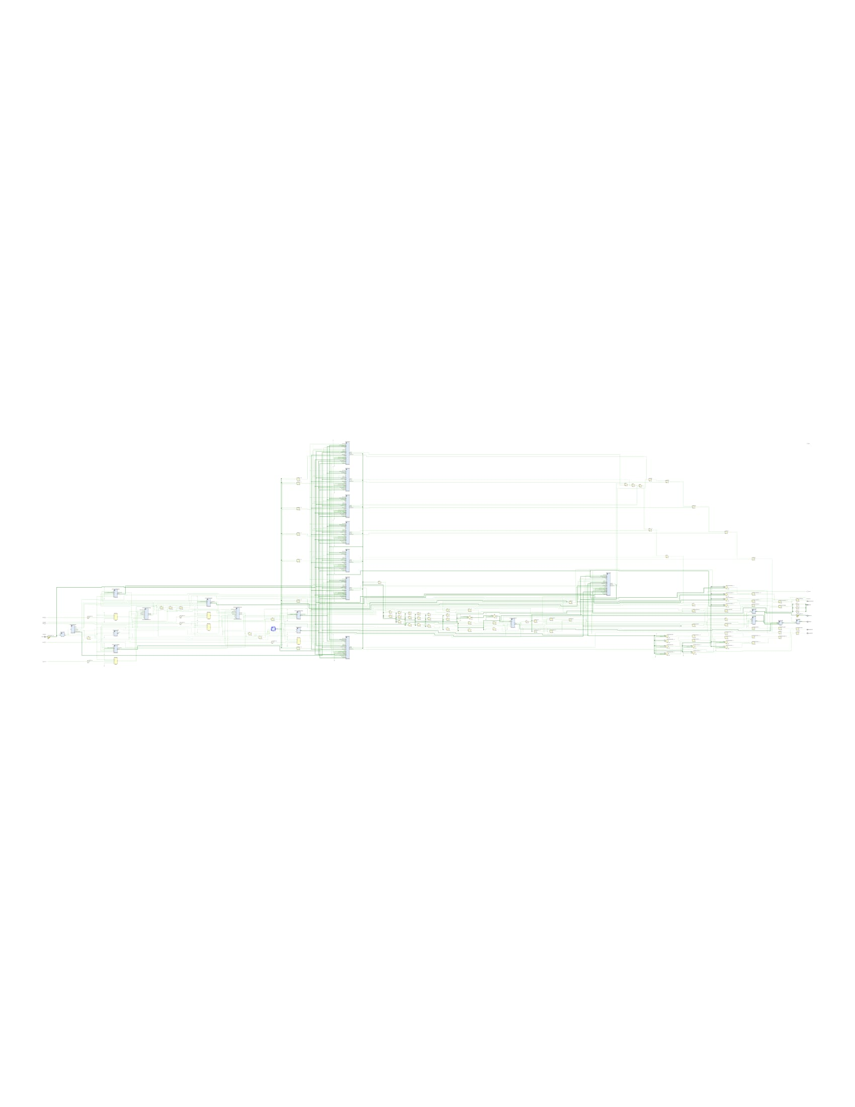

**LFSR:**

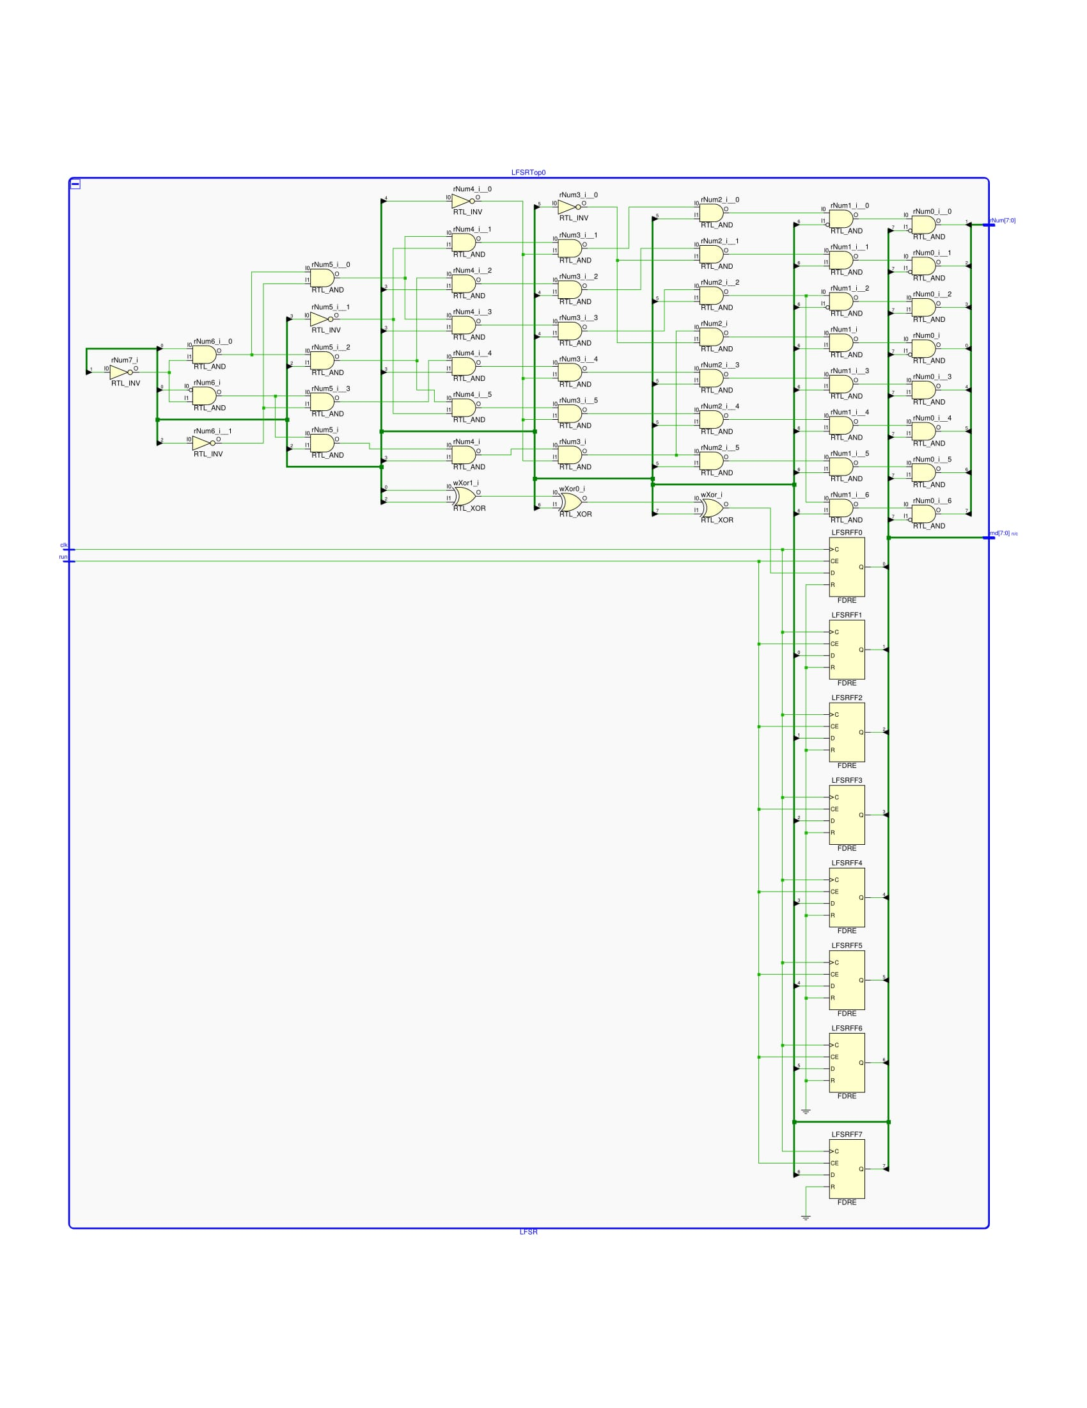

**VGA Controller:**

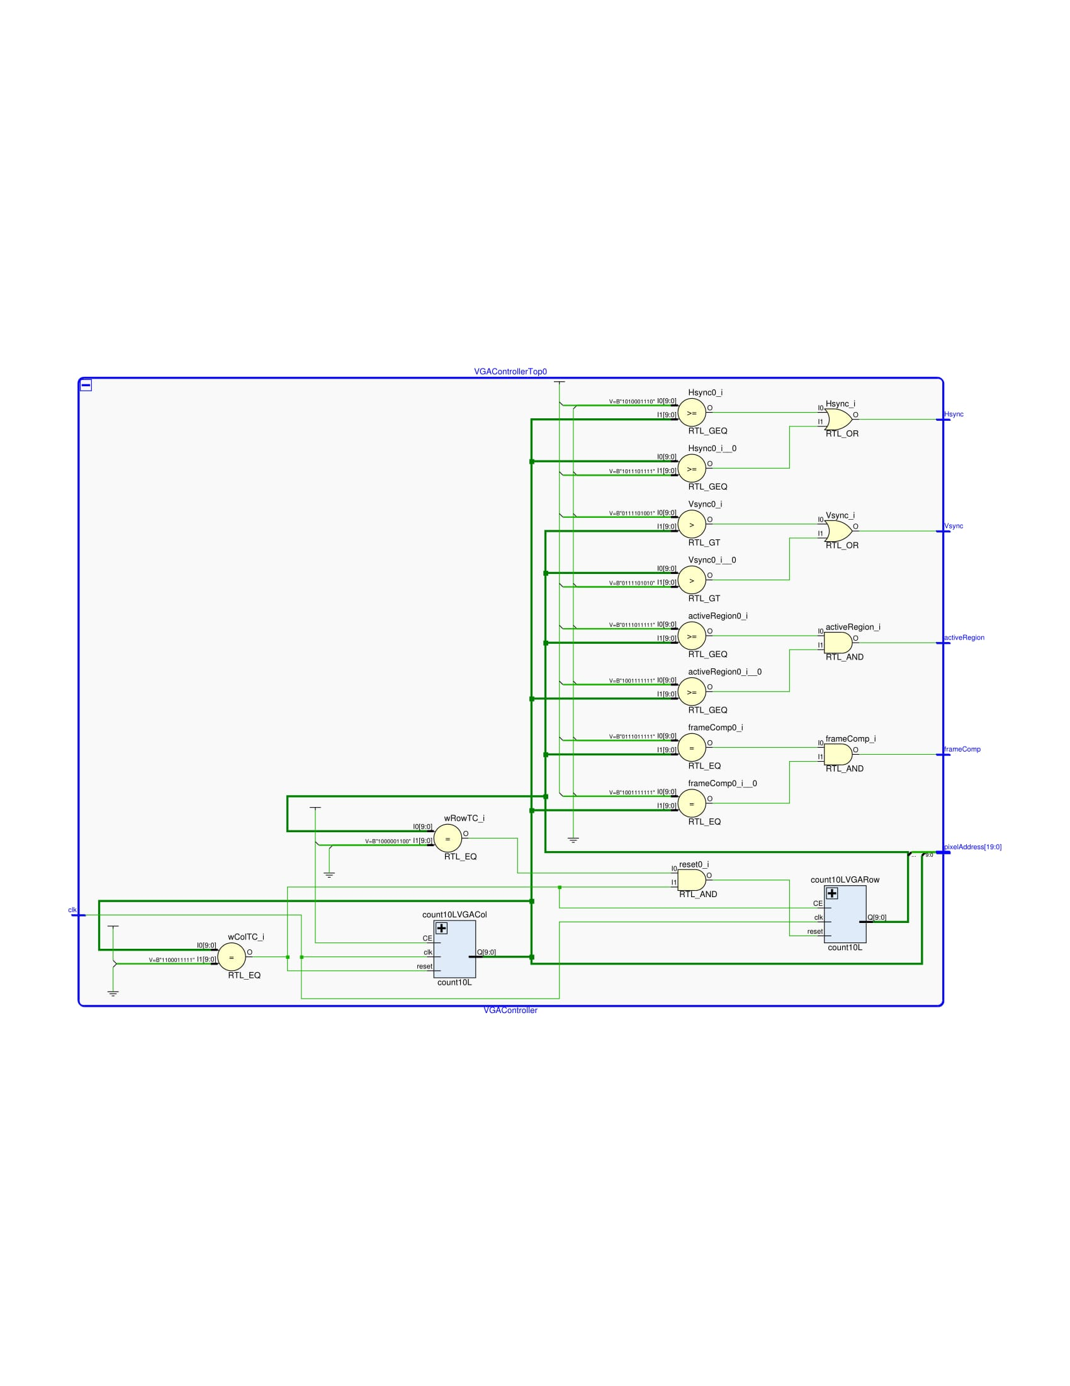

**Time Counter:**

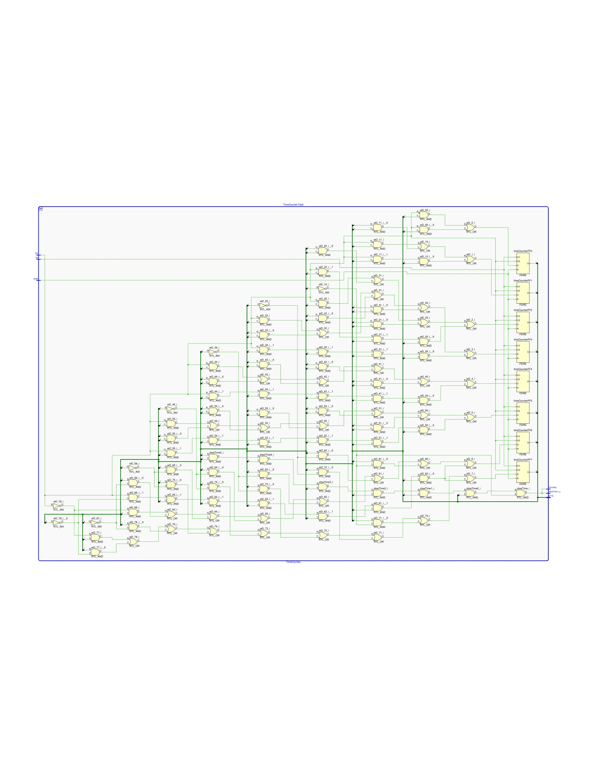

**Ball State Machine Left/Right:**

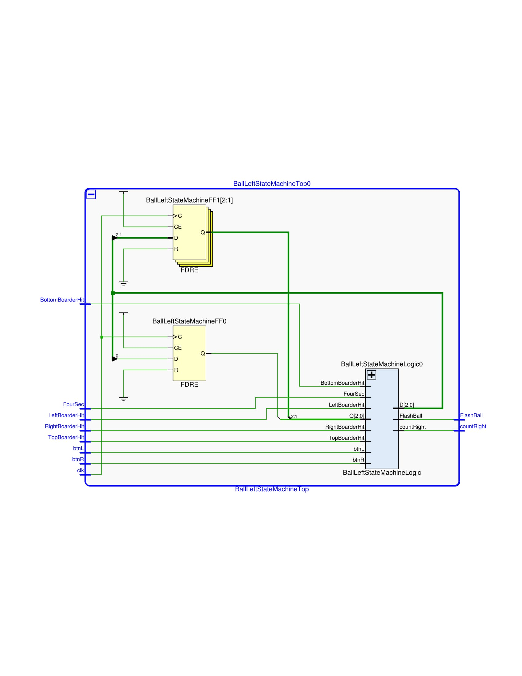

**Ball State Machine Up/Down:**

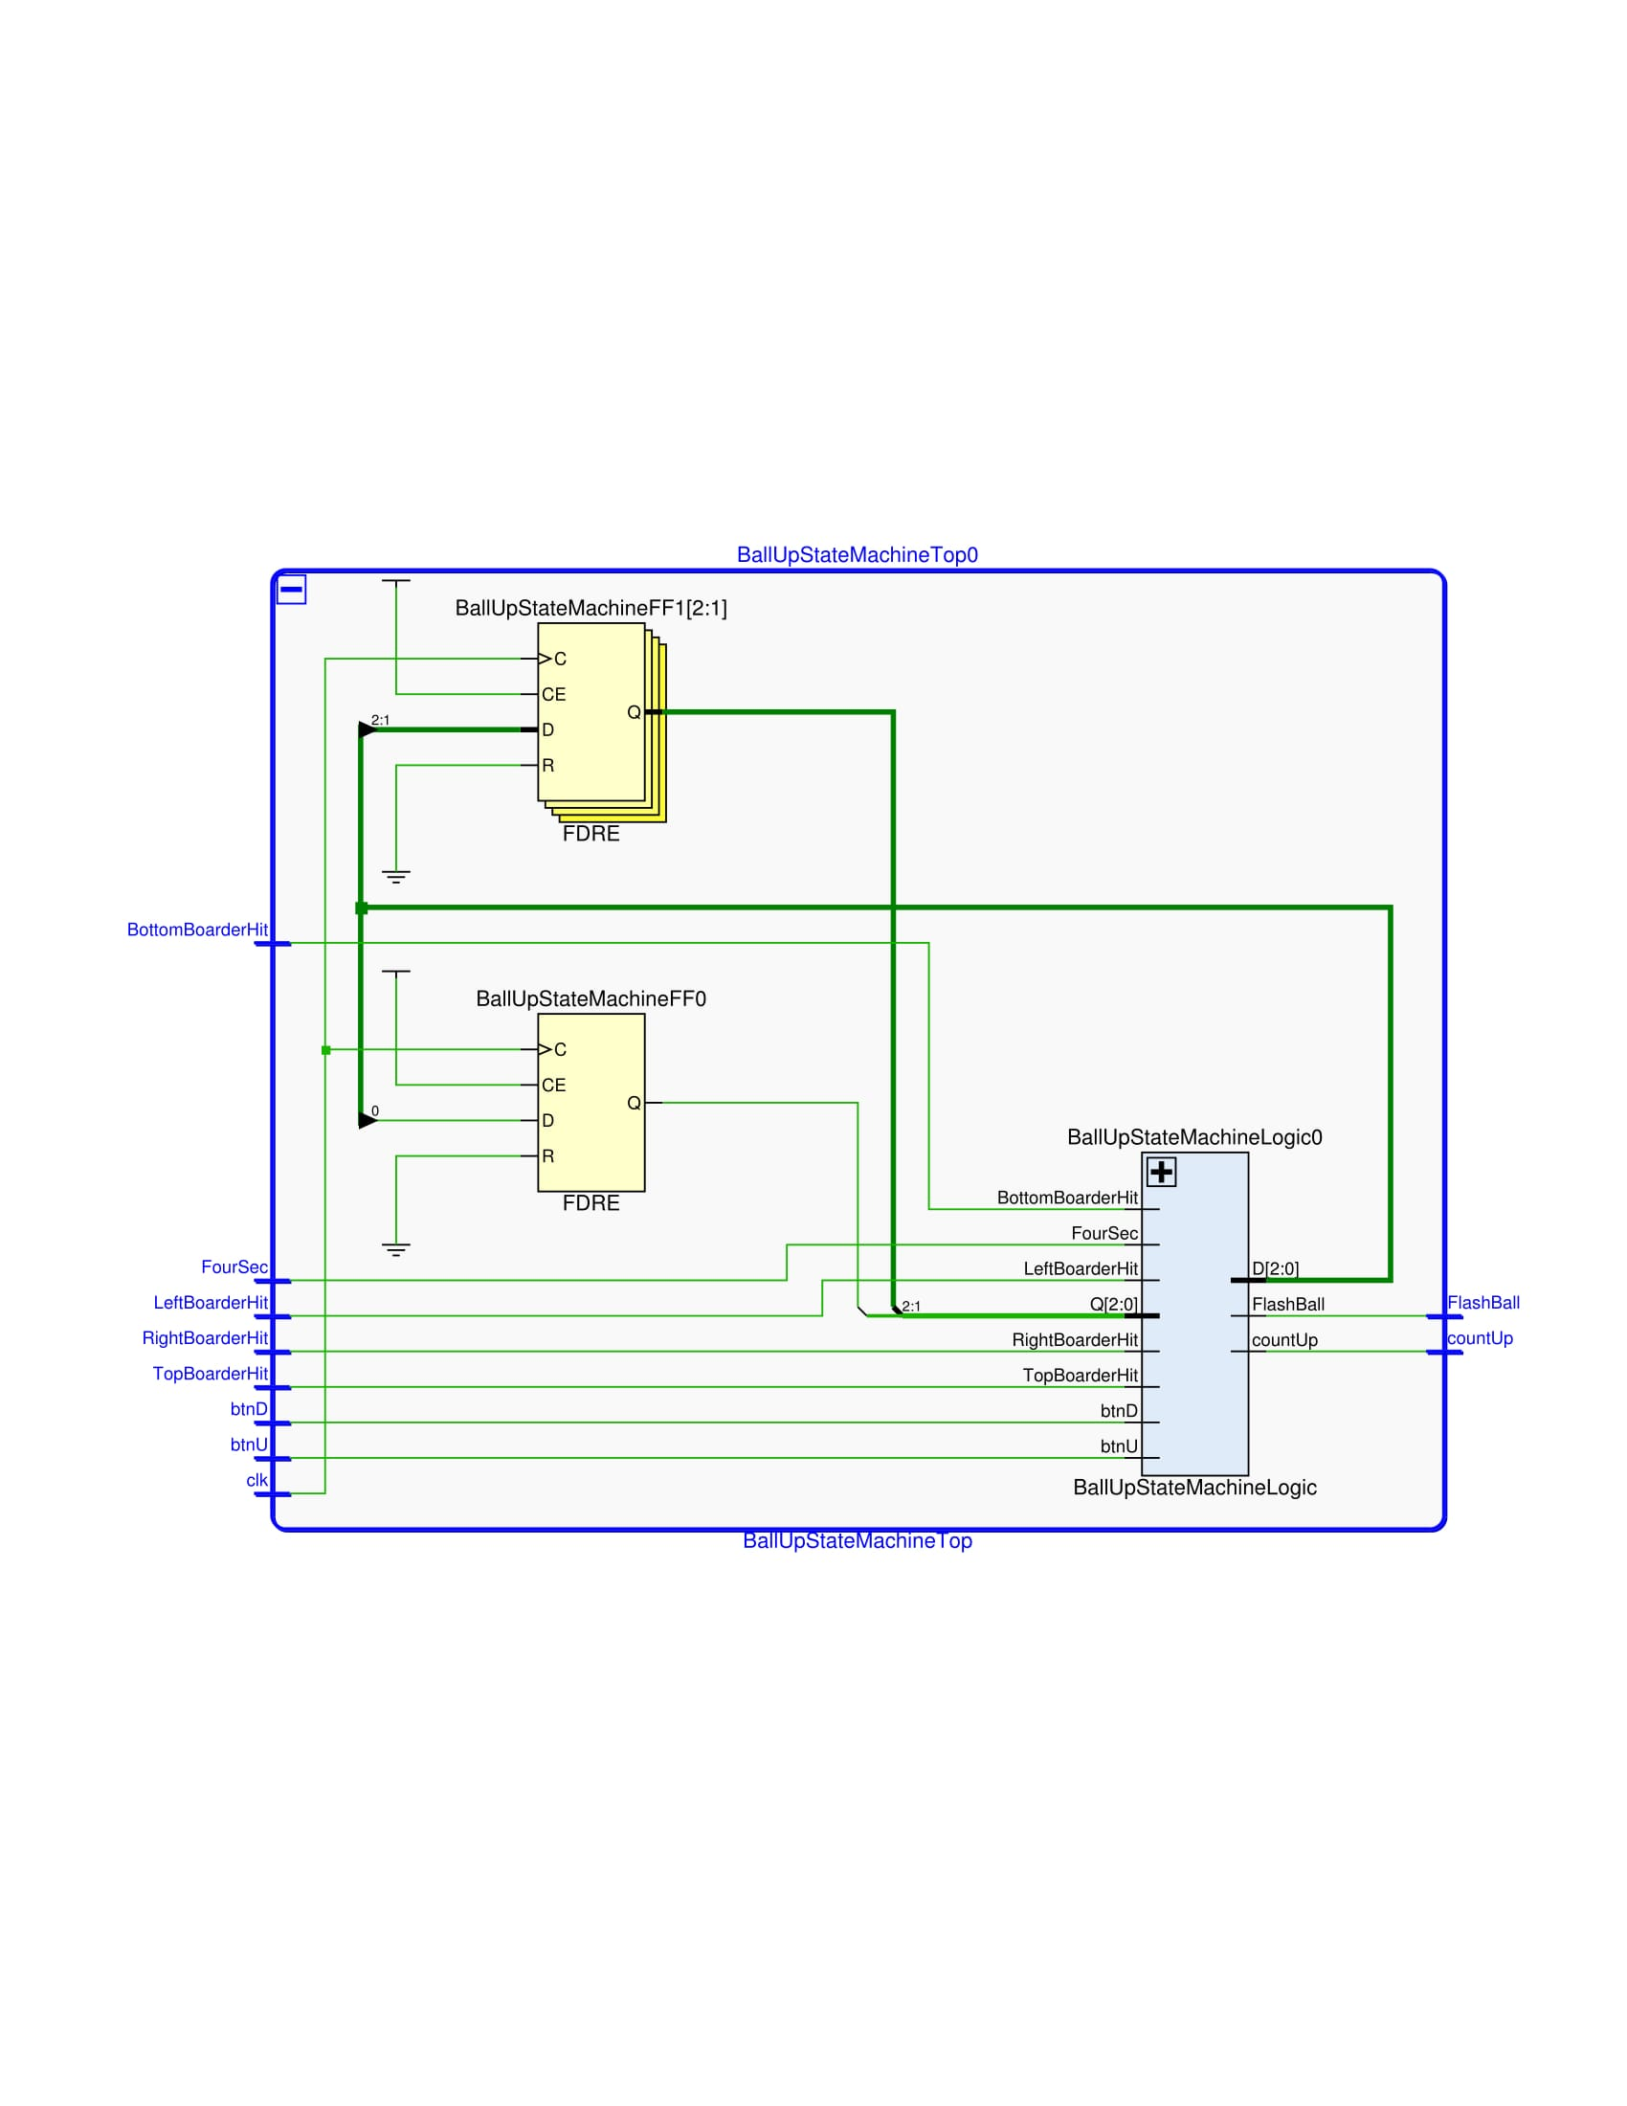

**12 Bit Up Down Counter:**

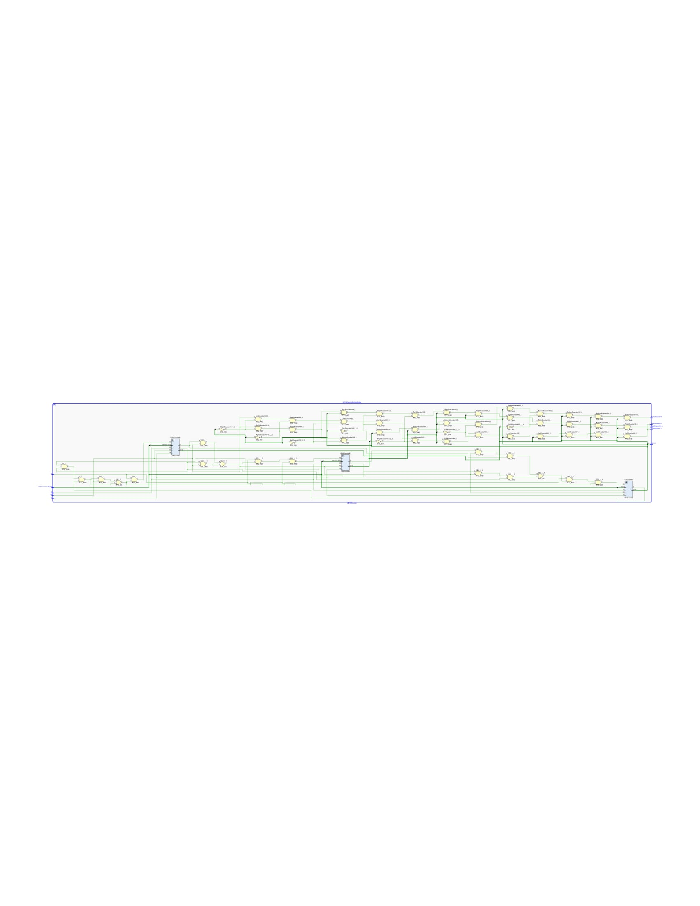

**Target Creator:**

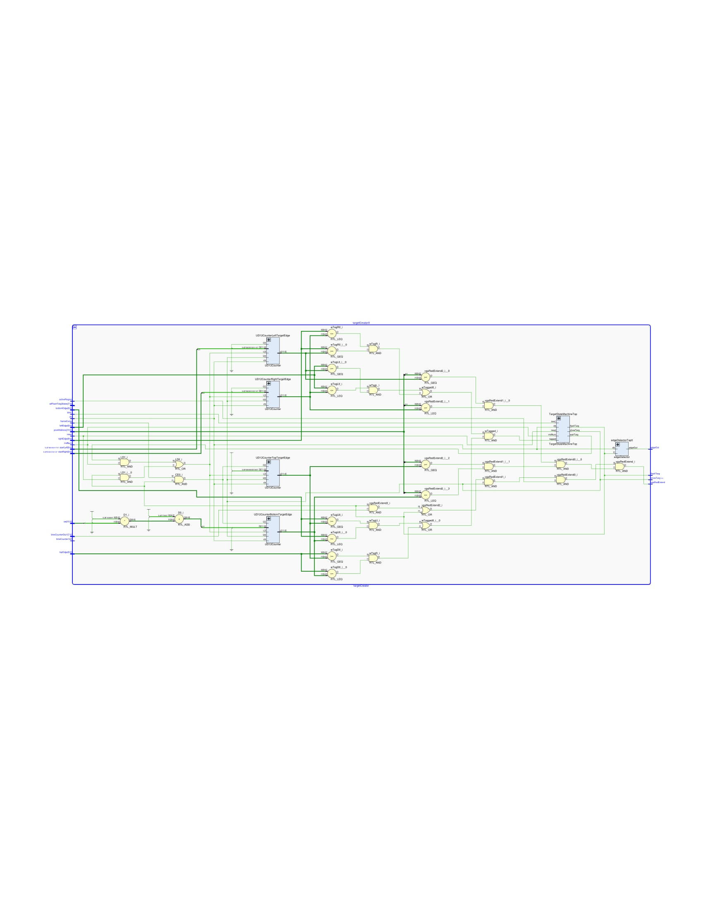

**Edge Detector:**

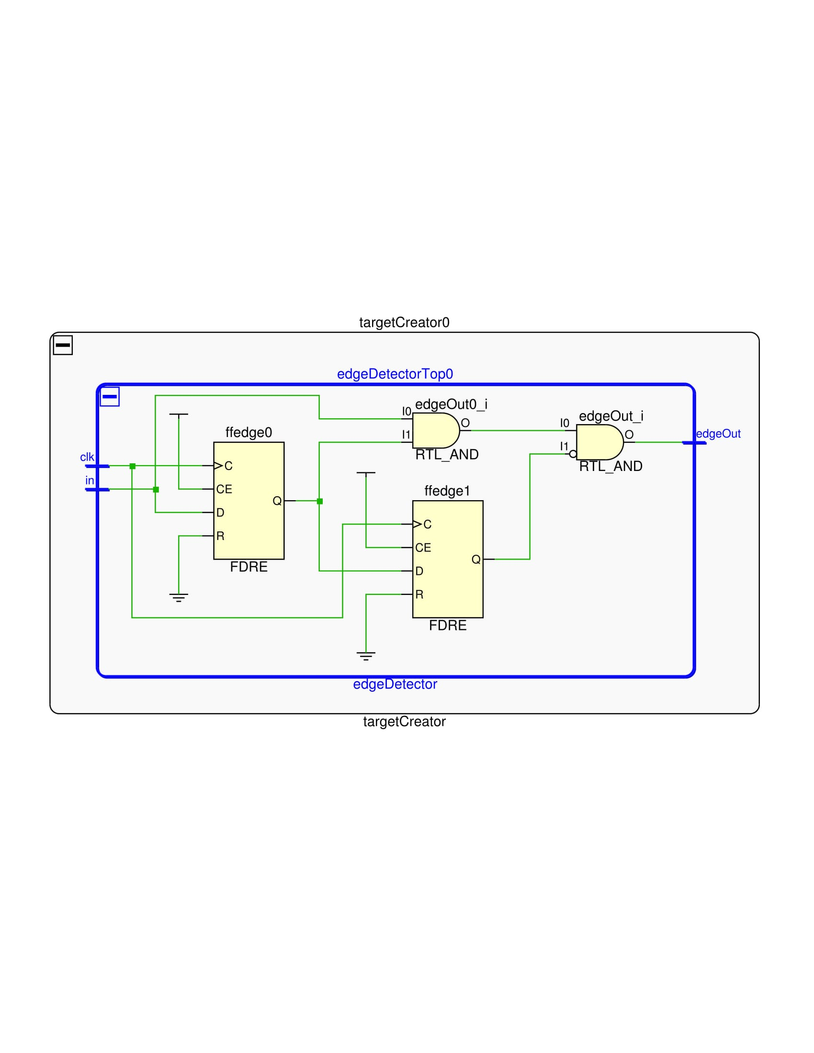

**Target State Machine:**

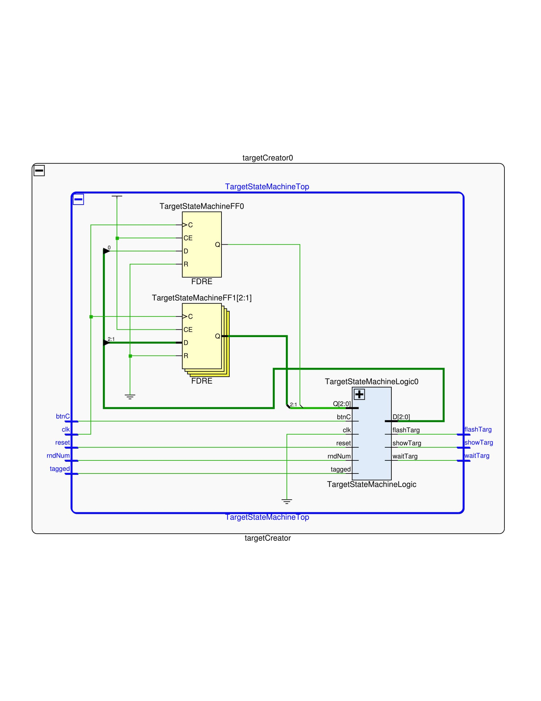

**14 Bit Up Down Counter:**

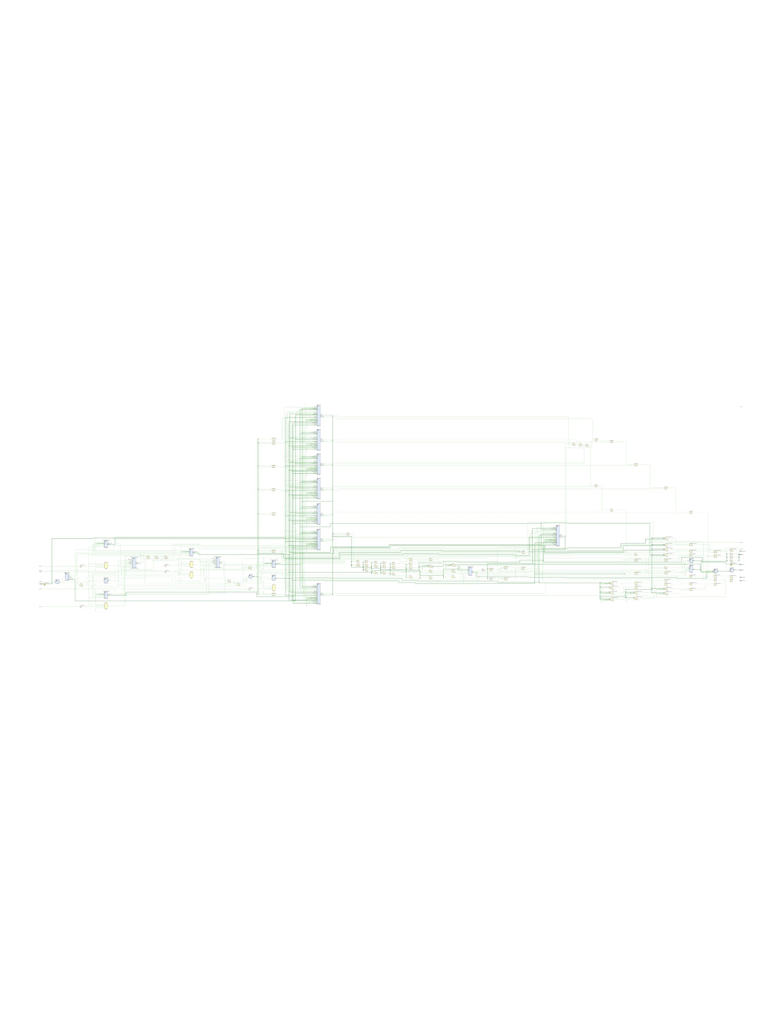

**Verilog:**

**Top Level:**

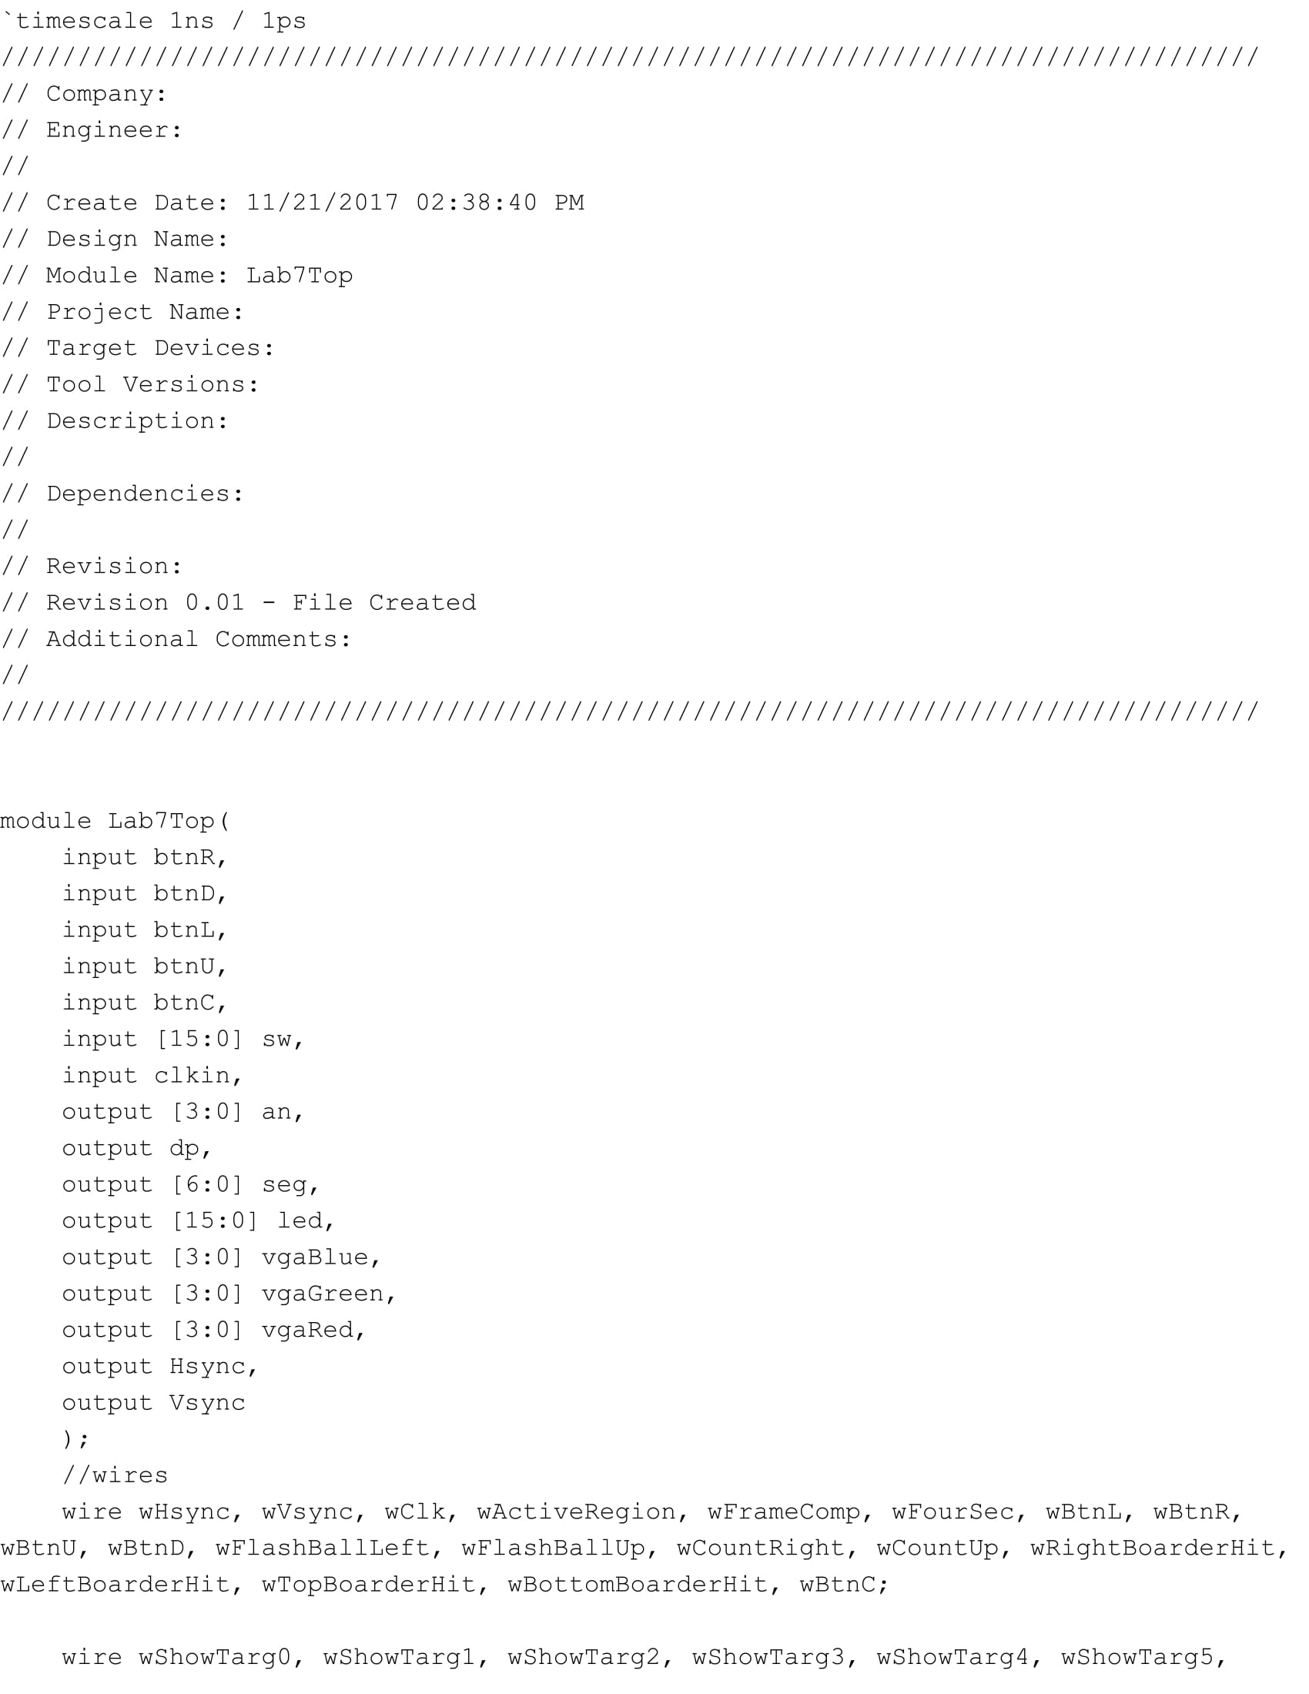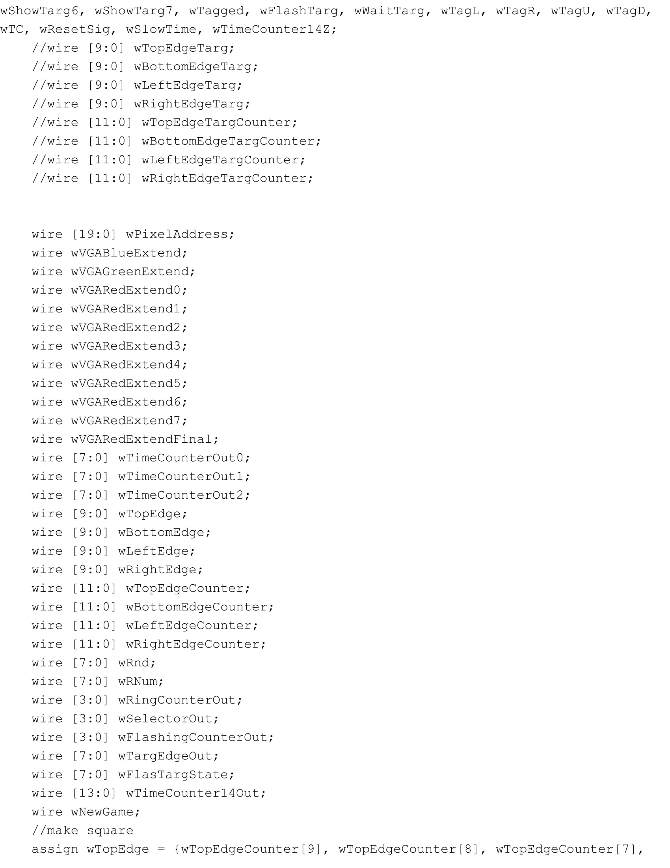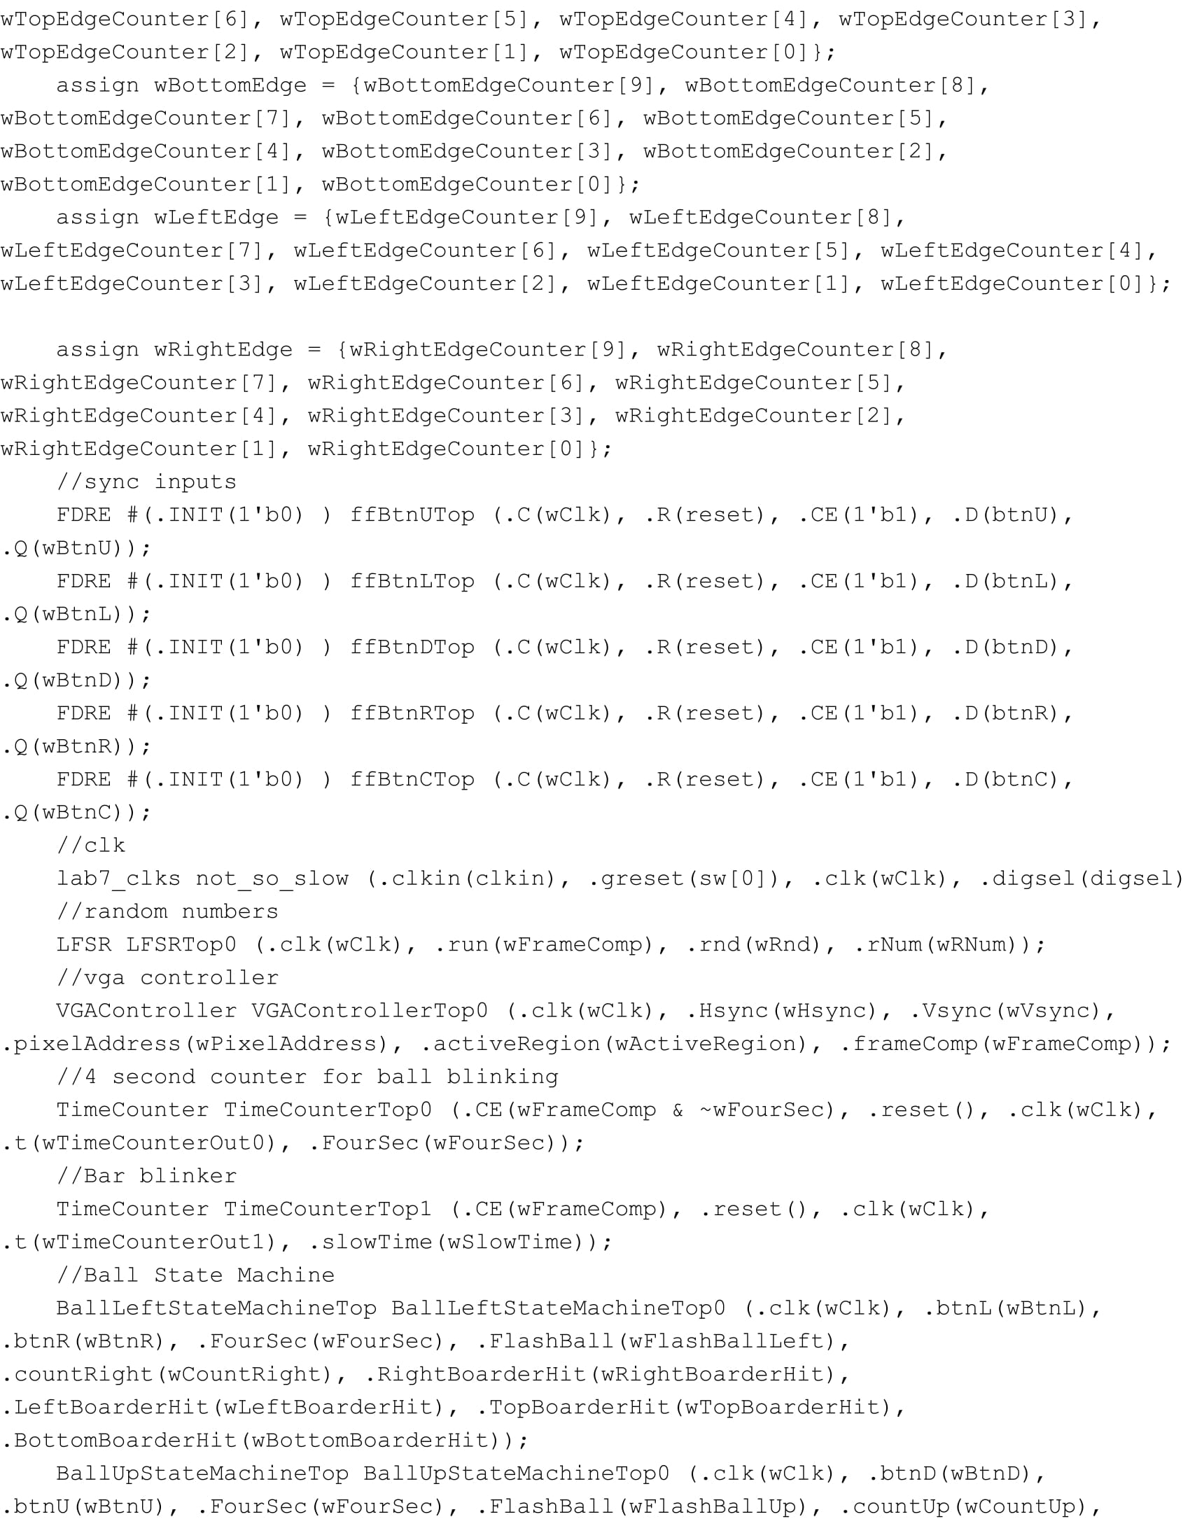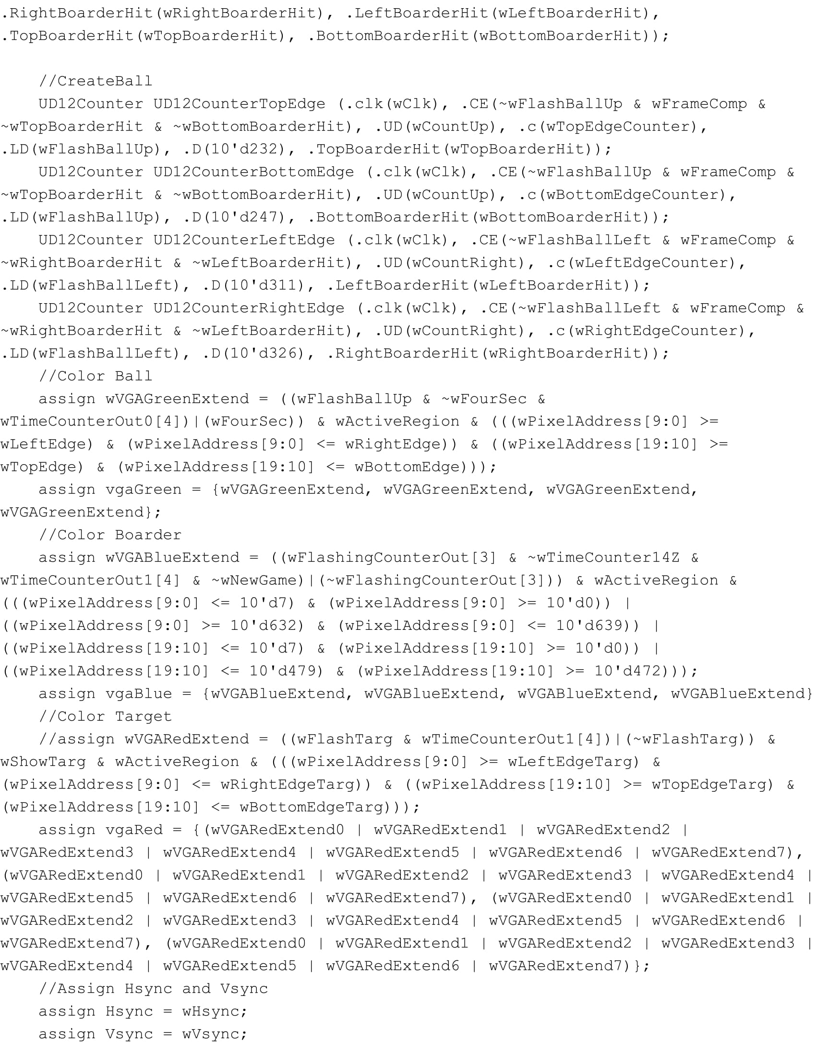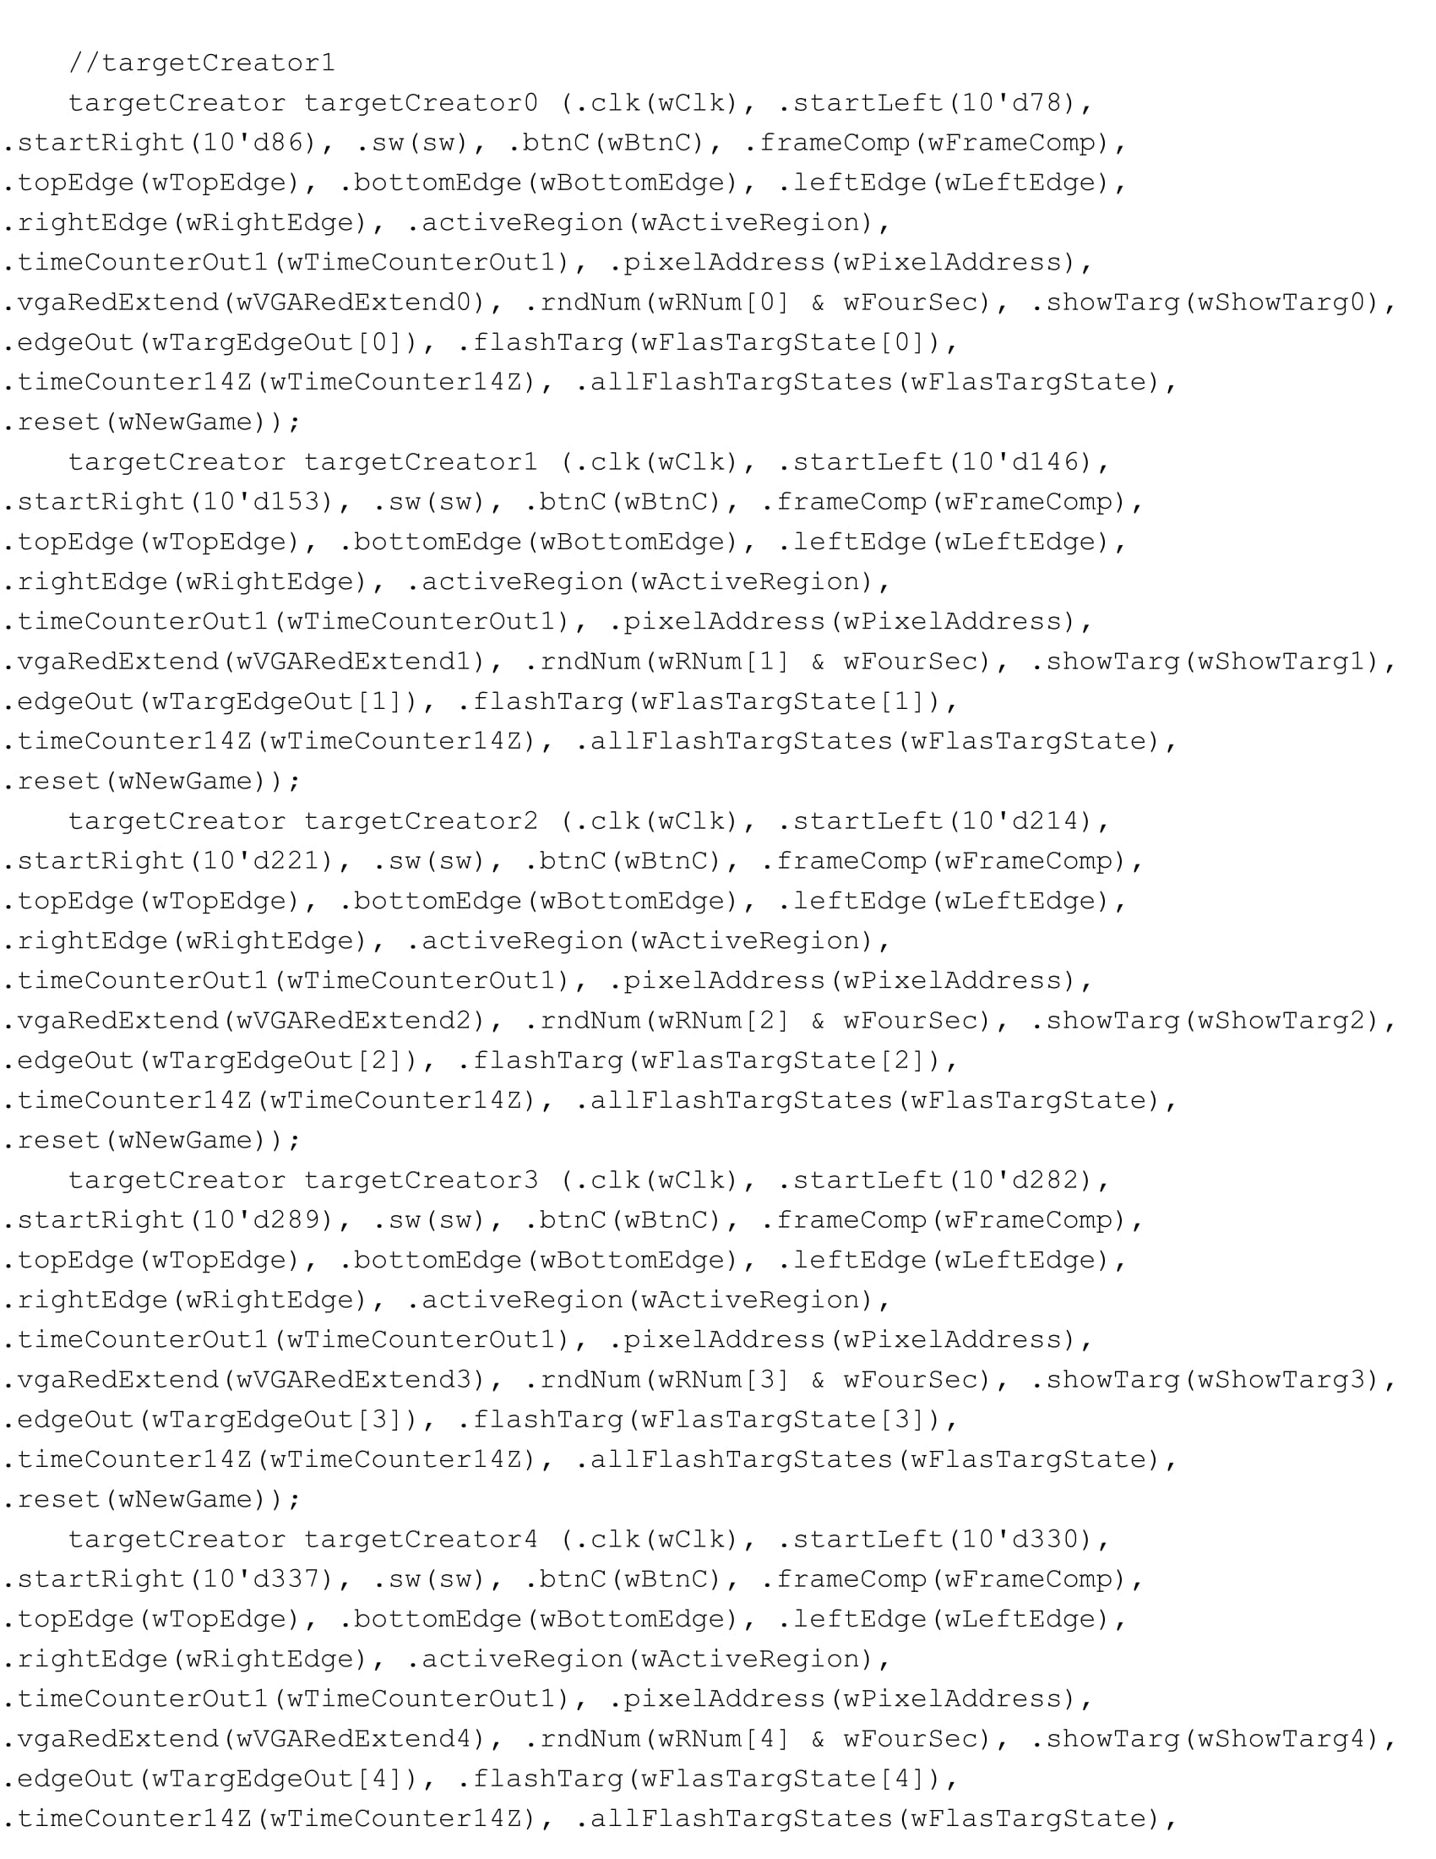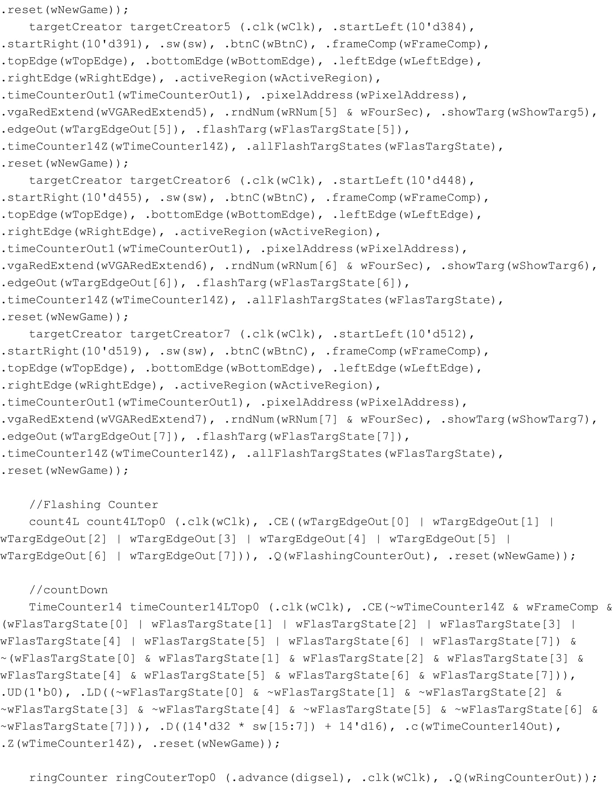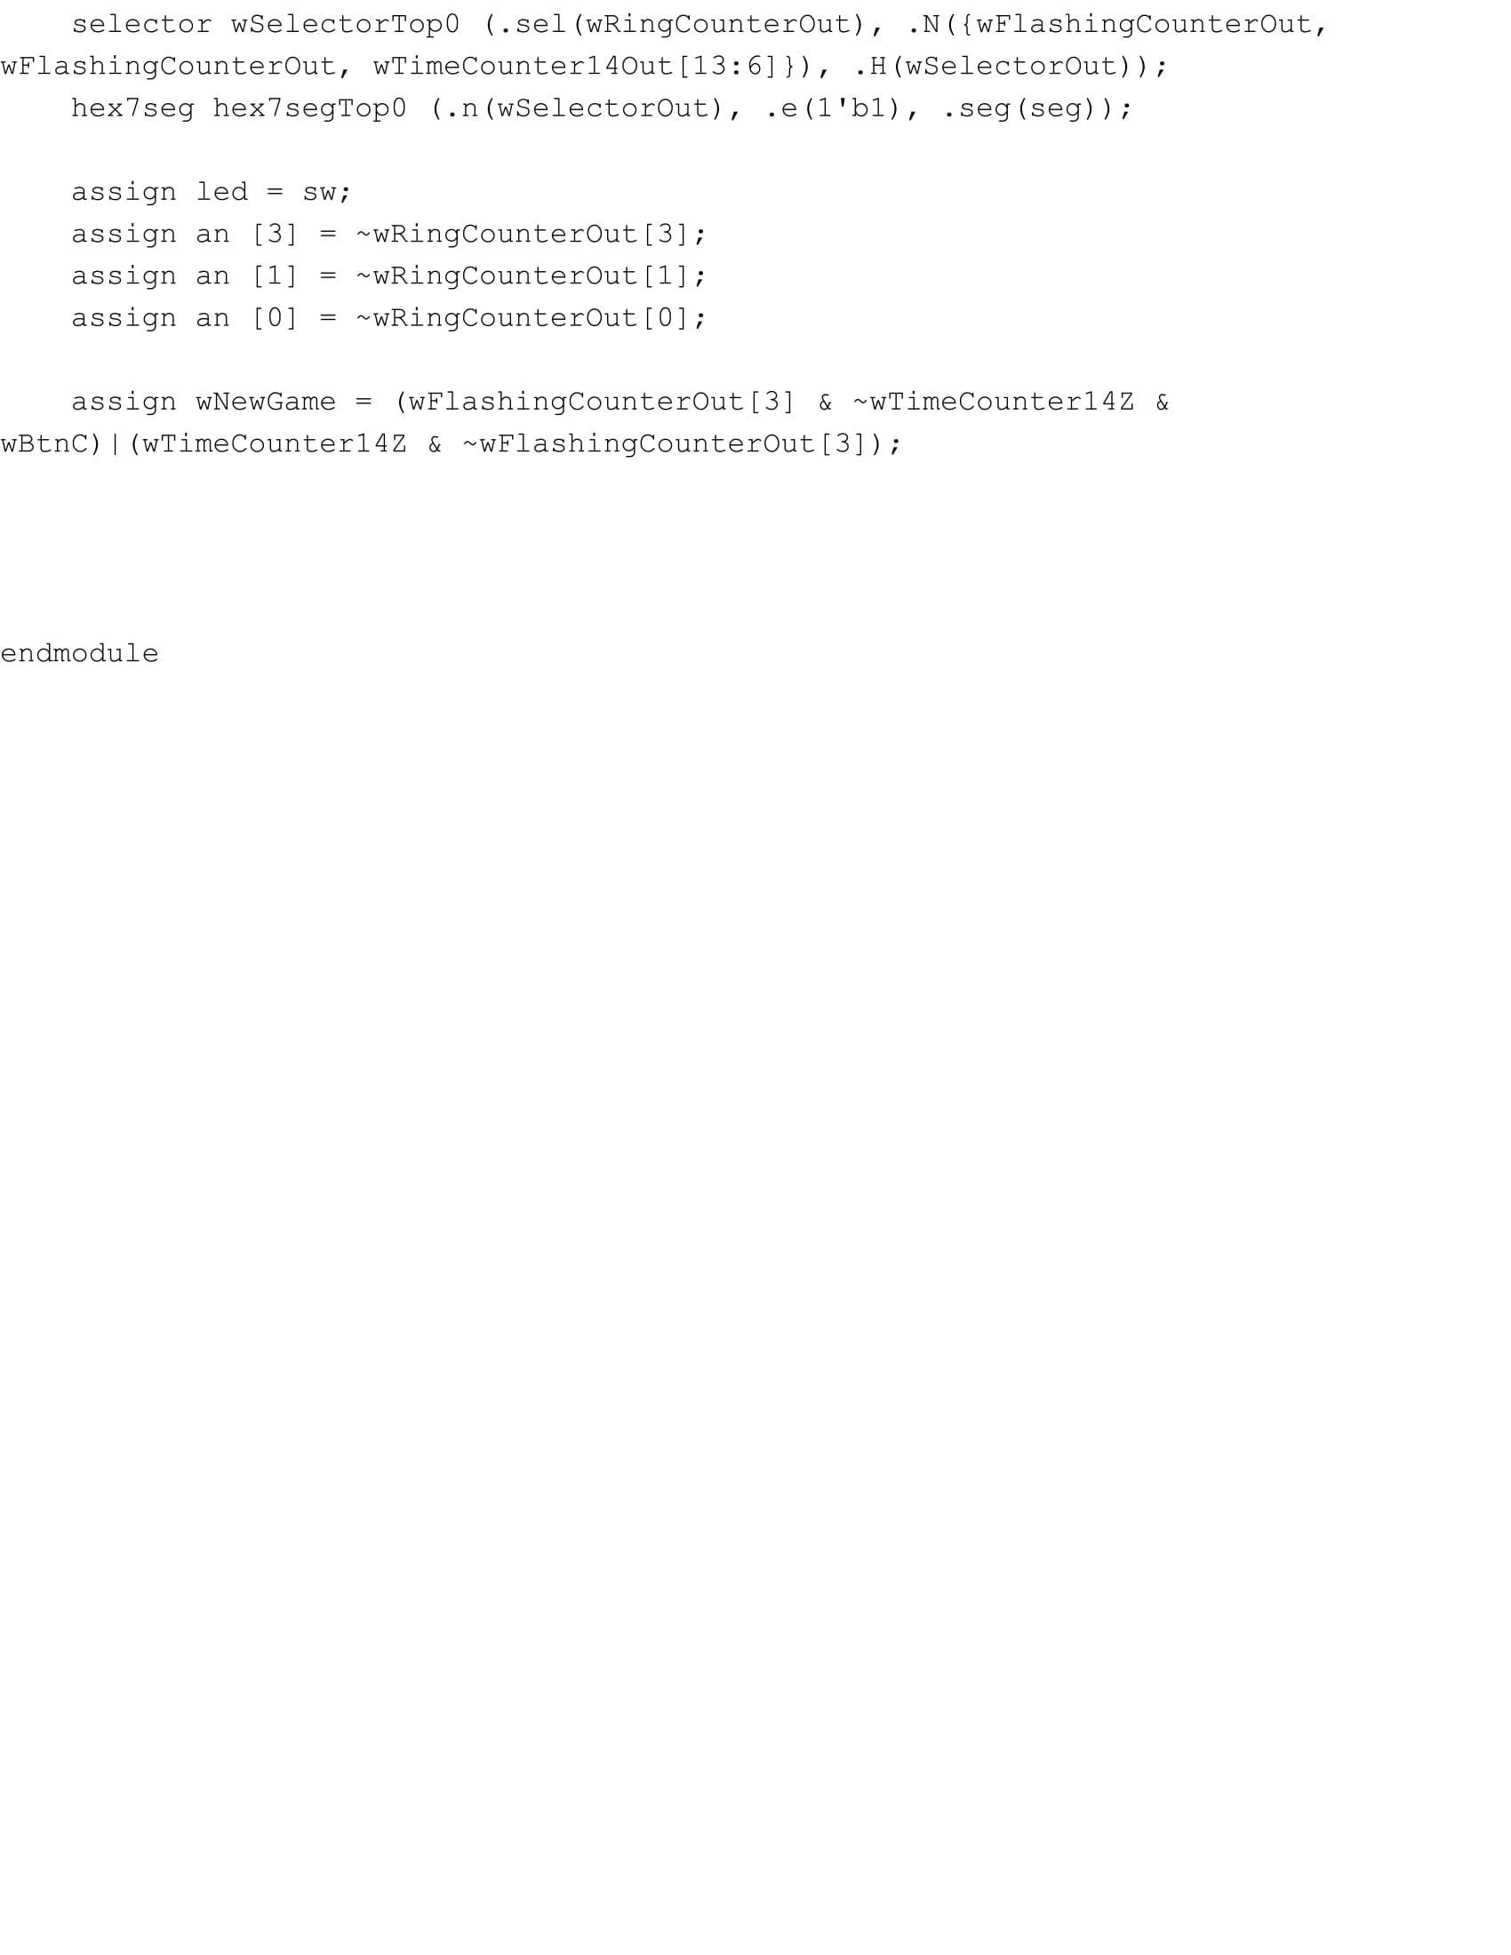

**LFSR:**

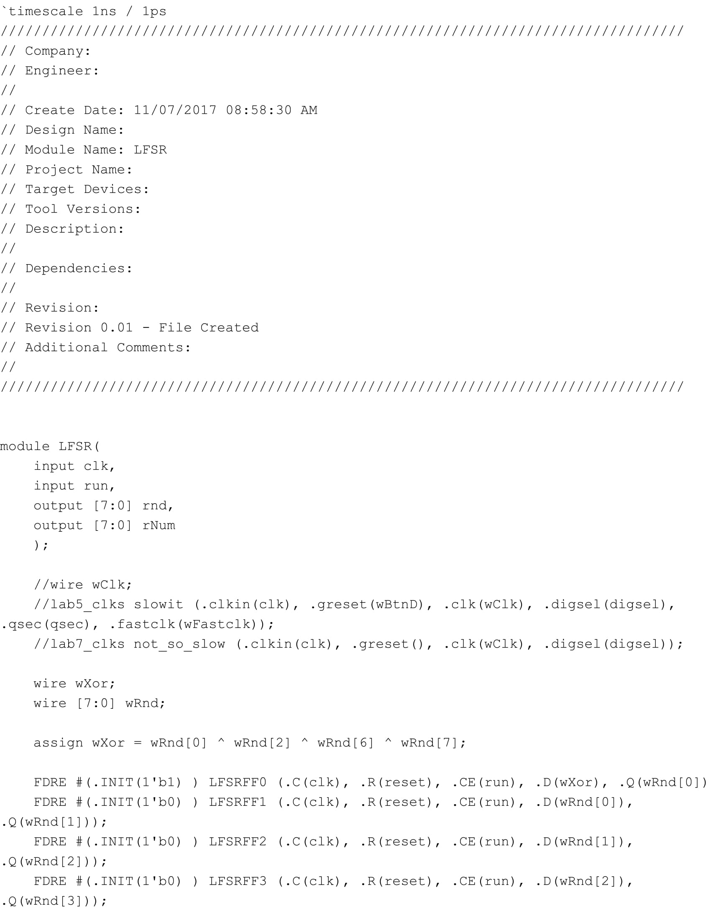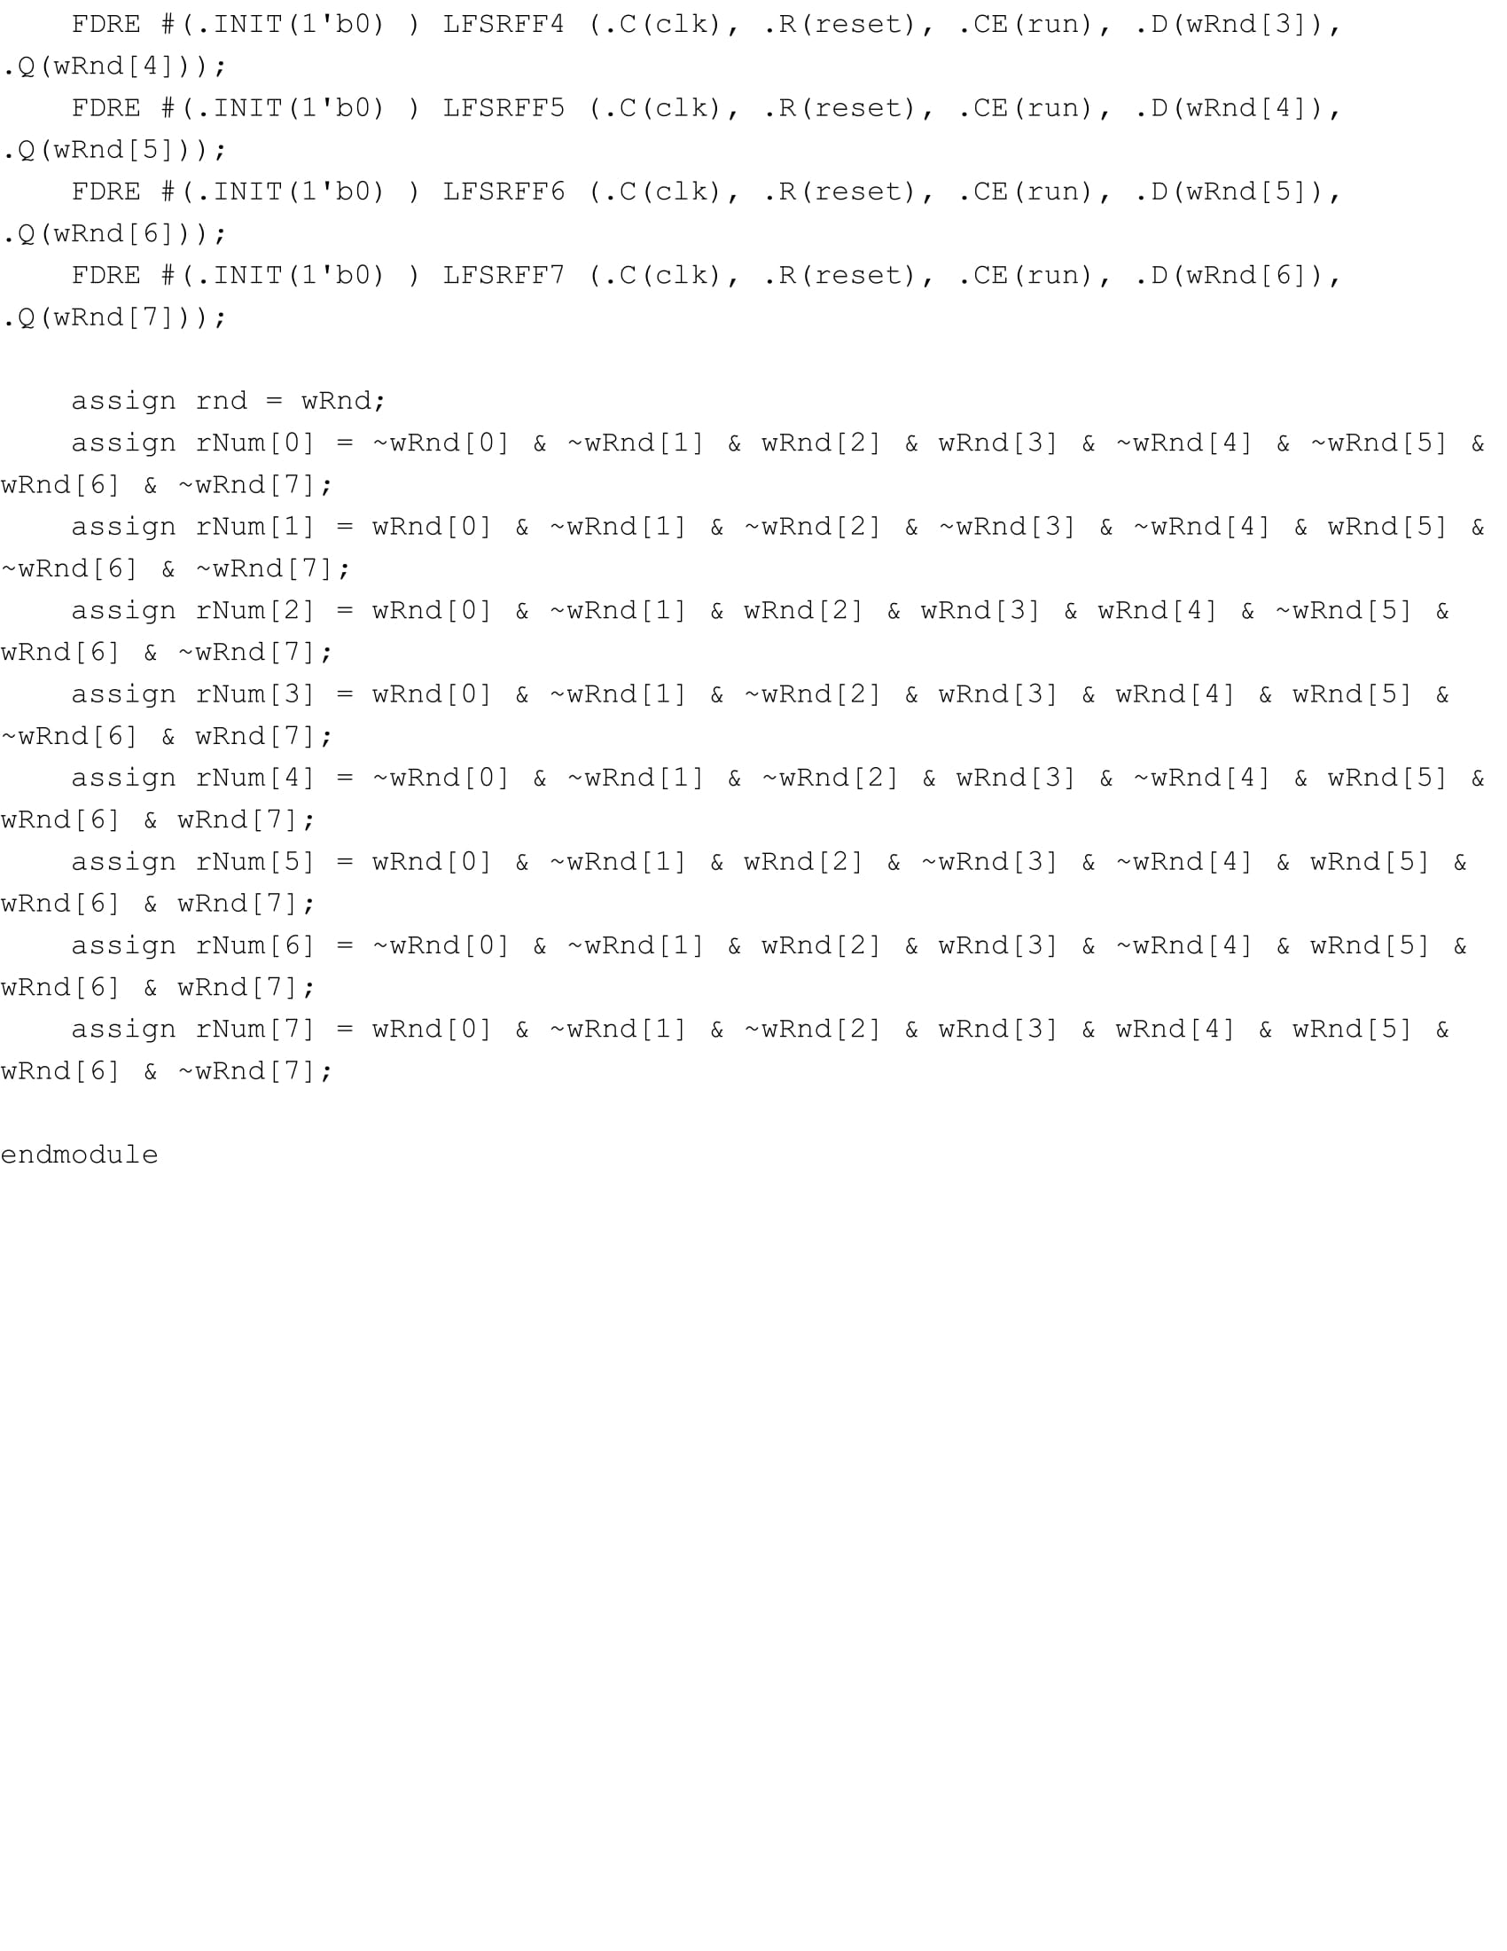

**VGA Controller:**

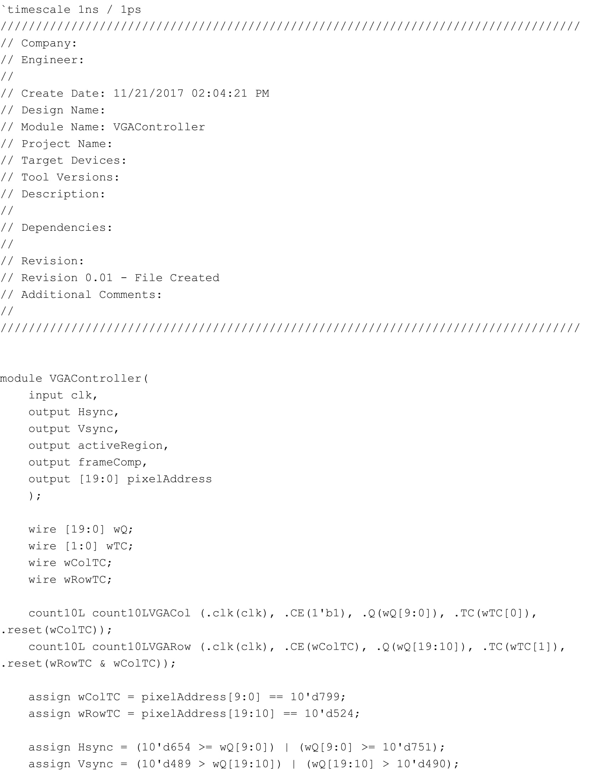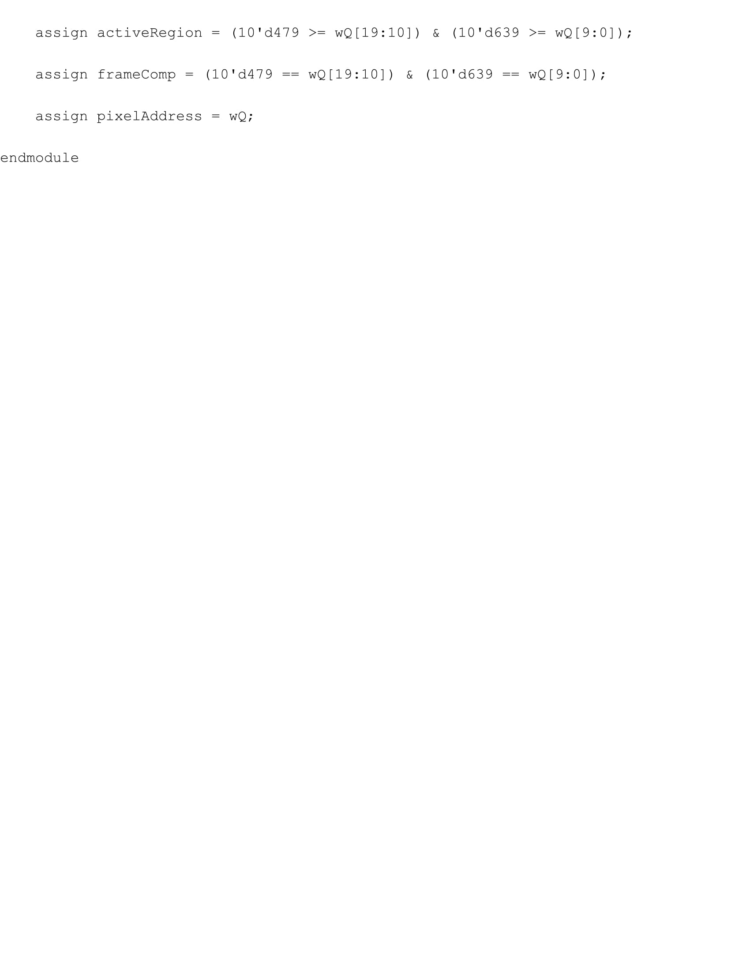

**Time Counter:**

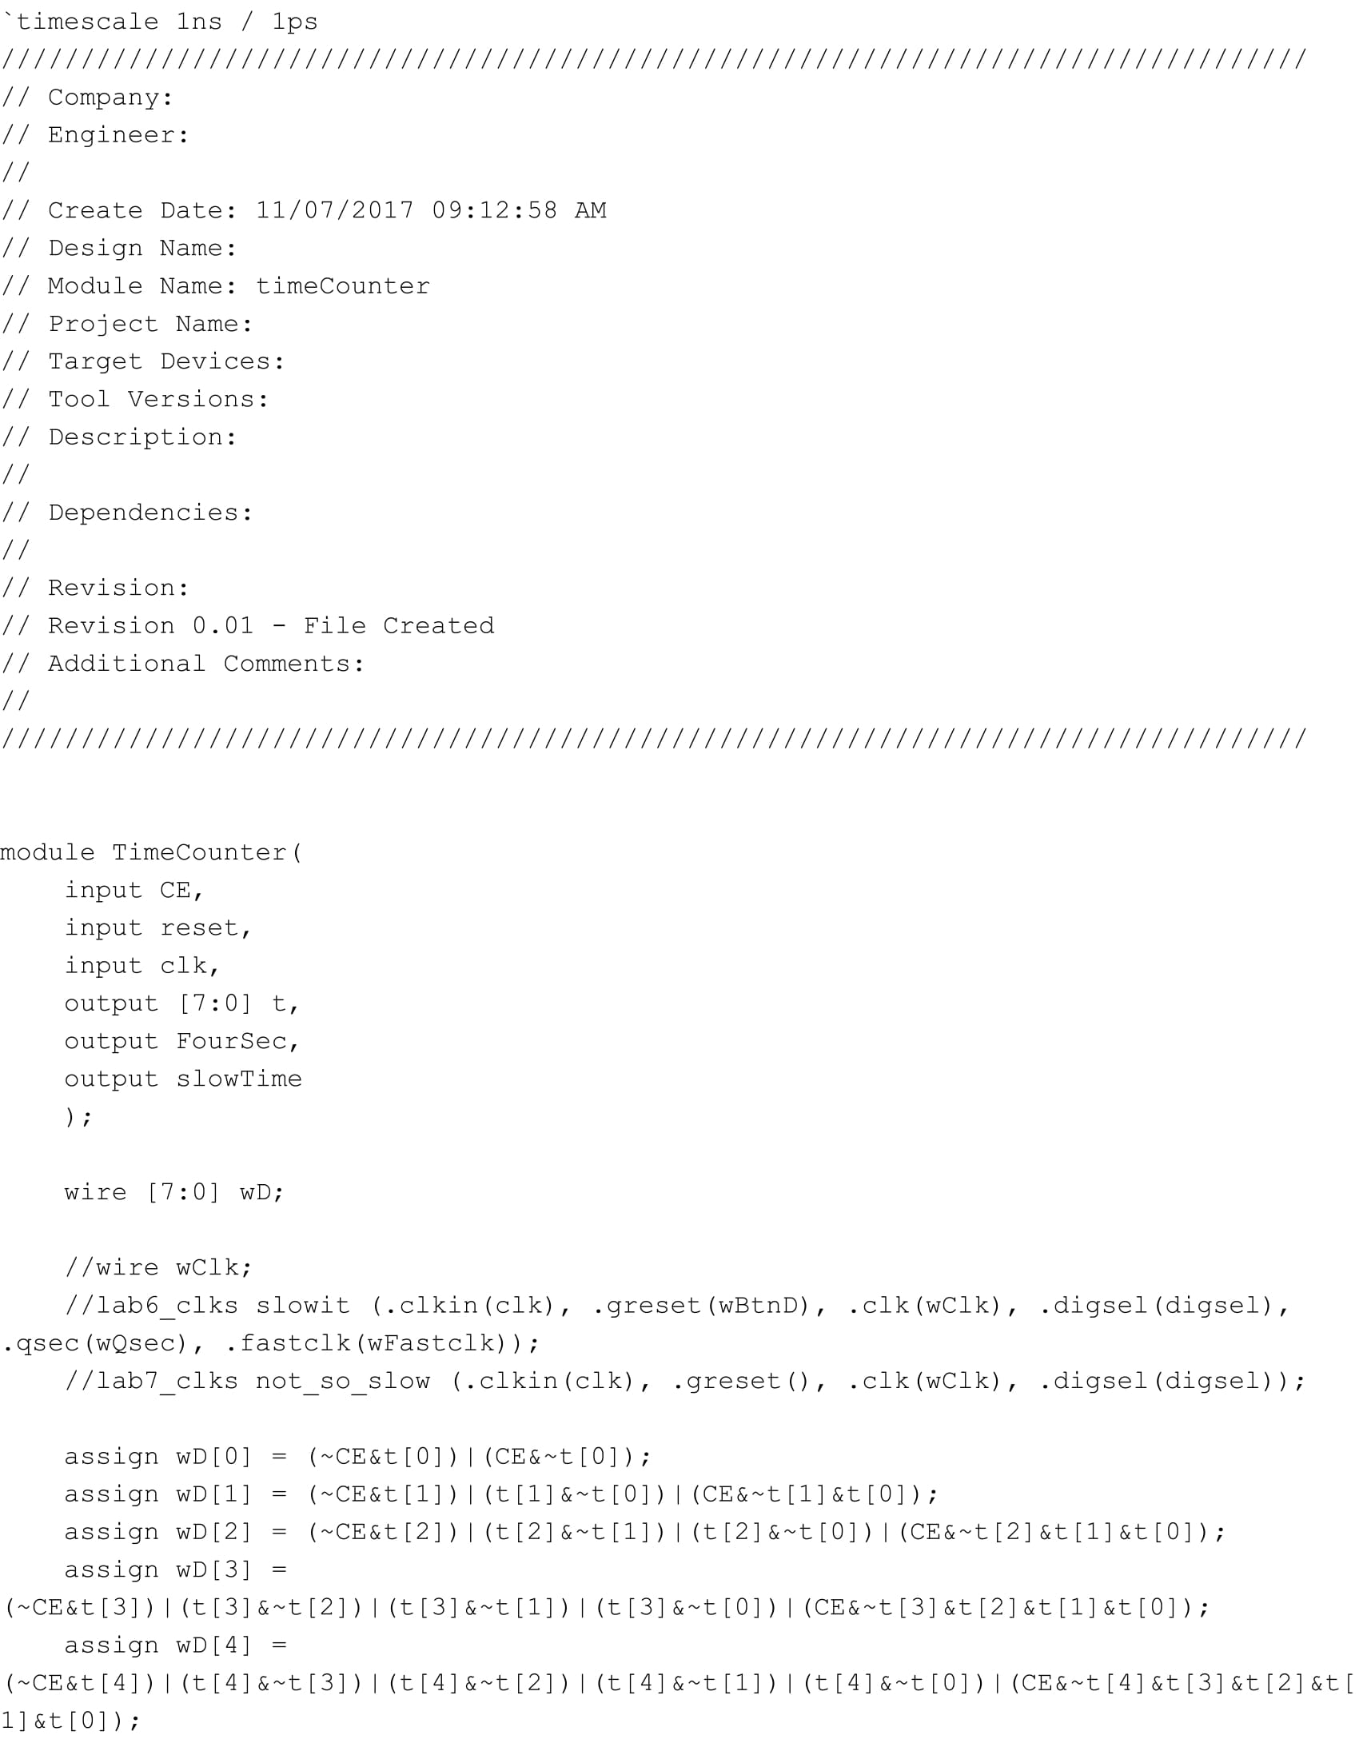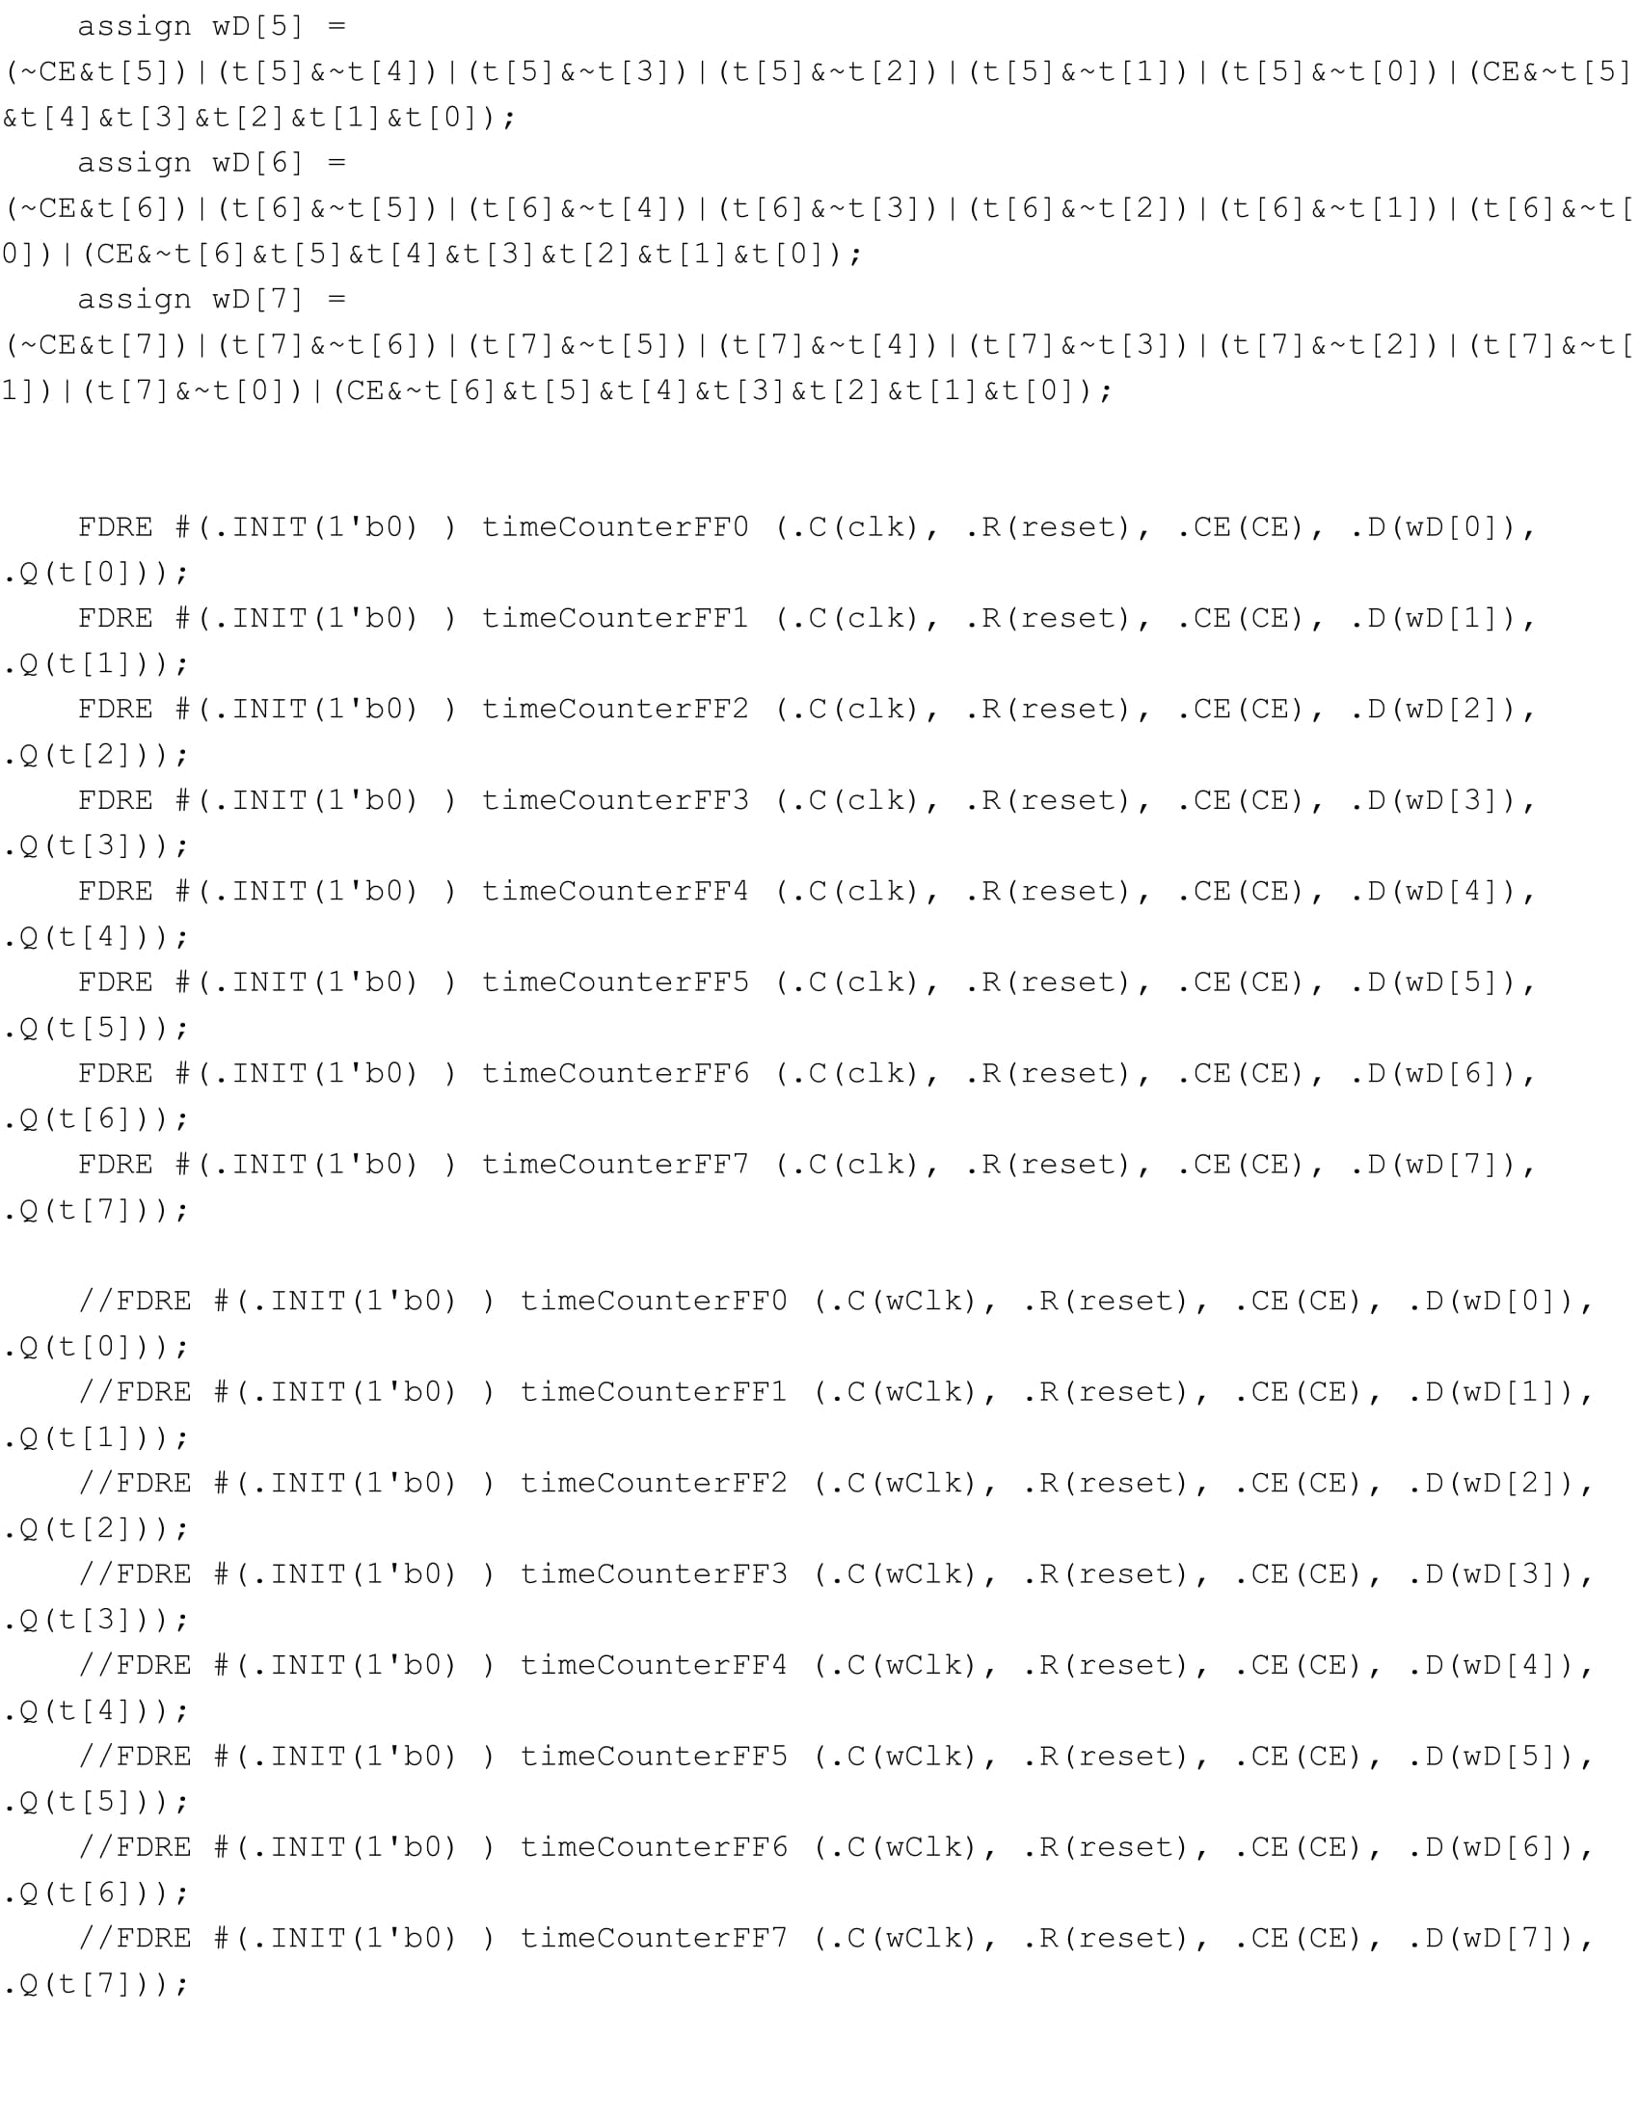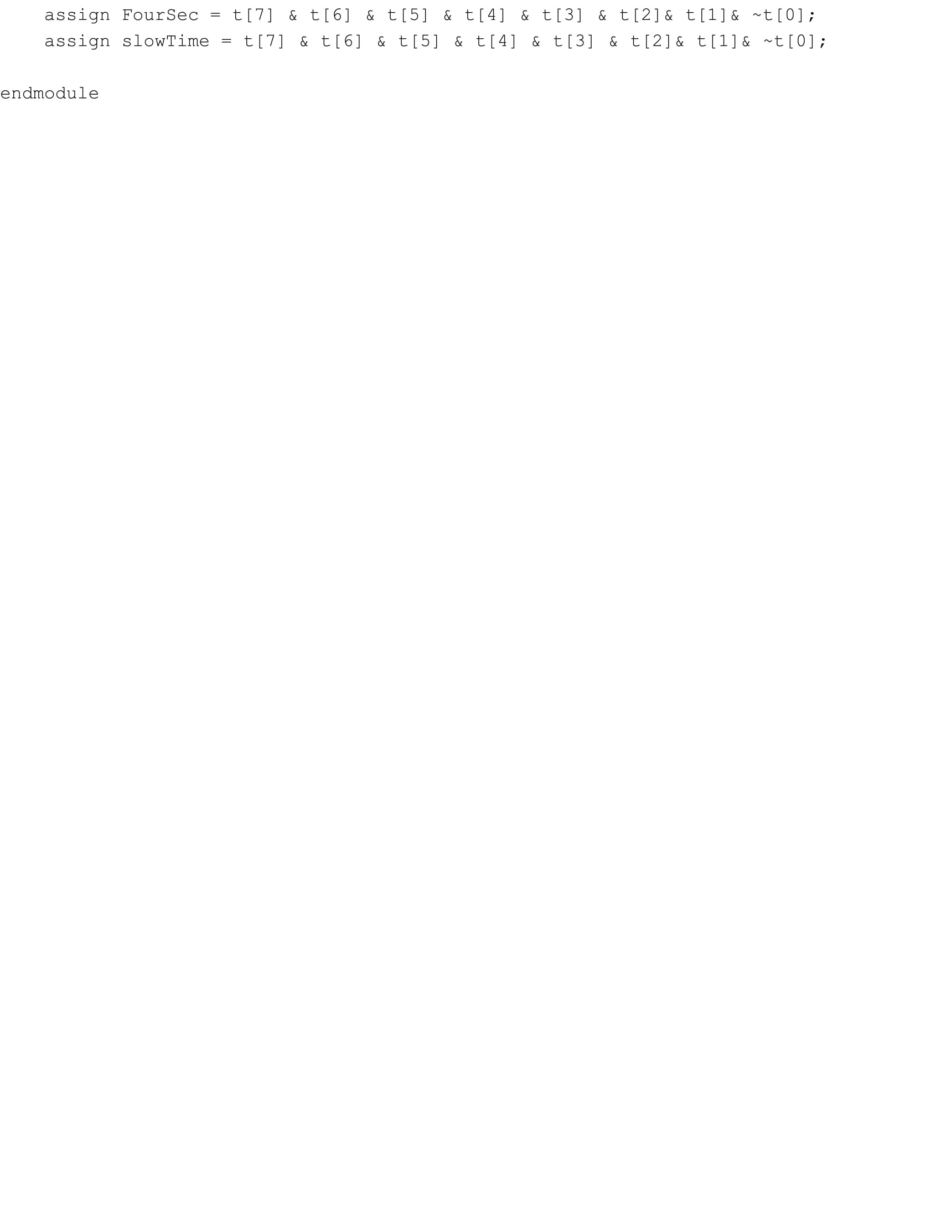

**Ball State Machine Up/Down:**

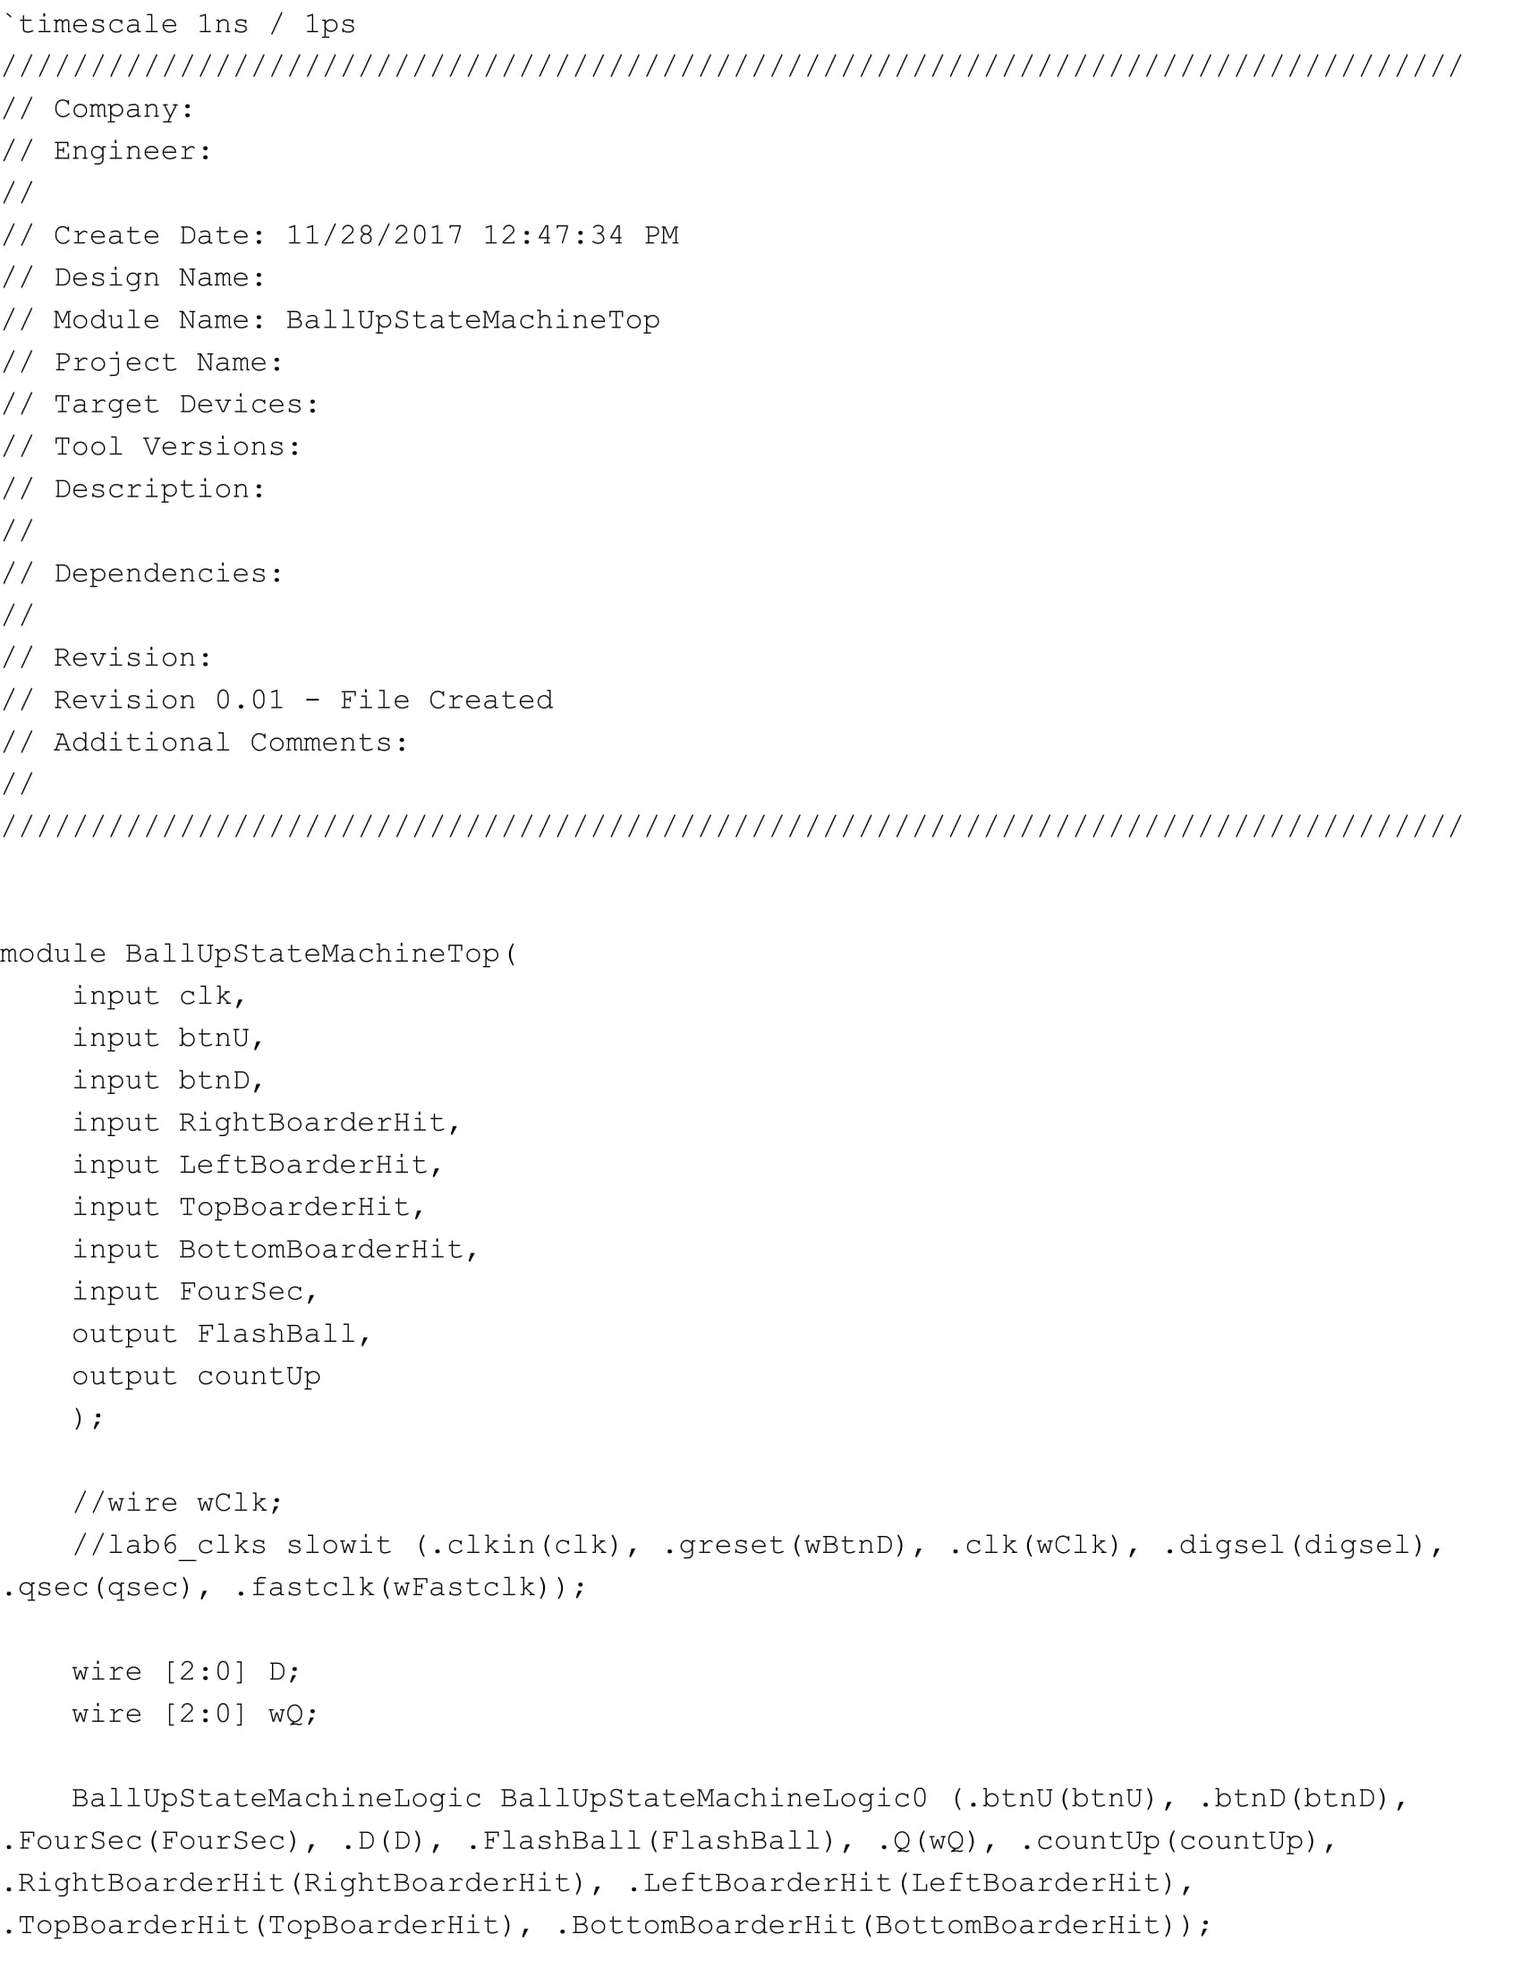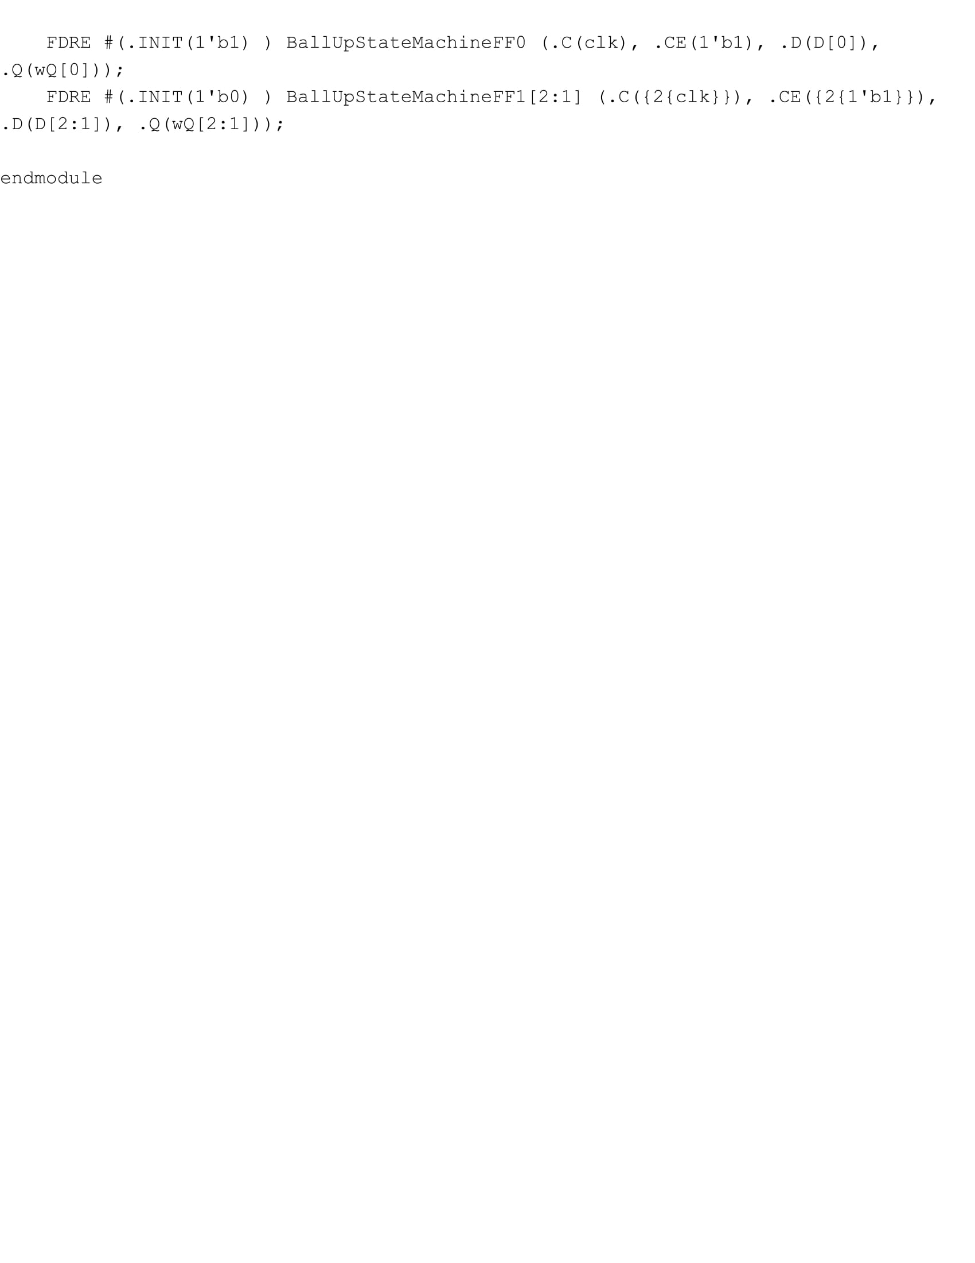

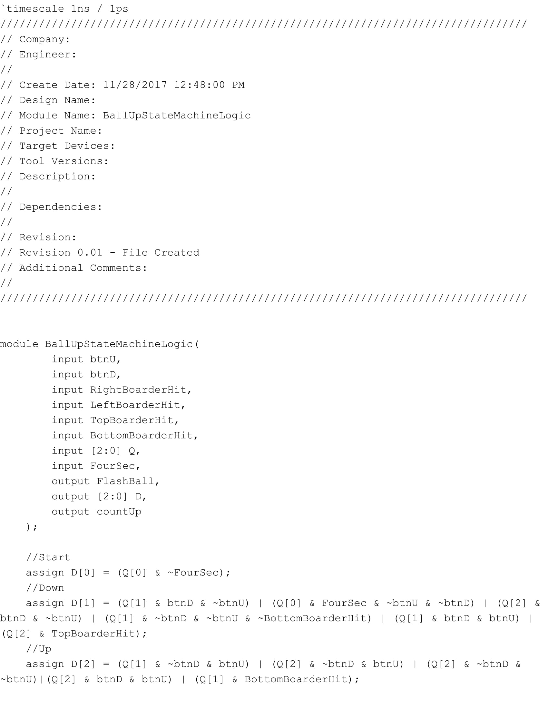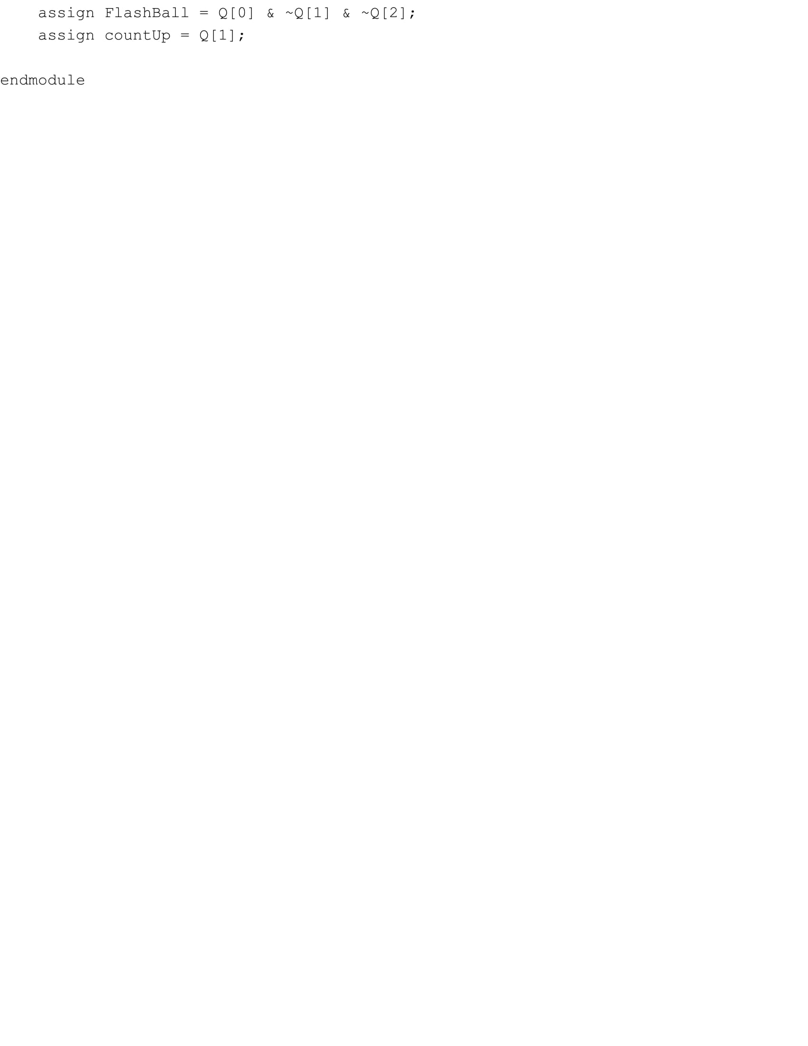

**Ball State Machine Left/Right:**

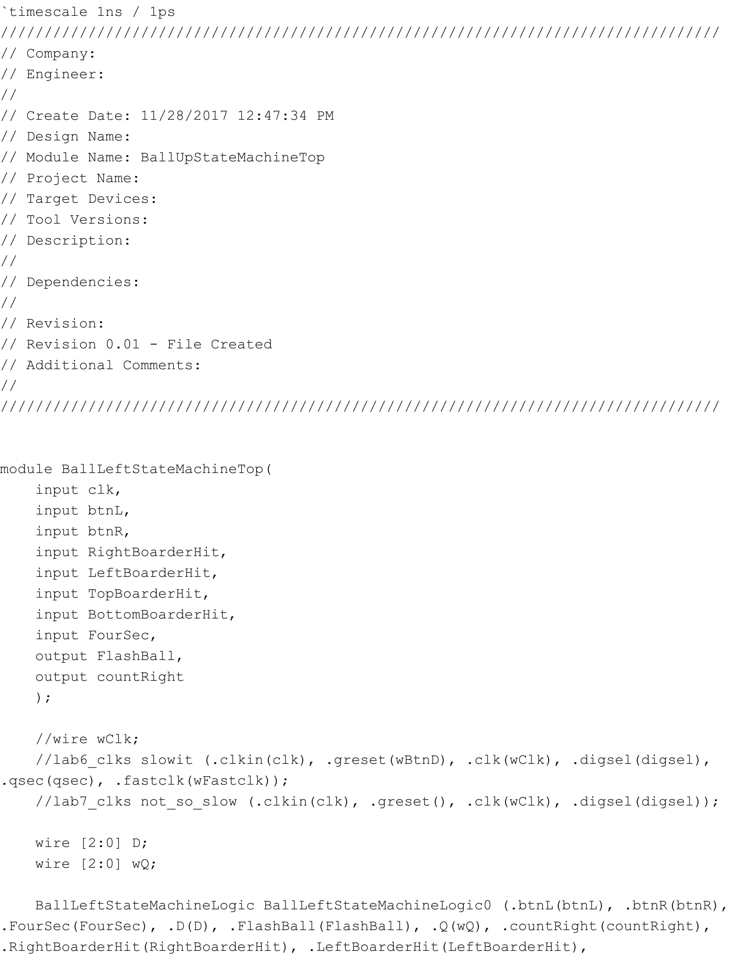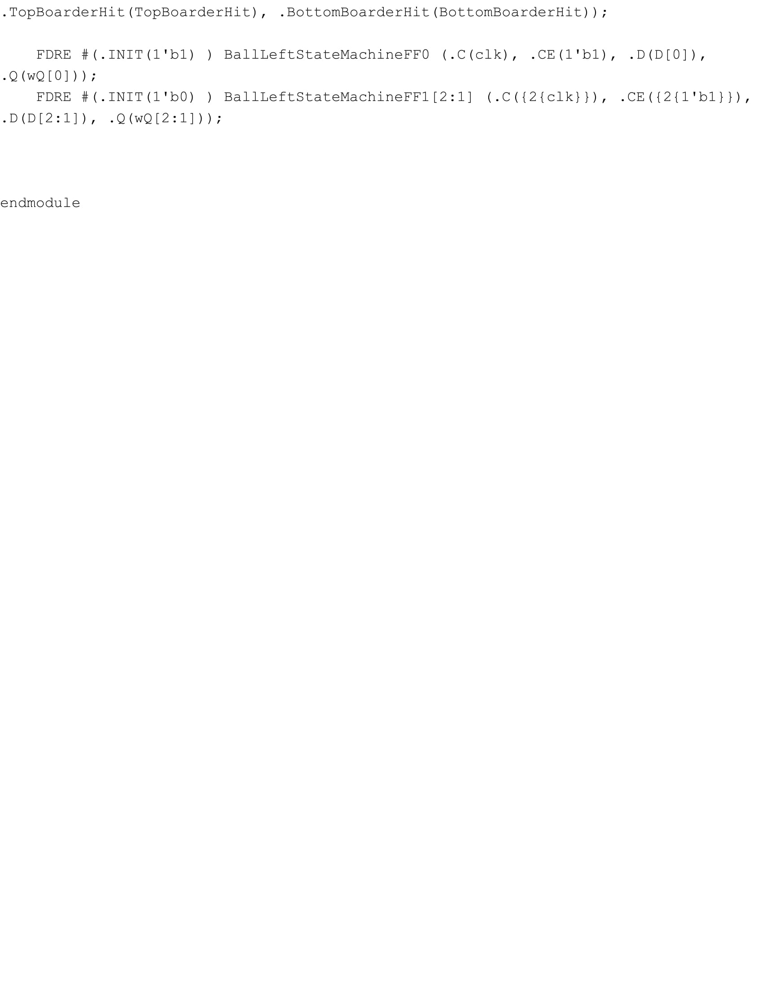

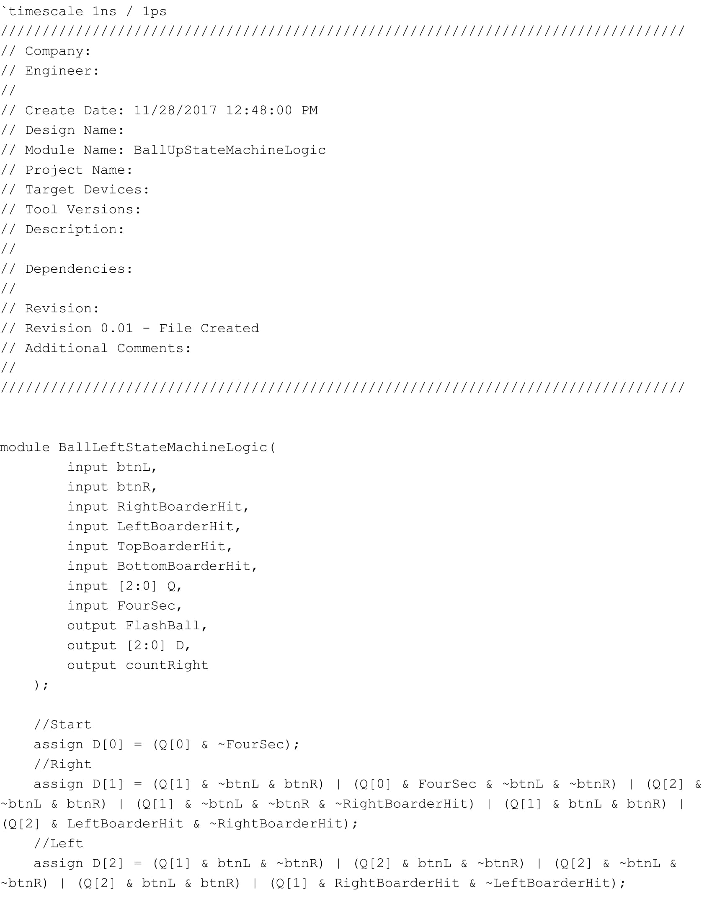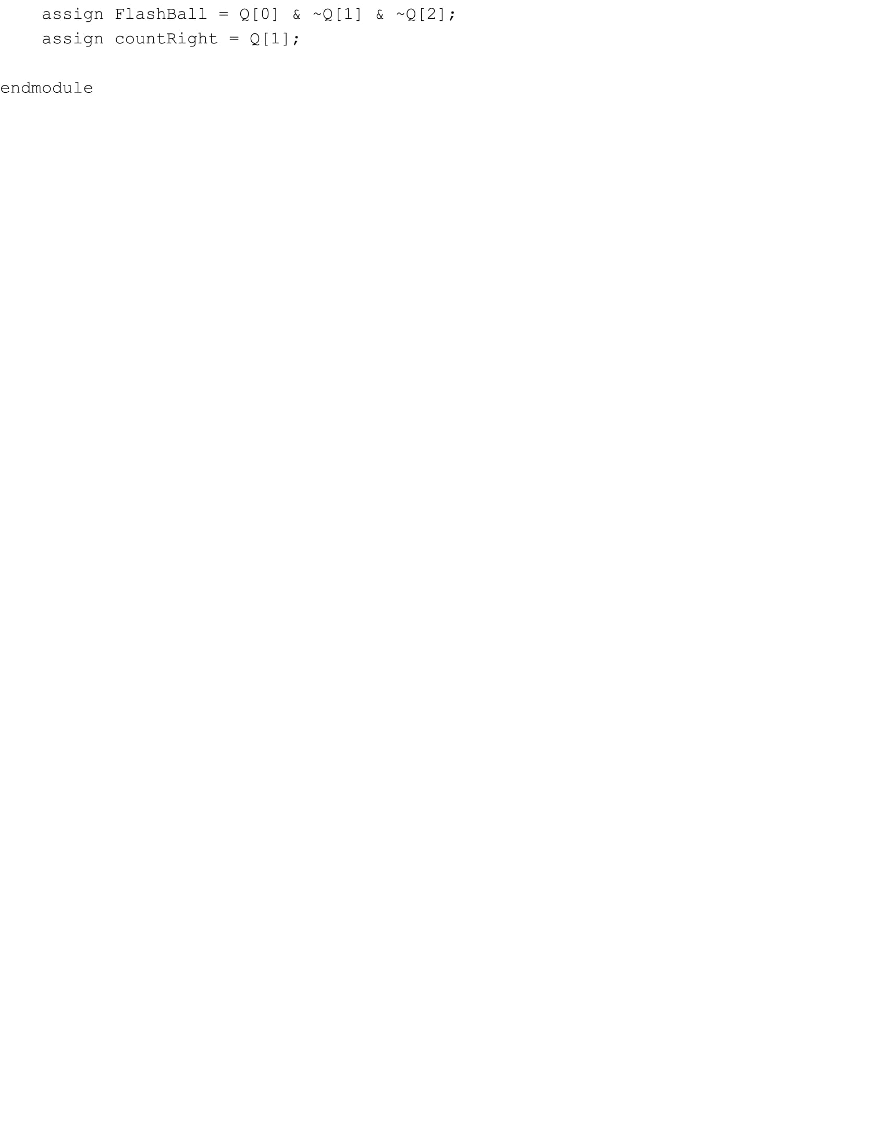

**12 Bit Up Down Counter:**

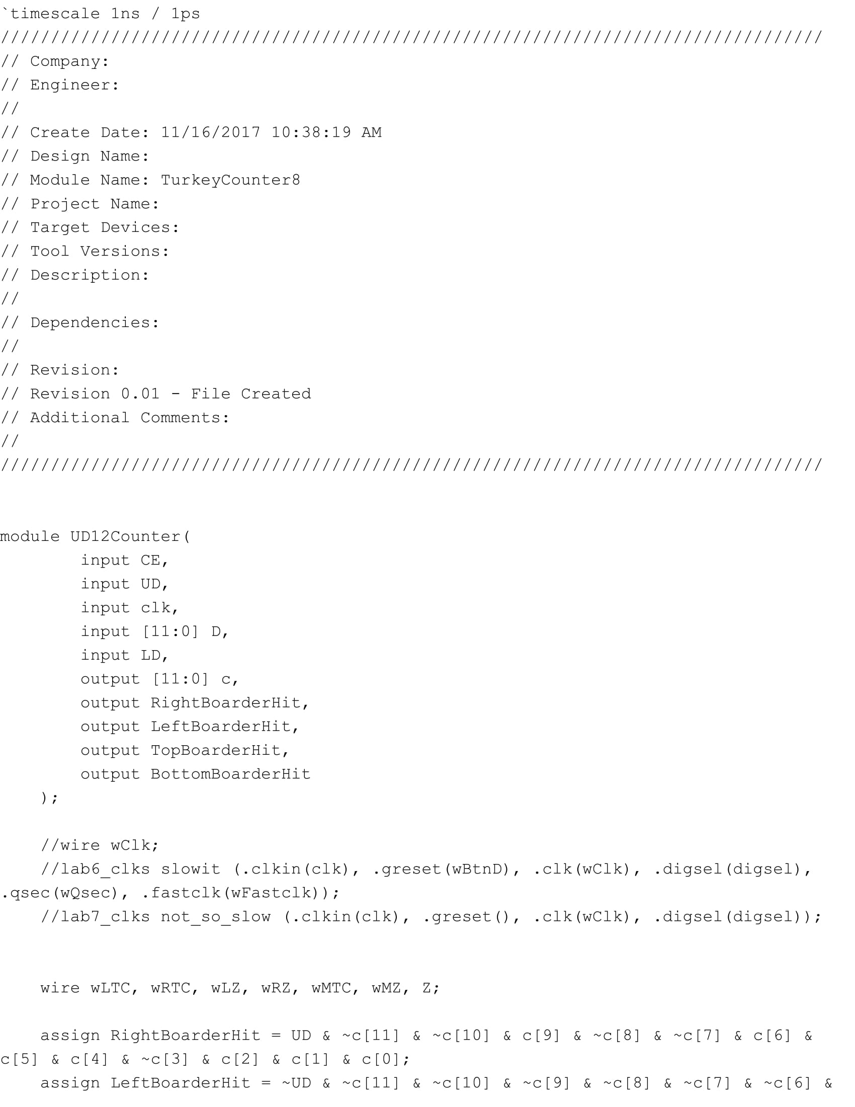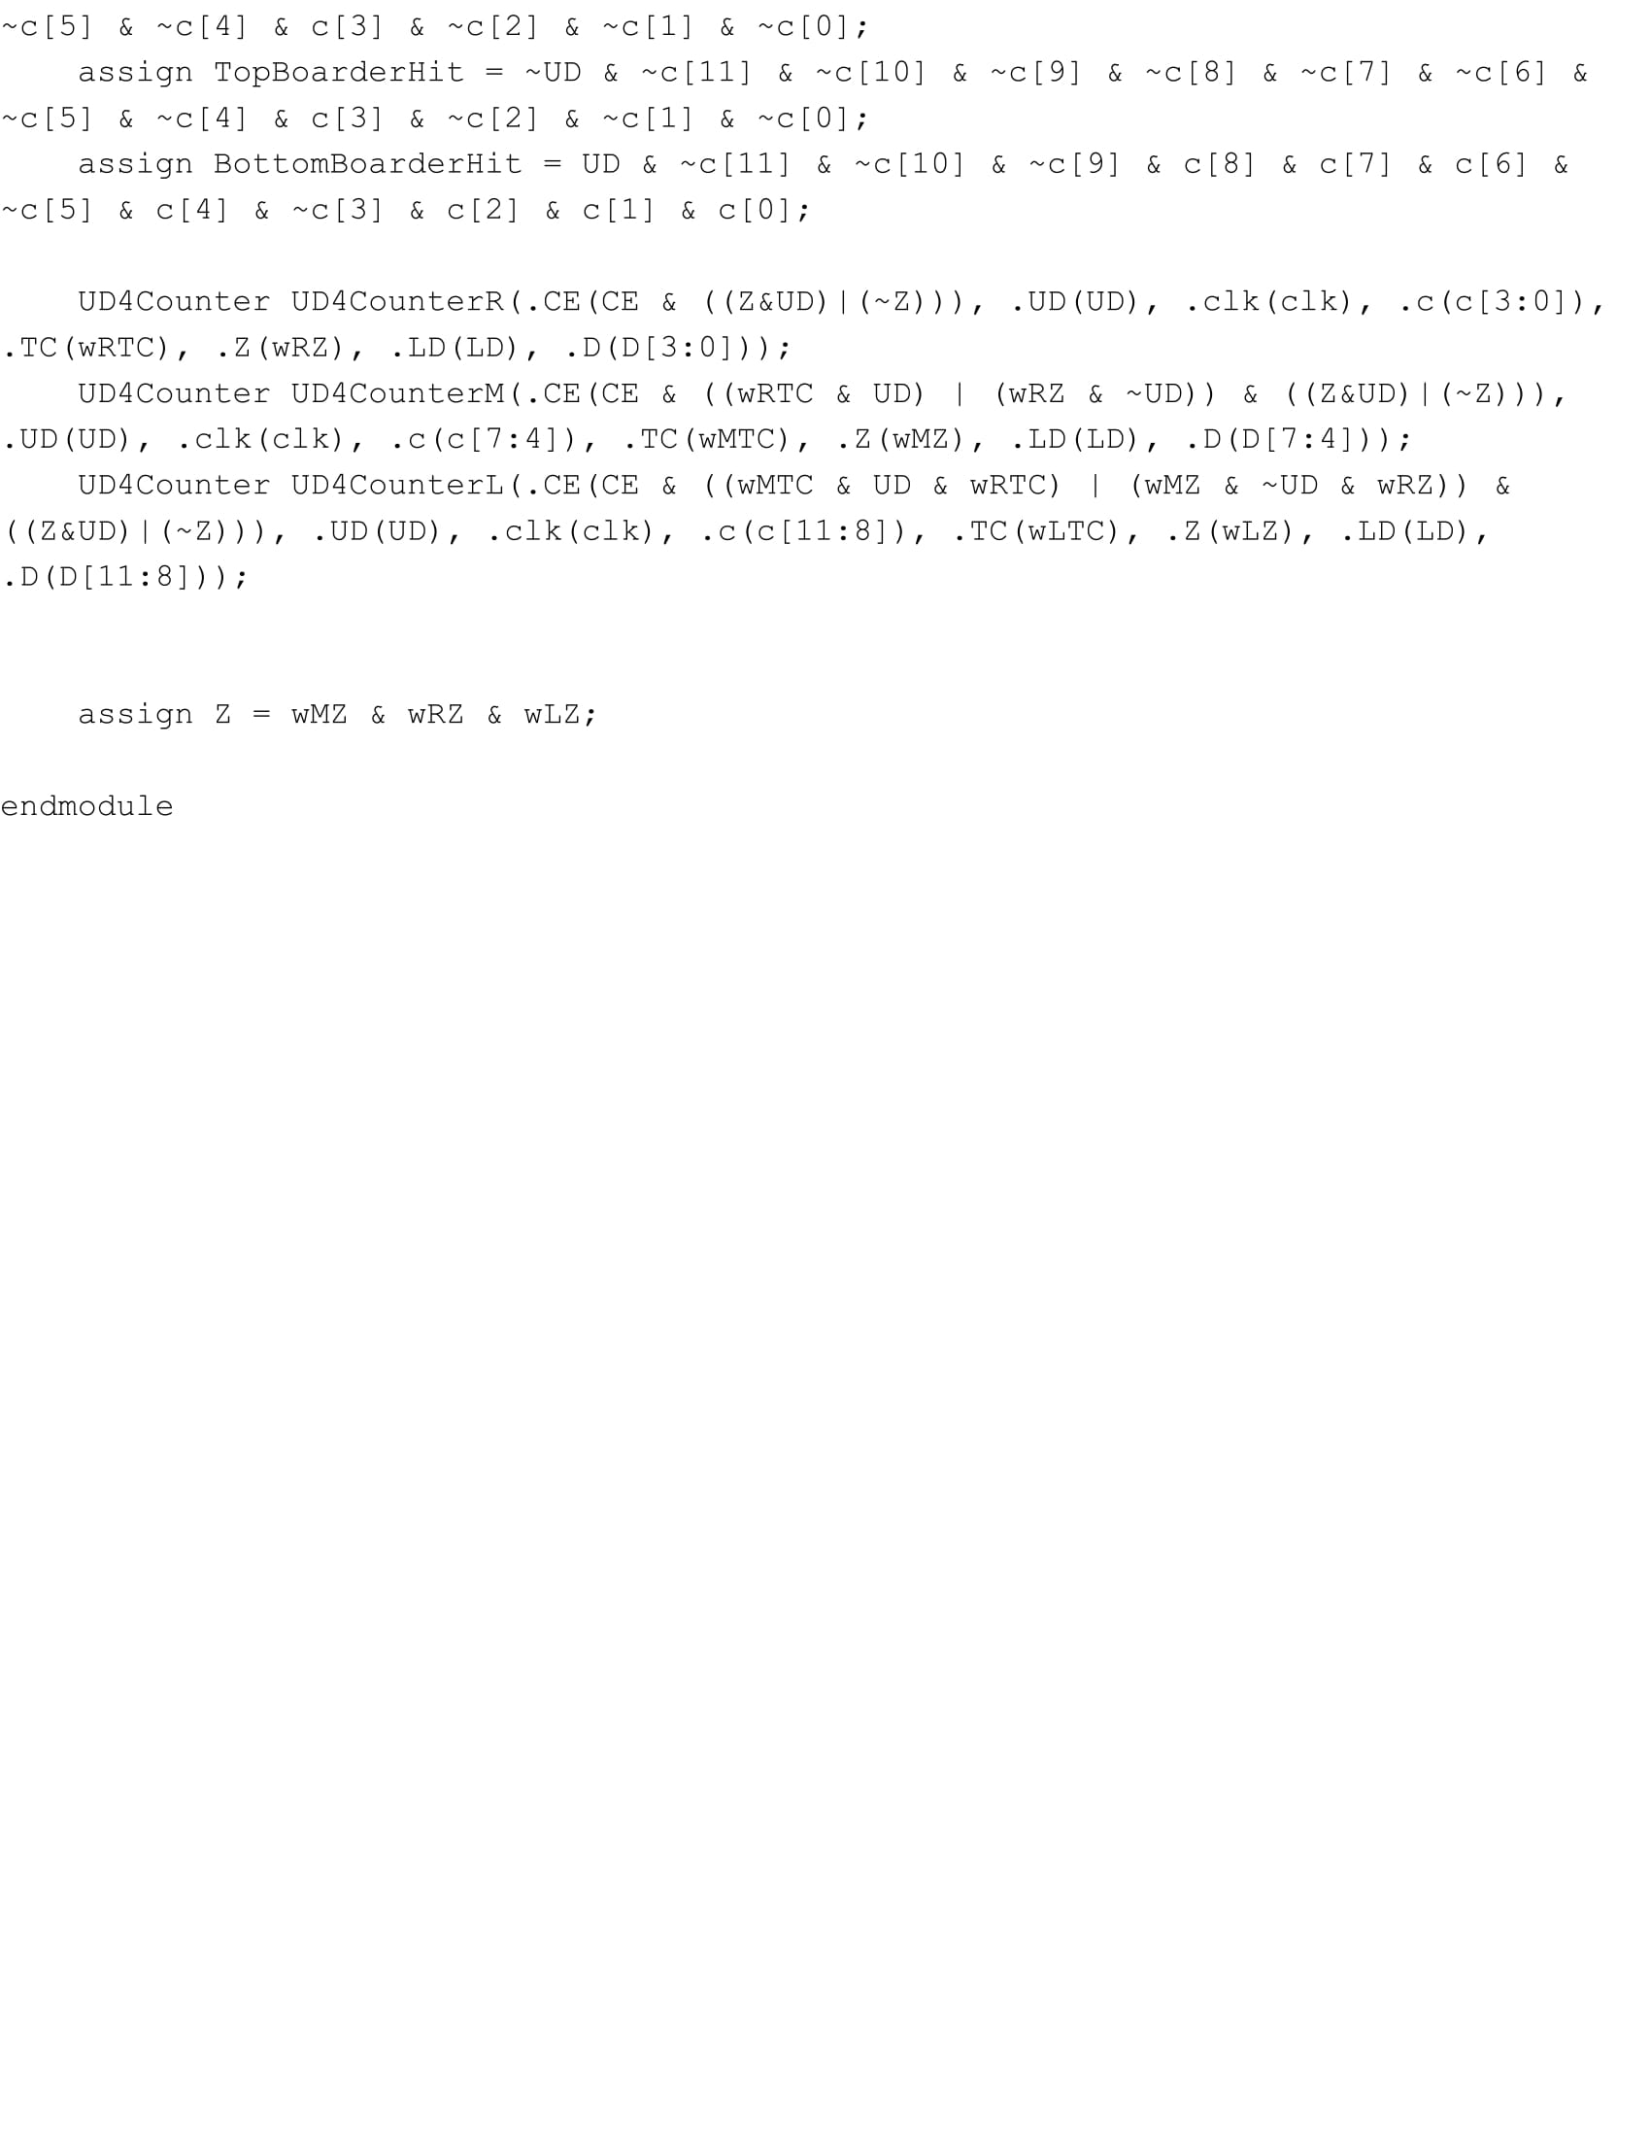

**Target Creator:**

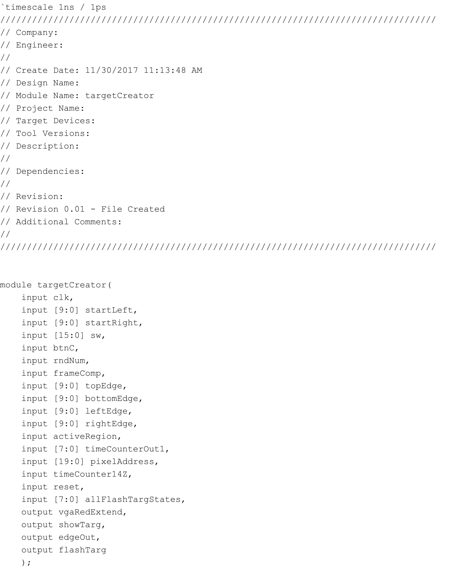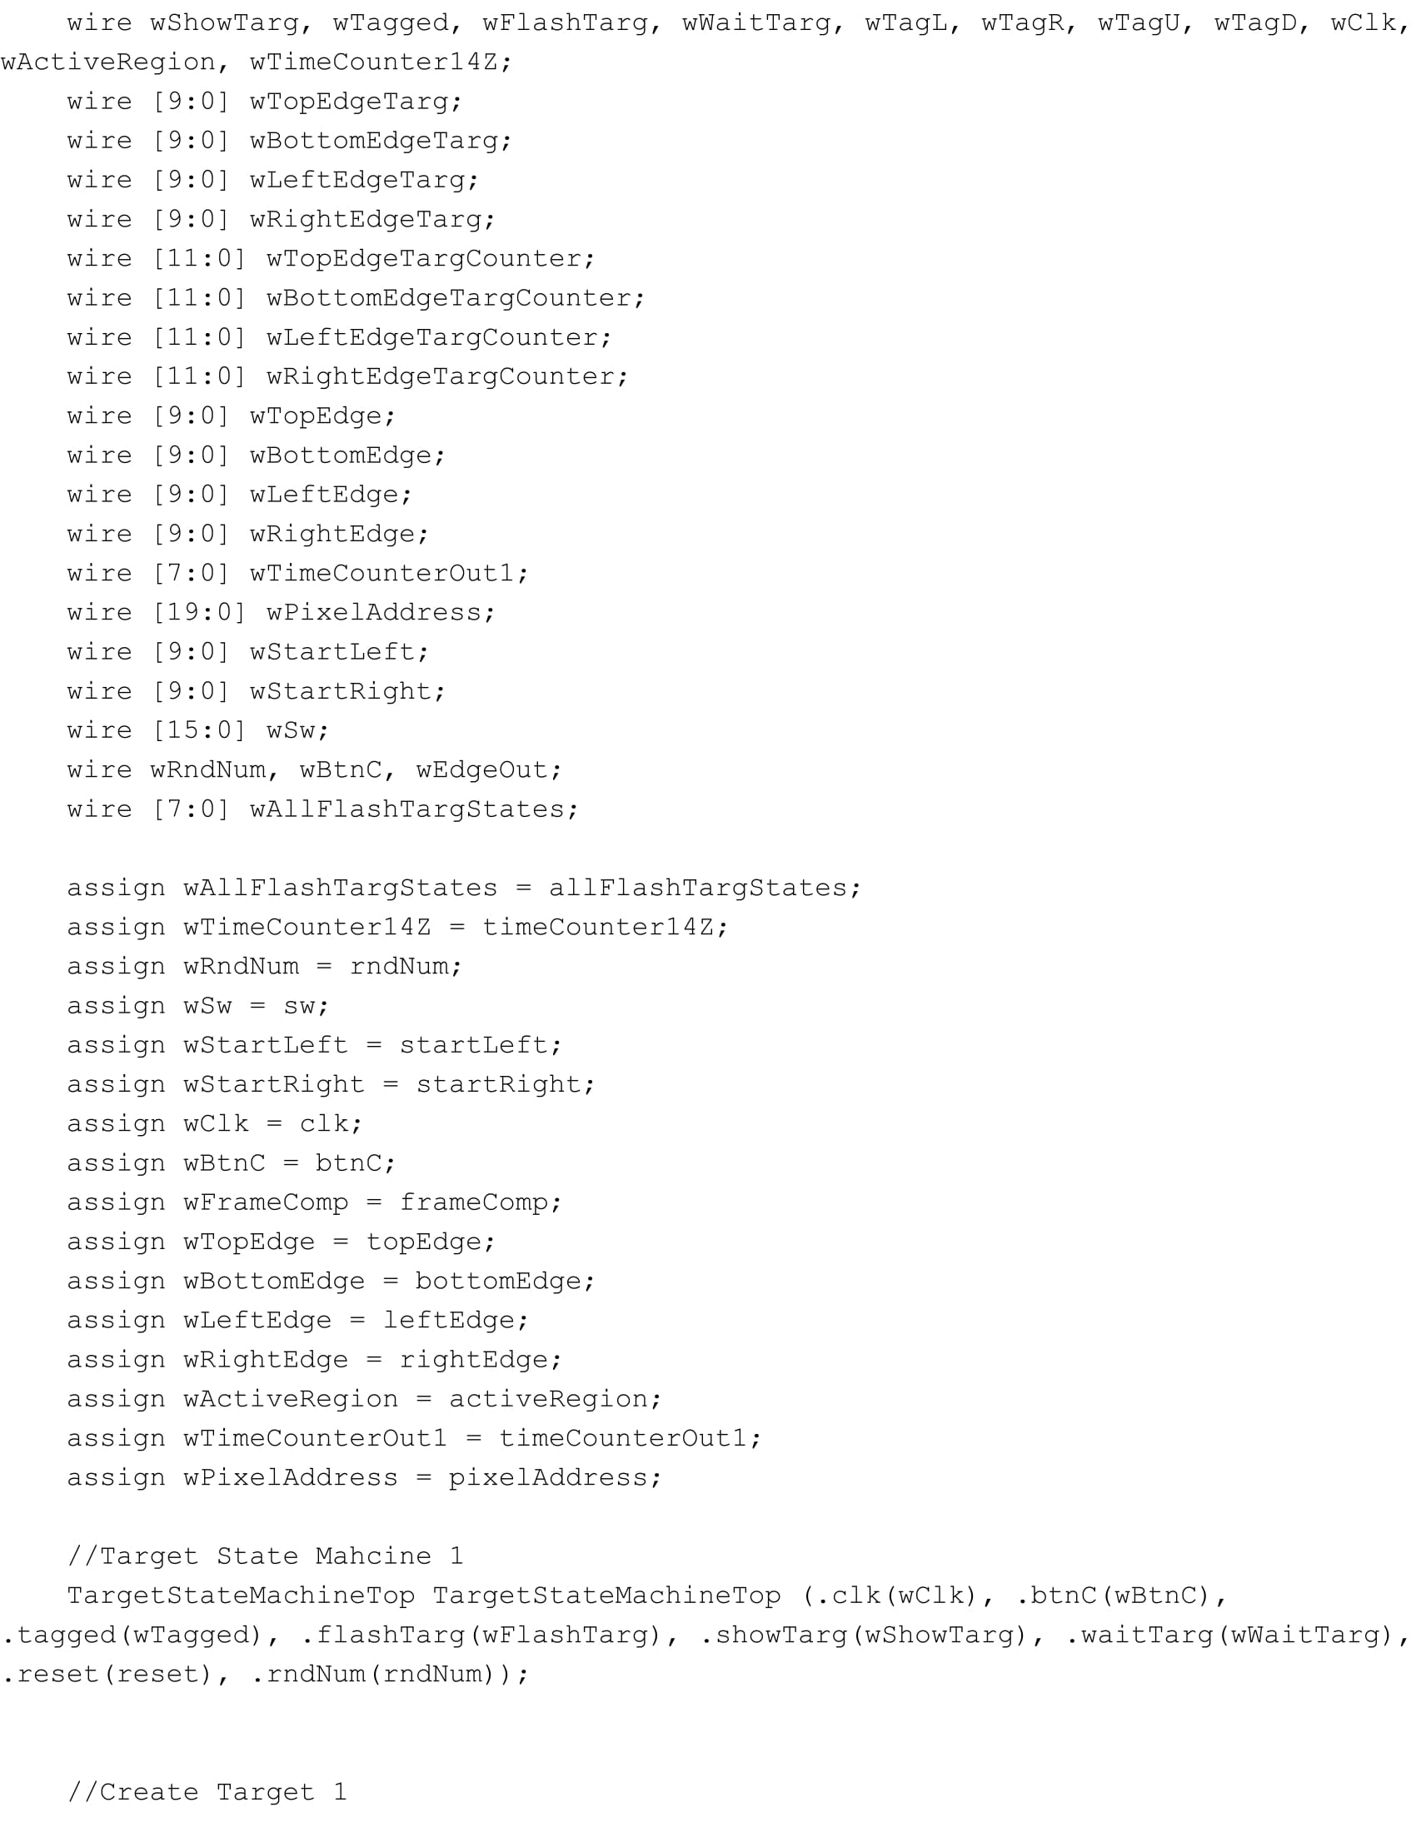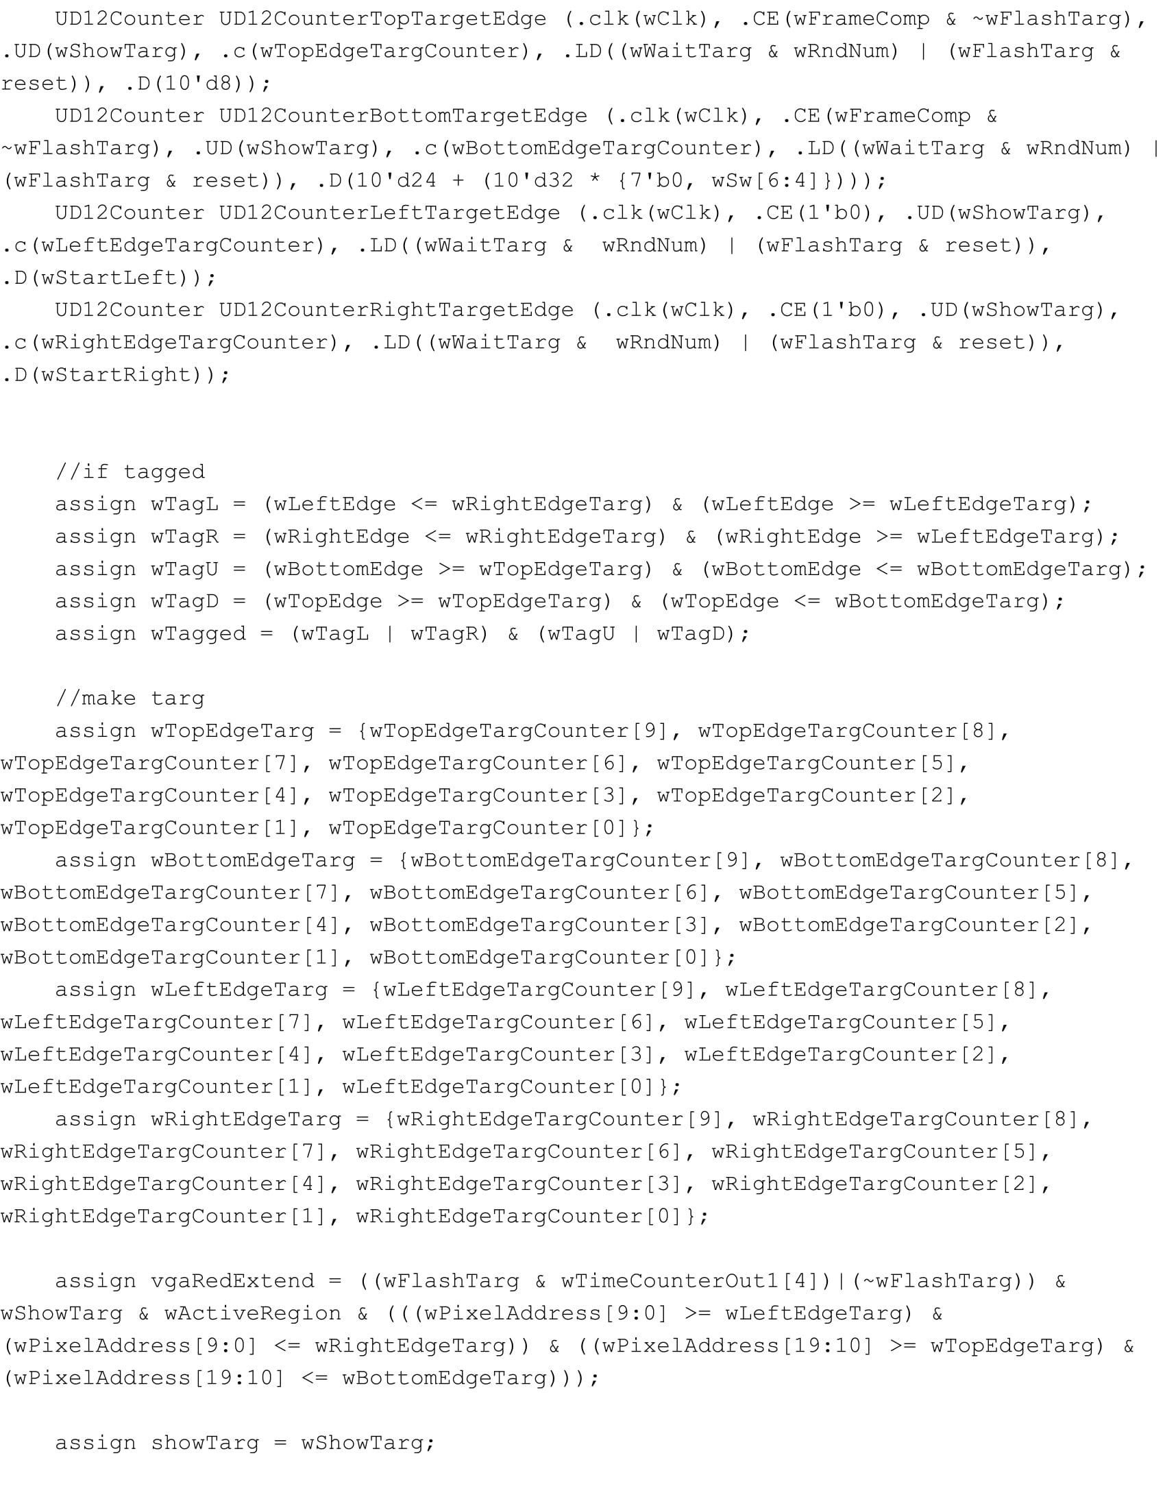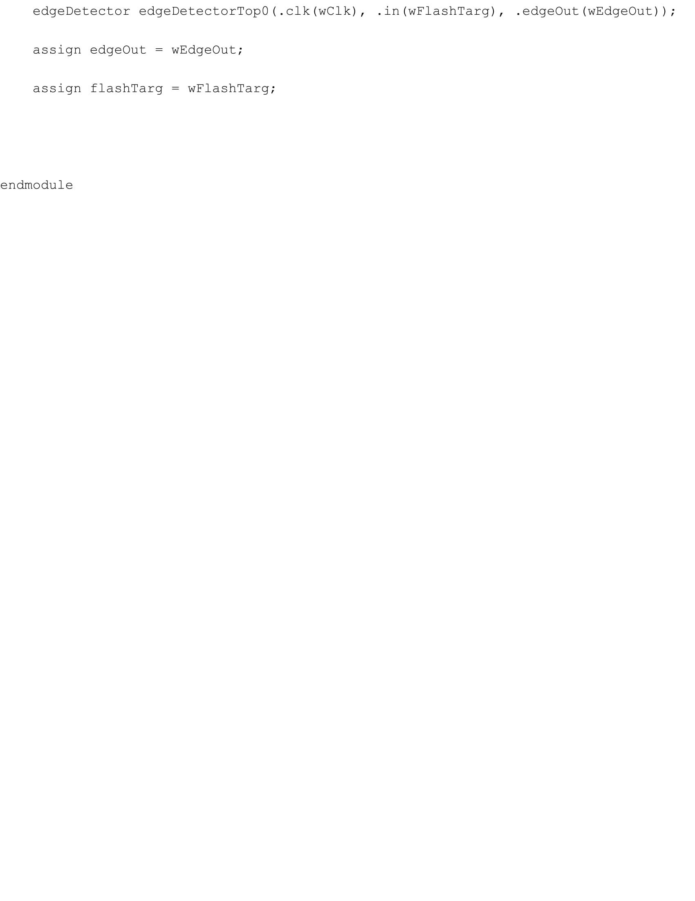

**Edge Detector:**

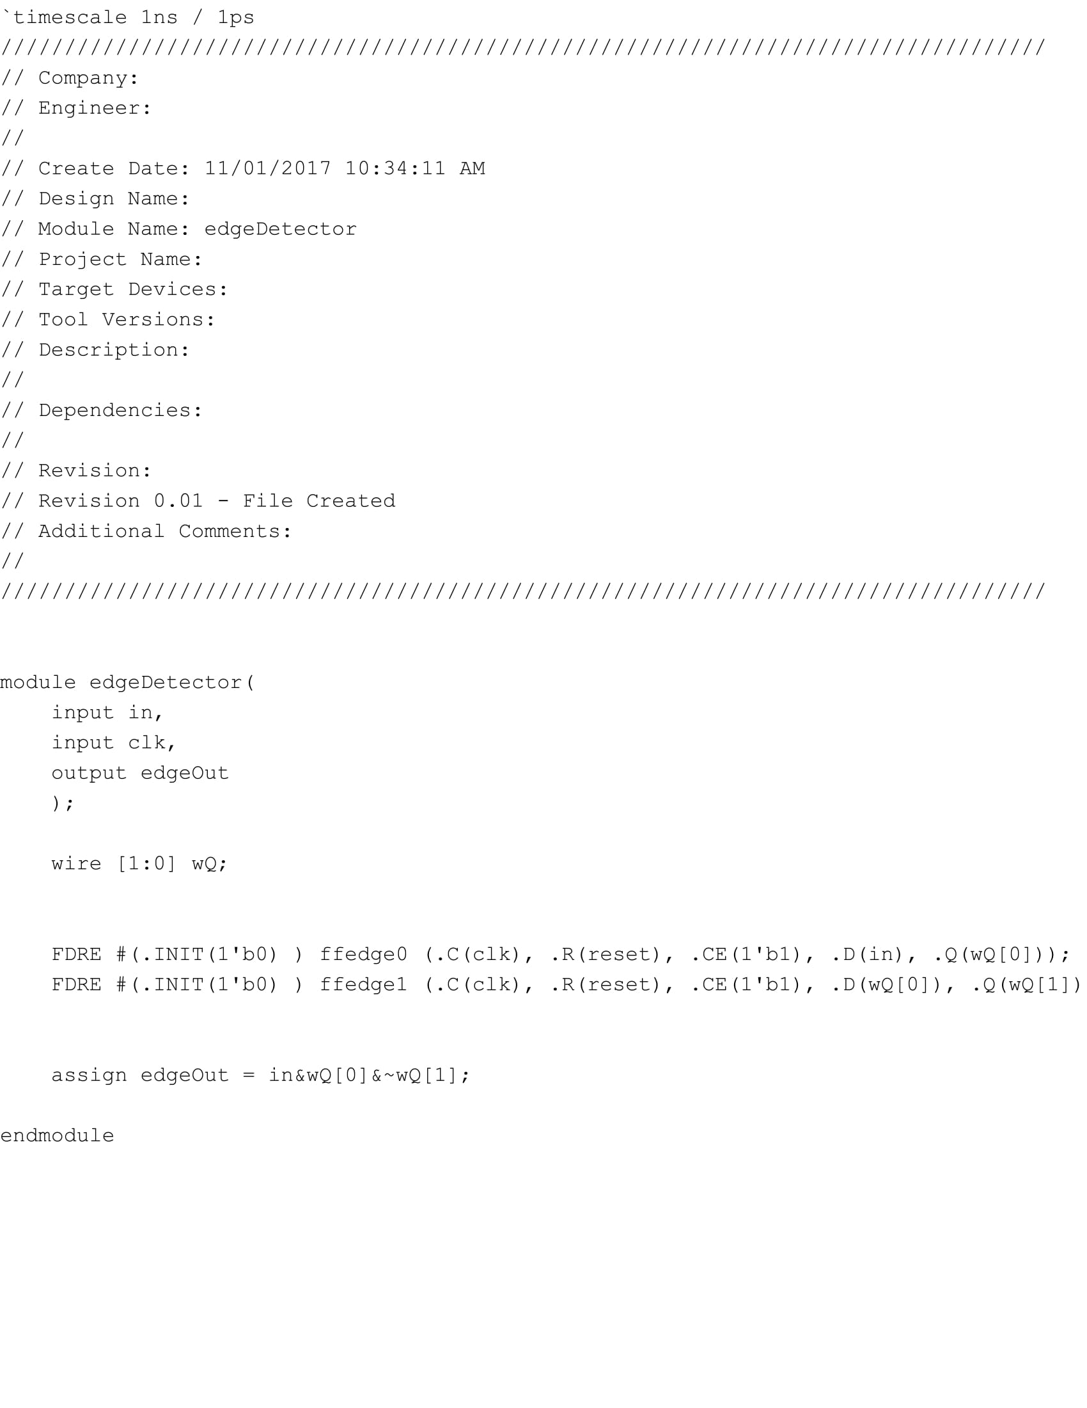

**Target State Machine:**

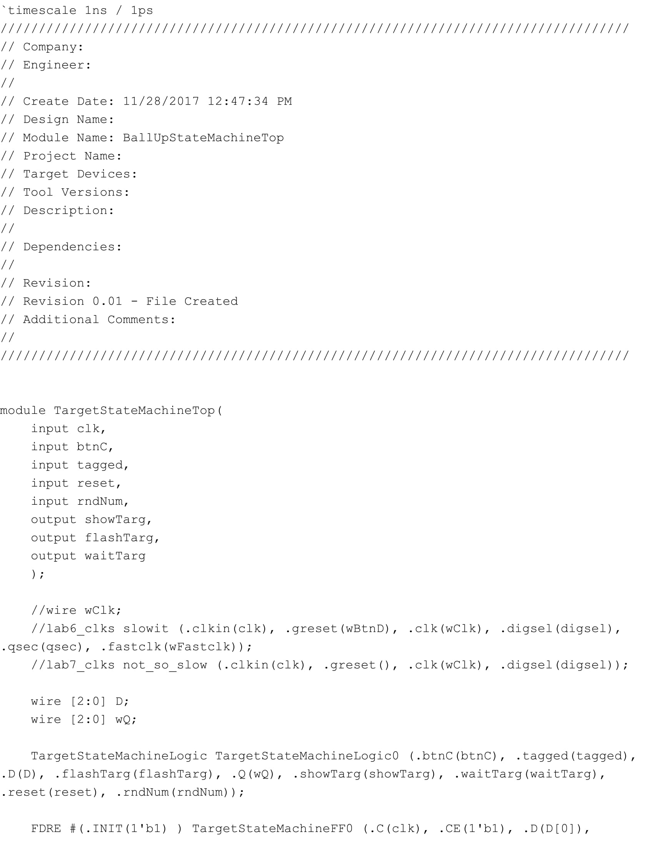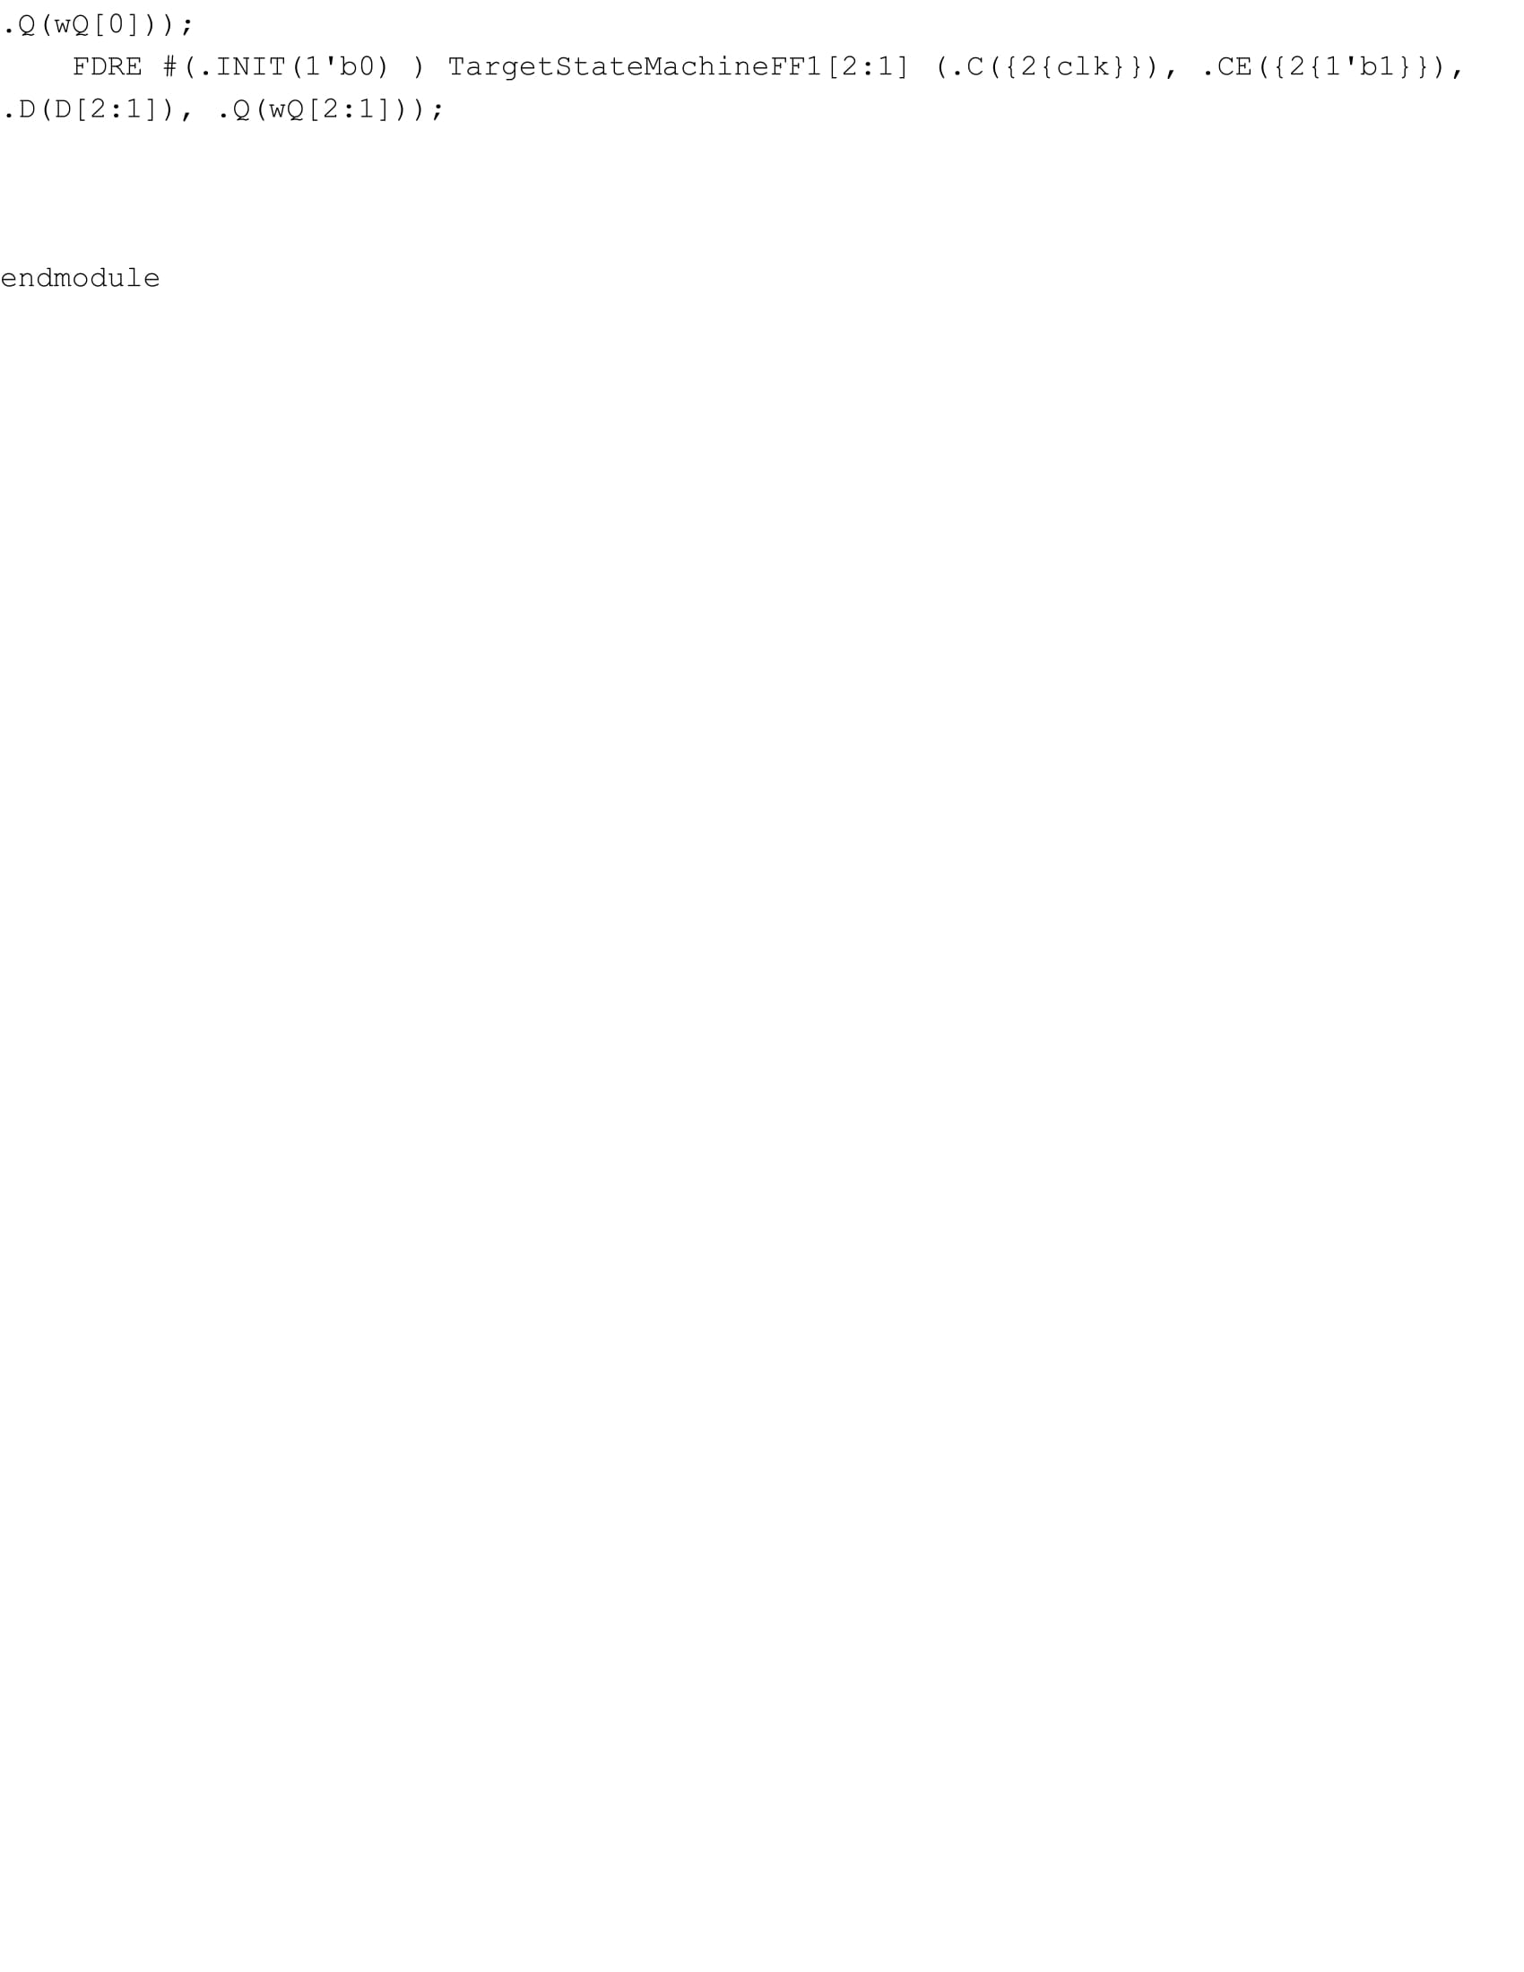

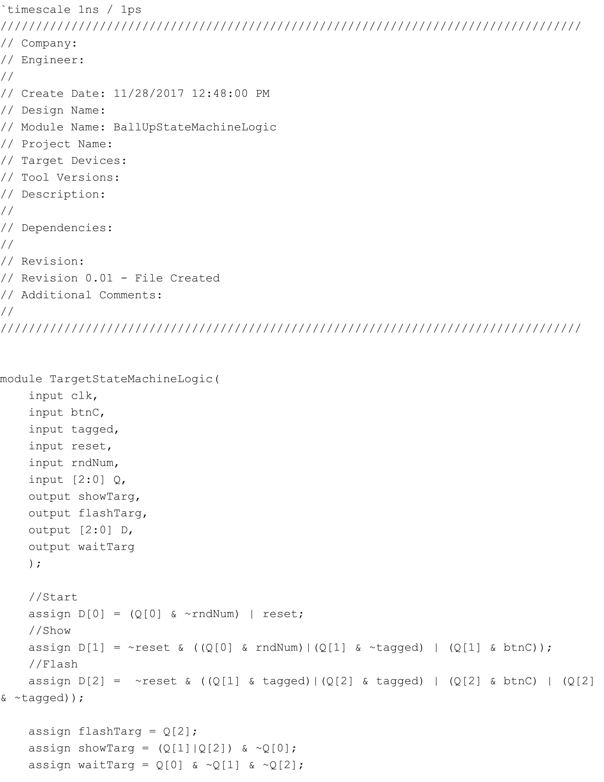

**14 Bit Up Down Counter:**

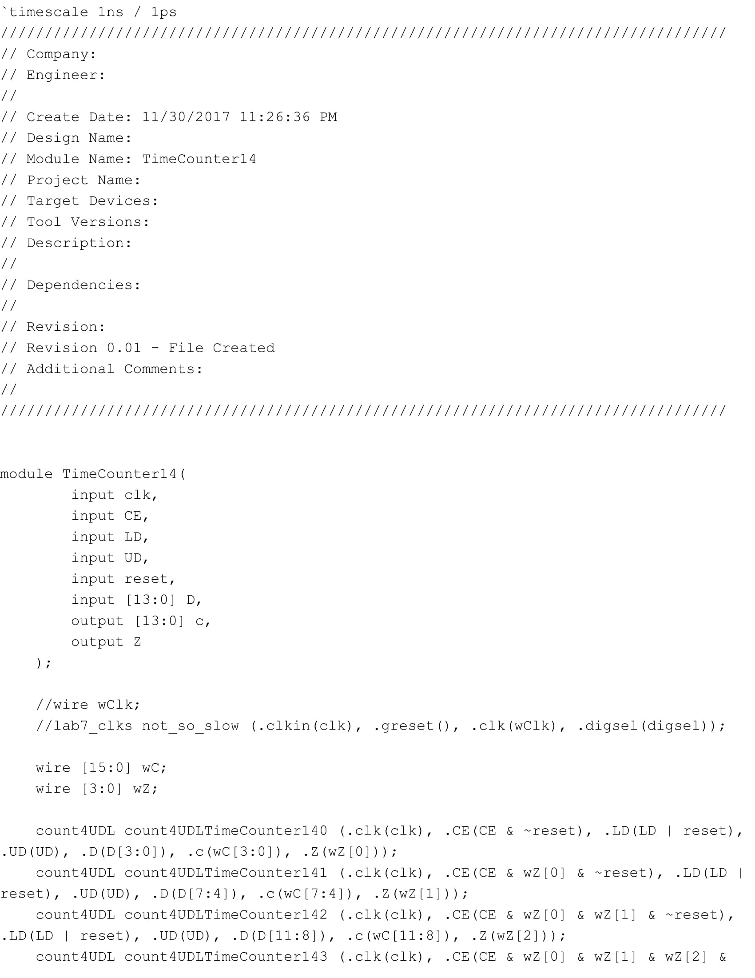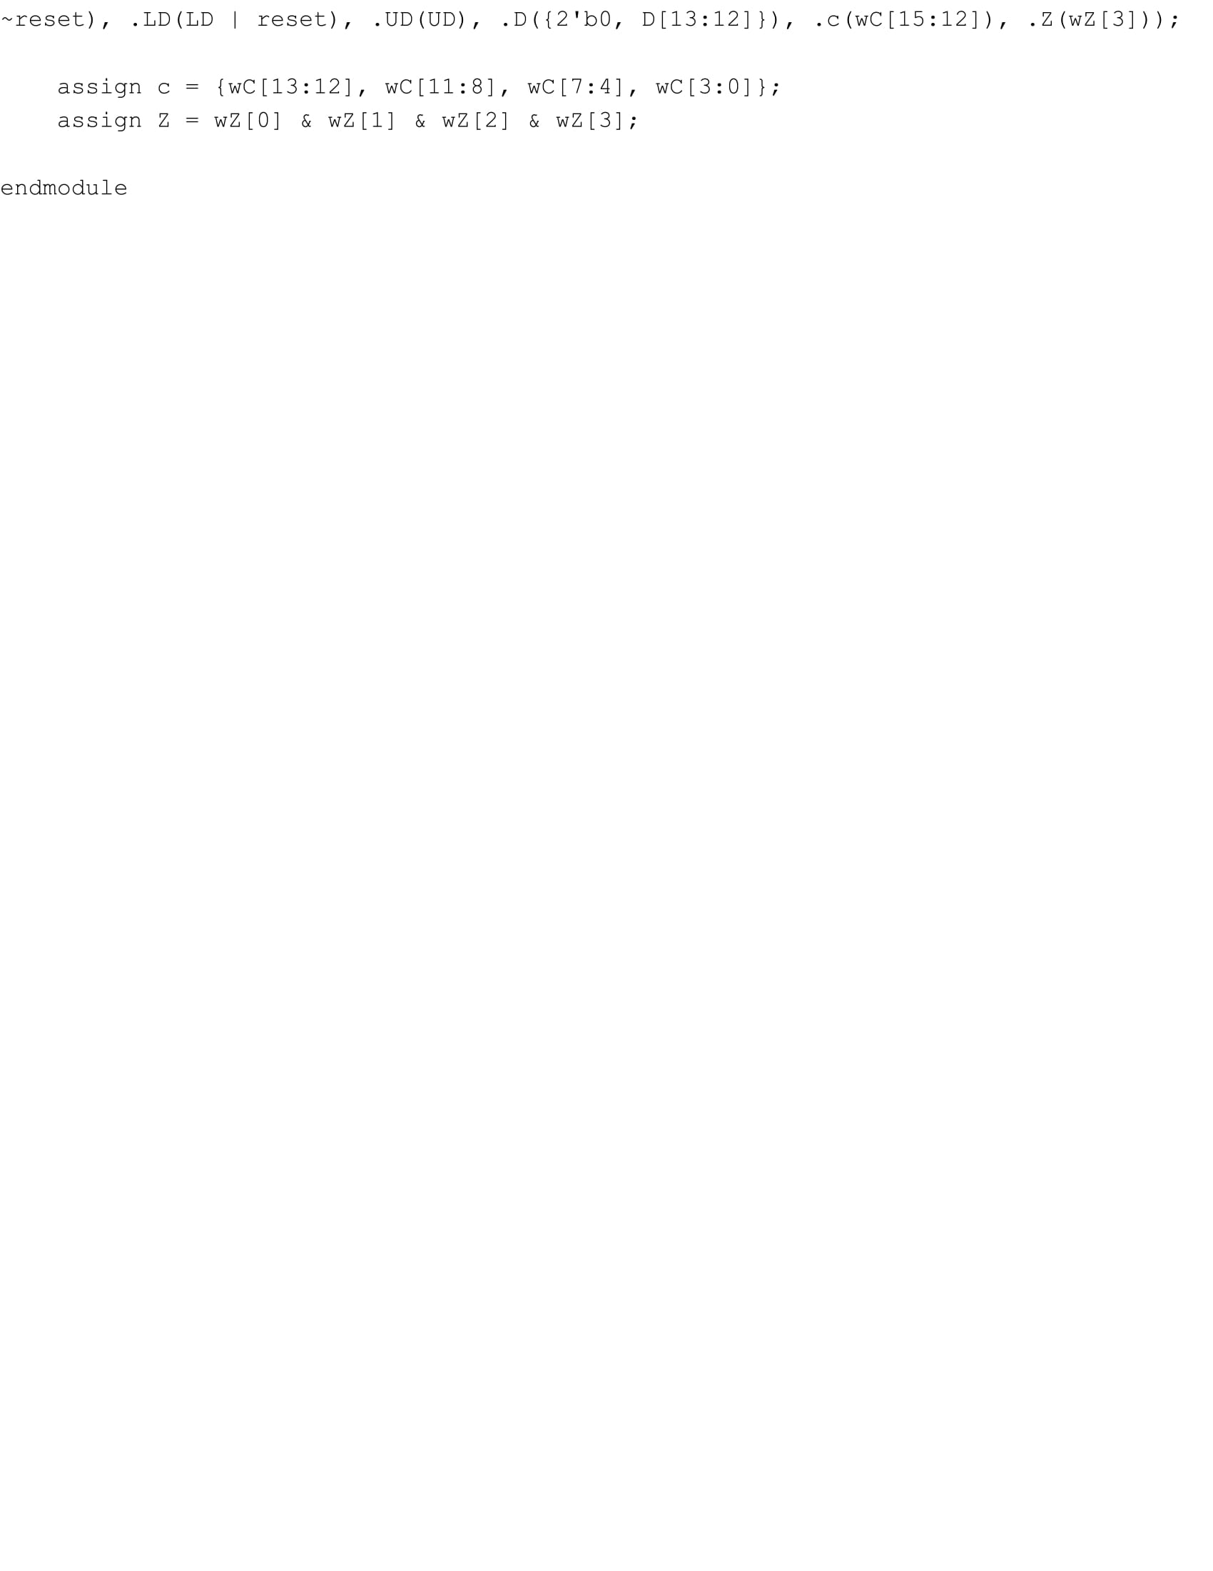

**VGA Sim:**

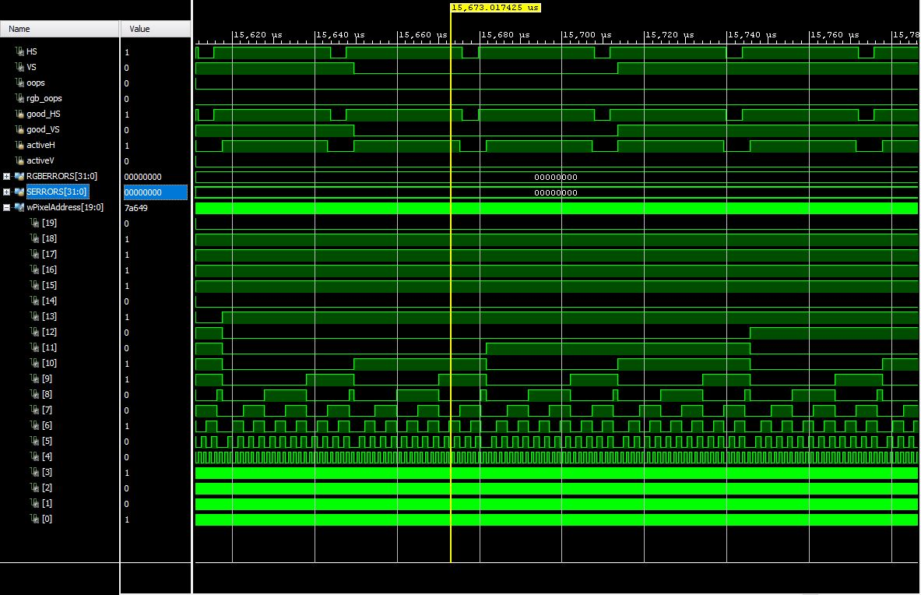

**Timing Report:**

**Design Timing:**

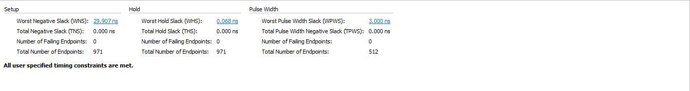

**Clock Summary:**

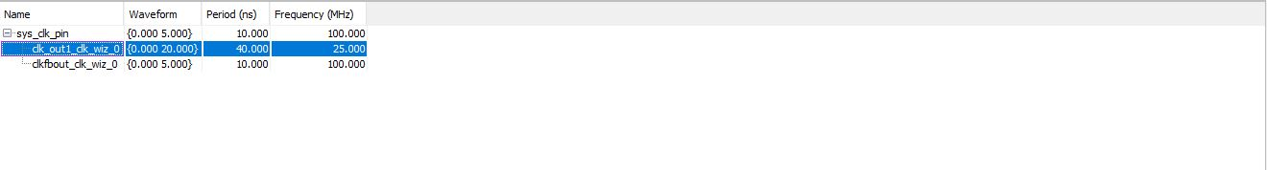

**Notebook:**

